GOODBYE CHADS, BUTTERFLY BALLOTS, OVERVOTES,
& RECOUNT RUCKUSES!

ELECTION REFORM IN FLORIDA: 2000-2003

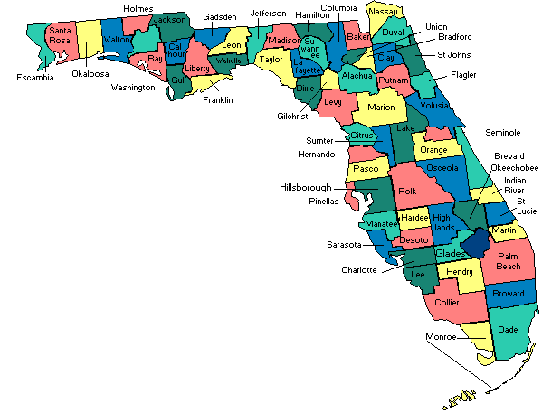

By

Susan A. MacManus
Distinguished University Professor
Department of Government & International Affairs
U. of South Florida, Tampa
4202 E. Fowler Ave., SOC 107
Tampa, FL 33620
(813) 974-5351
samacmanus@aol.com

Electionline.org
Election Reform: Politics and Policy Conference
National Press Club
Washington DC
May 29, 2003

GOODBYE CHADS, BUTTERFLY BALLOTS, OVERVOTES,
& RECOUNT RUCKUSES!

ELECTION REFORM IN FLORIDA: 2000-2003

Susan A. MacManus

______________________________________________________________________________

“Through trial and error, we Americans have learned a great deal about voting and elections and have mounted an increasingly open and fair system for determining the will of the people. Florida’s experiences with the 2000 presidential election were a very visible part of learning how to do better. That task continues.”(author’s emphasis)
Revitalizing Democracy in Florida (2001)

______________________________________________________________________________

Introduction

Election 2000 thrust Florida into the national spotlight in a less-than-flattering way. A close contest (a 537-vote, 0.009% margin of victory for George W. Bush), 36 days of post-election chaos, and an electorate tired of being the subject of jokes on Jay Leno and Late Night With Letterman led to major election reform in the Sunshine State. Florida’s embarrassment enlightened the rest of the nation and called attention to the urgency of election reform. Today, Florida’s election reforms have been called the most extensive in the nation.

The Governor’s Select Task Force on Election Procedures, Standards, and Technology report, a widely-publicized statewide public opinion survey, and pressure from the Governor (up for re-election in 2002), the Secretary of State, Florida’s 67 county supervisors of elections, and various civil rights groups (NAACP, 2002) forced Florida’s Legislature to enact sweeping new laws addressing everything from voting equipment, ballot design, recount rules, and better voter education to poll worker recruitment and training. The Florida Election Reform Act of 2001 substantially revamped the state’s election code. Subsequent reforms passed in the 2002 and pending in the 2003 sessions further strengthened the code by making it more compliant with various federal access requirements.

In 2001, incentive grants from the state to county supervisors’ offices for equipment purchase, voter education, and poll worker training were just the “carrot” needed to secure cooperation in a decentralized system. The “stick” was a required pre- election plan designed to hold individual counties accountable for reducing voter errors in the 2002 election cycle. (Supervisors are required to file post-election reports detailing their error reduction success rates.) The 2002 session election reforms brought Florida into compliance with the Americans With Disabilities Act. The 2003 sessions focused on refining election laws to secure federal funding for the state under the Help America Vote Act passed by Congress in late 2002.

A Constitutionally Decentralized
Election Administration System

With each successive reform, the state has somewhat strengthened the rule-making and coordination roles of the Department of State and its Division of Elections while maintaining the constitutionally-mandated decentralized election administration system. This would have required a formidable political balancing act had it not been for the fact that stakeholders at the local level both inside and outside government have generally agreed on many needed changes. For example, the Florida State Association of Supervisors of Elections (FSASE) and civil rights groups like the NAACP agreed on the need for the state to adopt uniform standards particularly with regard to voter list maintenance, voter education, and poll worker training.

Florida’s highly decentralized election administration system, summarized in Tables 1 and 2, is structured as follows:

The authority for the proper conduct of elections in the State of Florida rests with the Supervisor of Elections in each county. There are 67 supervisors and all are elected, except the Miami-Dade supervisor who operates under a county charter and is appointed. The supervisors are Constitutional officers, named in the 1968 Florida Constitution along with the Sheriff, the Clerk of the Circuit Court, the Tax Collector, and the Property Appraiser [for the various counties]. A few supervisors run on a non-partisan basis under their county charters; all others run by party affiliation. The Secretary of State is the chief elections officer of the state and the Division of Elections is under this cabinet position [now an appointive post]. The Division administers some aspects of elections such as qualifying state candidates for office and receiving financial disclosure forms. They formally certify election results. They certify election systems for their purchase by individual counties. They promulgate rules so that supervisors adhere to certain standards of guidelines. They provide legal opinions to supervisors on the interpretation of election law. During this process some have asked if the Division has authority over the operations of a supervisor’s office, and the answer to that is no. The Division acts as an interpreter of election law, and as a guide for standardization of procedures throughout the state. The actual administration of elections, however, is a local responsibility. The voters evaluate the performance of the supervisor every four years.

Table 1:

Florida’s State and Local Election Administrative Structure

Secretary of State
- Chief election officer – Appointed by the Governor beginning January 2003
- Provides guidance to 67 Supervisors of Elections, but does not supervise them
- Provides technical assistance to Supervisors of Elections
- Prescribes voter registration forms and procedures
- Prescribes rules concerning voting systems
- Qualifies federal, state and multi-county candidates

Election Canvassing Commission
- Three members of the Cabinet
- Canvasses all county returns and prepares election abstract

County Supervisors of Elections
- Local chief election official – 4-year term
- Appoints other local election officials; qualifies county and local candidates; mails and receives financial disclosure statements
- Administers voter registration; prepares ballots
- Administers absentee voting
- Conducts poll worker training
- Prepares and distributes election materials to each precinct

County Canvassing Board
- Supervisor of Elections, County Court Judge, Chair of the Board of County Commissioners
- Tabulates county vote and prepares abstracts for transmittal to Secretary of State

Election Day Officers
- Election Board: inspectors and clerks (appointed by Supervisor of Elections)
- Administers elections at precincts

Source: Federal Elections Commission and Florida Statutes; 2002 Governor’s Select Task Force on Election Procedures, Standards, and Technology. Tallahassee: Office of the Governor, December 30, 2002, p. 26.

Table 2:
The Division of Elections Works With Several Government Entities to Fulfill Its Responsibilities

Process/Function Activities Performed by the Division of Elections Activities Performed by Other Entities
Election Law Compliance • Issue advisory opinions • State attorneys – election law enforcement
• Monitor campaign finance reporting • Florida Elections Commission* - election law
• Qualify candidates for state/federal and multi-county enforcement
offices • County supervisors of elections** - county
• Conduct candidate training candidate qualifying
Voter Participation • Voter registration workshops • County supervisors of elections-voter
• Ineligible voter identification registration list maintenance, voter eligibility
determinations, and voter education
Election Administration • Tabulate county vote totals for state/federal • County supervisors of elections – polling
Elections place operations
• Certify voting systems • County canvassing boards***-certify county
• Prescribe ballot instruction and layout via vote totals
administrative rule • Election canvassing commission****-certify
results for state/federal elections

Notes: * Florida Elections Commission: As specified in s. 106.24, F.S., the Florida Elections commission is composed of nine members. The President of the Senate, the Speaker of the House of Representatives, the minority leader of the Senate, and the minority leader of the House of Representatives shall each provide a list of six nominees to the Governor for initial appointment to the commission. The Governor may appoint two members to the commission from each list. The Governor shall appoint the ninth commission member, who shall serve as chair of the commission.
** County supervisors of elections: Each county has a supervisor of elections, who is a constitutional officer, named in the 1968 Florida Constitution.
*** County Canvassing Board: As specified in s. 102.141, F.S., county canvassing boards are composed of the supervisor of elections; a county court judge, who shall act as chair; and the chair of the board of county commissioners.
**** Election Canvassing Commission: As specified in ss. 102.111 and 102.121, F.S., the Elections Canvassing Commission consists of the Governor and two members of the cabinet selected by the Governor.
Source: Office of Program Policy Analysis and Government Accountability, OPPAGA Justification Review: Most Election Reforms Implemented; Additional Actions Could Be Considered. Tallahassee: OPPAGA, Florida Legislature, October 2002, p.2.

As of January 1, 2003, the Secretary of State position in Florida became an appointive position—chosen by the Governor. (This change was part of a constitutional amendment restructuring Florida’s Cabinet that was approved by the voters in 1998.) The Secretary of State appoints the head of the statewide Division of Elections. While both the Secretary of State and the Division of Elections chief play important roles in election administration, they “do not have unilateral authority over elections administration and must interact with and to a large extent depend upon independently-elected Constitutional officers—Florida’s 67 Elections Supervisors—for proper election administration” (Governor’s Select Task Force 2002: 25). (See Appendix A for an organizational chart of the Division of Elections.)

The 67 Boards of County Commissioners also play an important role in election administration primarily because they must approve the budget of each county supervisor of elections. The level of funding “is a major factor in determining the types of voting systems, the amount and quality of voter education, and other important elements of effective elections.” (Governor’s Select Task Force 2002: 25). In addition, the Chair of the Board of County Commissioners, along with the County Court Judge, and the County Supervisor of Elections make up the county canvassing board.

The Help American Vote Act (HAVA) is projected to further strengthen the state’s coordination role. Under the law, the state will be required to maintain a statewide voter registration system, direct federal funds through the chief state election officer to local governments, and lay out a plan to enhance coordination between the state and its local governments. (More will be said about this later in the chapter.)

Hitting “Ground Zero” Running

Once the presidential election was resolved by the U.S. Supreme Court in Bush v. Gore, Florida’s Governor Jeb Bush (R) wasted no time in issuing an Executive Order creating a 21-member Select Task Force. The bi-partisan task force was charged with reviewing the state’s election procedures, standards, and technology following the chaos of the 2000 presidential election. (The Governor signed Executive Order Number 00-349 on December 14, 2000. The order mandated that the first meeting “shall be held no later than January 3, 2001.”) Florida’s task force “was the first citizen commission in the nation following the controversial election to make a comprehensive assessment of the election process and to recommend extensive changes.”

Staffed by The Collins Center for Public Policy, Inc., a well-respected non-partisan and independent think tank based in Tallahassee and Miami, the task force’s “strategy was to understand how Florida’s electoral process works, listen to the concerns of voters and experts about areas that needed improvement, and debate and recommend workable solutions” (Governor’s Select Task Force, 2001:16).

Specifically, the Governor’s Executive Order instructed the Task Force to make policy recommendations and/or propose legislation to improve the state’s election system by March 1, 2001 at which time the Task Force would be dissolved. The Governor, the President of the Florida Senate, the Speaker of the House of Representatives, and the Secretary of State were the designated recipients of the task force report under the Order.

The Task Force held five meetings in four Florida locations across the state (Tallahassee-2, Orlando, Davie—near Ft. Lauderdale, and Jacksonville. Input from experts and the general public was extensive. The group’s deliberations were broadcast on public television (including C-SPAN) and widely covered by the state’s print media.

The Governor’s Select Task Force report, Revitalizing Democracy in Florida, was completed just prior to the beginning of the 2001 legislative session and included 35 specific recommendations covering: voter responsibility and education; voter education best practices and funding; voter bill of rights and responsibilities; civic education; poll worker recruitment, training, and communication; improving precinct-to-central office communication; voter comments cards and suggestion boxes; nonpartisan election of supervisors; prohibition of active partisans on county canvassing boards and the state elections canvassing commission; county election supervisors budget appeals; a uniform and standardized statewide voting system for the 2002 election cycle; funding for new voting systems; decertification of punch card, lever, paper, and Marksense central tabulation voting systems; acceleration of certification of voting technology and continuous review of standards; uniform statewide standards for counting ballots and for recounts for each type of voting system; a statewide online voter registration database; substitution of a voter information card for a voter registration identification card; changes in dates of first and second primaries; a uniform poll closing time resolution to be sent to the U.S. Congress; ballot design reviews; provisional ballots; allowance of convenience absentee voting; changing requirements for information on absentee ballots and requests for absentee ballots; clarification of challenges to absentee ballots; acceleration of research and programs involving electronic Internet voting for overseas voters; broader jurisdiction for the State Elections Canvassing Commission; establishment of a clear threshold for automatic manual vote recounts; limiting manual recounts to ballots not counted by machines; establishing a margin for automatic recounts; ensuring an open manual recount process; automatic recounts in all parts of multi-county election districts; recounts for all precincts in a district (not just three); clarification of grounds for contesting an election; and expanding the time between the primaries and the general election and for certification of election results. (Governor’s Select Task Force, 2001: 74-83).

In addition, the Task Force recommended five areas in need of further study and action: 1) the restoration of voting rights of ex-felons with completed sentences, (2) the preparation and accuracy of a list of possibly disqualified voters, (3) a complete overhaul of the Florida Elections Code by the 2002 legislative session, (4) the sanctity and security of polling places, and (5) third party voter registration and ballot delivery activities (Governor’s Select Task Force, 2001: 84-85).

A post-task force analysis by its staff director reiterated the inadequacies of state election laws that existed prior to the Legislature’s massive revamping of the code during its 2001 session. Among the glaring inadequacies were:

- A poor voter registration system, which “had limited usefulness as a current, complete, and accurate voter roster for election days” (Pritchett, 2002:9). (Each county had its own registration database; these databases were occasionally consolidated into a state Central Voter File.)
- No minimum state standards for voter education
- No minimum state standards and hourly requirements for training poll workers
- No uniform polling place manual to guide poll workers on election day procedures
- No unified, user-friendly voting system; ballot designs and voter error rates varied by the type of voting system in place in a county. (There were 5 different systems certified for use at the time.)
- No conditional, or provisional, ballot procedure.
- No clear timing for certifying election results.
- No clear statutory guidelines to determine when to grant recounts; no uniformity across counties for recounts.
- No clear standard for contesting an election.

The task force report, as previously noted, addressed each of these shortcomings, many of which were also perceived as essential starting places for reform by Florida voters.

STATEWIDE SURVEY 2001:

FLORIDIANS WANT REFORM, NOW!

The Florida Legislature’s 2001 session convened on March 6 and adjourned on May 4. On April 23, near the end of the session, the results of a statewide public opinion survey of 600 Floridians were released. Legislators heard “loudly and clearly” that the public expected state legislators to fix the election system and would primarily hold them accountable if no reforms were made. Three-fourths of the survey respondents said it was “very important” for the state legislature to tackle reform before election 2002. Half identified the state legislature as the entity they would hold most responsible for failure should no election reforms be adopted before the next statewide election in 2002. (See Figure 1.)

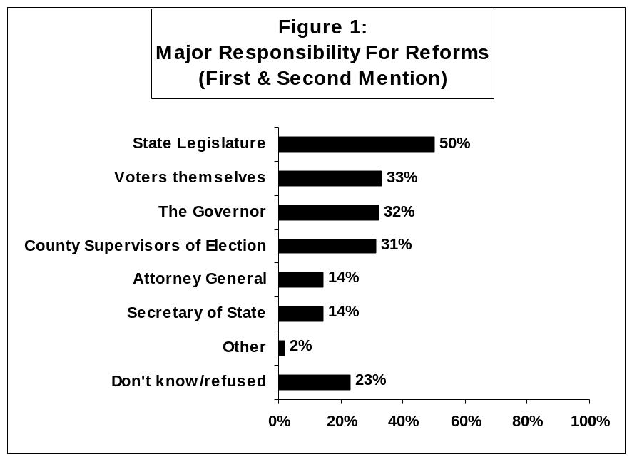

Note: Survey respondents were asked: “If no election reforms take place before the

next statewide election in 2002, which of the following do you think should be held the

most responsible for the lack of vote reform in Florida? The next most responsible?”
Source: Telephone survey of a random sample of 600 adults 18 & older conducted
April 3-8, 2001 by Schroth & Associates (Washington DC) for The Collins Center for
Public Policy, Inc. and the James Madison Institute; margin of error +/-4%.

Why the Mess in 2000?

The survey also asked Floridians to identify what they saw were the major reasons for the problems some citizens experienced when they voted in November 2000. As shown in Figure 2, confusing ballot designs (39%), voter carelessness (38%), and punch card ballots (29%) were the most often cited reasons for “the amount of problems that many Floridians experienced when they voted last November in Florida.” Opinions varied considerably across groups of voters.

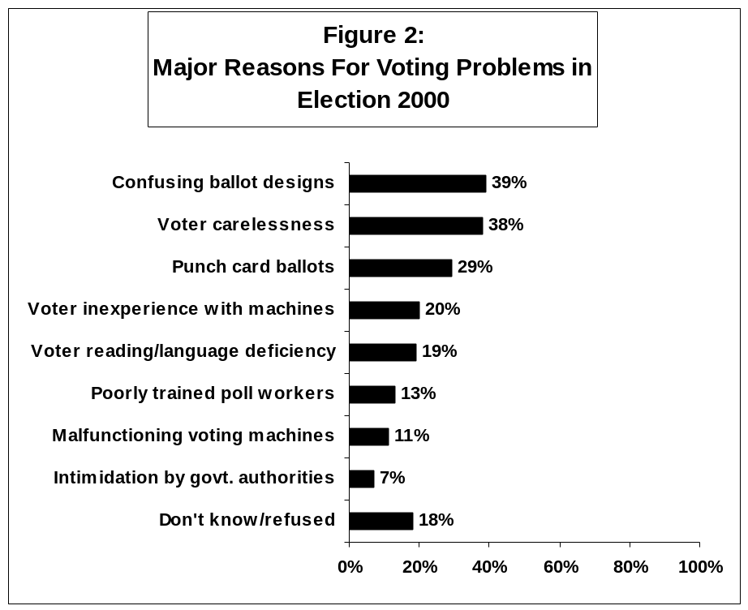
Note: Survey respondents were presented with the 8 reasons, then asked: “Which of the following
reasons do you believe had the greatest effect on the amount of problems that many
Floridians experienced when they voted last November in Florida?” And which is the next reason
that had the most effect? The percentages reported in the Figure are first and second mentions.
Source: Telephone survey of a random sample of 600 adults 18 & older conducted
April 3-8, 2001 by Schroth & Associates (Washington DC) for The Collins Center for
Public Policy, Inc. and the James Madison Institute; margin of error +/-4%.

Generally, African Americans, non-Cuban Hispanics, and Democrats cited government-related reasons (ballot design, voting machine inaccuracies and malfunctions, poll workers, and government officials) whereas white, Cuban-Americans, and Republican residents more often pointed to individual voter-based reasons (carelessness, lack of experience using voting equipment, reading & language deficiencies).

What Reforms Are Most Urgent?

Floridians first and foremost said they wanted standardization and uniformity—of voting machines, ballot layout and design, recounting rules (for close elections and for absentee ballots), and poll closing times. (See Figure 3.) There was also significant support for the creation of a statewide voter registration list to help reduce fraudulent voting by ineligible persons, better voter education, better training of poll workers, and an improved voter registration system. Well over half of those surveyed favor prohibiting Florida Cabinet officials from being actively involved in campaigns other than their own, nonpartisan election of county Supervisors of Election, and outlawing punch-card voting machines.

But only one-third support restoring the voting rights of felons and less than one in five favor voting via the Internet.

The Florida Legislature Closely Follows Citizen Priorities

Florida’s elected officials proved to be quite attentive to the electorate’s demands. They overwhelmingly passed the Florida Election Reform Act of 2001 (S1118) on the last day of the legislative session. (The vote in the Senate was 38 Yeas and 2 Nays. It was unanimous in the House. At the time, the partisan makeup of the Senate was 25 Rs & 15Ds; of the House, 77Rs & 43Ds.) When Governor Jeb Bush (R) signed the bill into law on May 10, he acknowledged that “The citizens of Florida spoke loud and clear on this issue, and we have responded with this historic election reform legislation.”
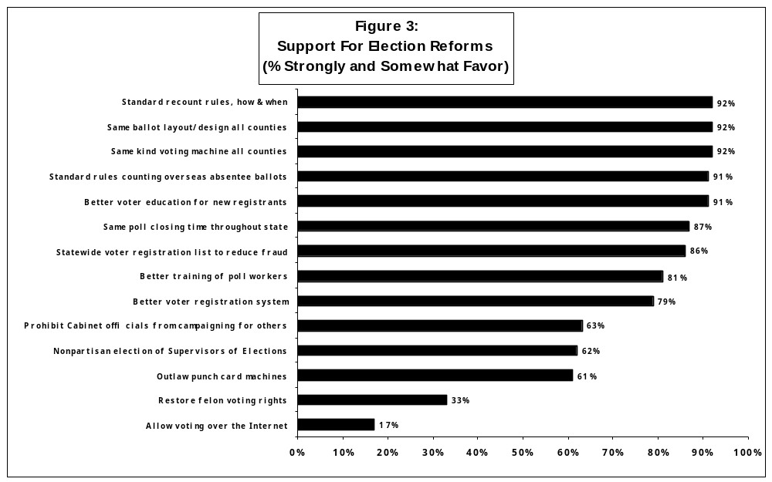
Note: Survey respondents were presented with a list of suggested reforms emanating from reforms suggested by The Governor’s 2001 Select Task Force
on Election Procedures, Standards, and Technology, and from hearings held by other groups like the U.S. Civil Rights Commission. They were then asked
whether they strongly favor, somewhat favor, somewhat oppose, or strongly oppose each reform.
Source: Telephone survey of a random sample of 600 adults 18 & older conducted April 3-8, 2001 by Schroth & Associates (Washington DC) for The Collins Center for
Public Policy, Inc. and the James Madison Institute; margin of error +/-4%.

The Election Reform Act of 2001: A Major Overhaul

The legislation restructured the roles and responsibilities of the voters, county supervisors of elections, poll workers, the Florida Department of State and its Division of Elections, other state agencies, and canvassing board members at the local and state levels, among others.

Some of the major requirements of the new law are to:

- Require the use of voting technology that is precinct-based and allows the voter to correct mistakes made while voting;
- Prohibit punch card and other antiquated voting systems in Florida.
- Provide Florida counties with $24 million over the next two years to modernize their voting equipment.
- Provide for the development of a standardized and unambiguous ballot design to be used in Florida’s primary and general elections.
- Provide $6 million in funding for the development of voter education programs and the recruitment and training of poll workers.
- Provide $2 million for the development and implementation of a statewide centralized voter registration database by June 2002.
- Allow a voter whose name does not appear on the voter registration roll to vote a provisional ballot that will be counted if the voter is subsequently found to be properly registered to vote.
- Clarify and provide standards for the procedures to be followed when recounting votes.
- Facilitate absentee ballot voting by Florida’s military and overseas voters.
- Clarify that vote totals are to be certified no later than 7 days following a primary election and 11 days following a general election.
- Eliminate the second (or runoff) primary for the 2002 election cycle; gives the Legislature the option of deciding whether to permanently enact the second primary elimination.
- Remove justification requirements for absentee ballot voting to increase the convenience of the voting process.
- Require the posting of a Voter’s Bill of Rights and Responsibilities in each polling place in Florida.

These reforms tracked closely with those recommended by the Governor’s 2001 Select Task Force and with opinions expressed in the Collins Center-James Madison Institute public opinion poll of April 2001 (MacManus, 2001; Pritchett, 2002).

Not Now, But Maybe Later

Among the recommendations that were not adopted were two that a majority of the population favored: nonpartisan election of county supervisors of elections and prohibiting members of county and statewide canvassing boards from being active in partisan political activity while serving as members of these boards. The Legislature also failed to require the automatic restoration of felons’ voting rights, but this reform was not as high a priority among the population at-large as the other two. Both of these reforms have been revisited by the Legislature without success.

ELECTION REFORM LEGISLATION: 2002
Laws passed in the 2002 session broaden the scope of voter education responsibilities, more definitively spell out voter rights, and ensure that Florida’s electoral system conforms to the Americans with Disabilities Act of 1990.

H493 authorized private individuals and groups interested in registering voters to reproduce voter registration applications. It requires that the Department of Highway Safety and Motor Vehicles and other voter registration agencies forward unsigned or incomplete voter registration applications to the appropriate supervisor of elections within five days. This is designed to allow the supervisors to contact the potential registrant and help him/her complete the registration application. The bill permits voters to change their addresses via telephone or e-mail, if the voter provides his or her date of birth. Convicted felons and persons adjudicated mentally incompetent, when notified by certified mail that they are potentially ineligible to vote, must now be told that they can request a hearing before the supervisor to show cause why they should not be removed from voter rolls. (Section 98.075 provides for an appeal to the Circuit Court if the elector is dissatisfied with the supervisor’s decision at the hearing.) Under the bill, information on how to update voter signatures must also be published at least once each general election year.

A major thrust of S1350 is to ensure that Florida’s electoral system conforms to the Americans with Disabilities Act of 1990. It abolishes limitations on the length of time (five minutes) a voter is allowed to occupy voting booths. It delineates the specific forms of communication and information that must be used to reach hearing, visually, and physically impaired voters. Candidates, political parties, and political committees “must use closed captioning and descriptive narrative in all television broadcasts regulated by the Federal Communications Commission that are on behalf of, or sponsored by,” them. Voting systems must also be accessible—physically, visually, and audibly. The Act delineates specific accessibility requirements, ranging from minimum height for voting booths, minimum decibels, color combinations and font size, to strength requirements. It dictates that certified voting systems must inform voters of an undervote or overvote. Finally, the Act mandates accessibility and signage requirements at polling places (parking spaces, accessible paths of travel). It requires the Department of State to “develop a mandatory, statewide, and uniform program for training poll workers on issues of etiquette and sensitivity with respect to voters having a disability.”

This legislation was in response to recommendations made by The Secretary of State’s 2001 Select Task Force on Voting Accessibility in Florida in its January 14, 2002 report. The 21-member Task Force, co-chaired by State Senator Richard Mitchell and State Representative Larry Crow, held five hearings across the state and prepared a final report. It concluded that: “There are significant, severe, and pervasive obstacles that have been placed in the path of Florida’s voters with disabilities” (Secretary of State Task Force, 2002:i). It singled out problems with privacy, accessibility—to the polls (transportation), at the polling place, and to equipment—and registration (low rates among the disabled). The report recommended major revisions to the Election Code (Chapters 97-106, Florida Statutes) to put the state in compliance with the Americans with Disabilities Act with regard to accessibility standards for certification of voting systems and for polling places. It also recommended a one-hour mandatory training program for all election officials and poll works on etiquette for all voters with disabilities (mobility impaired, blind or visually impaired, deaf and hard of hearing).

S618 revises the Voter’s Bill of Rights and Responsibilities and specifically informs the voter that failure to perform any of the responsibilities does not prohibit a person from voting. It requires poll workers to give direct voting instructions instead of referring voters to a voting instruction model. To protect the integrity of the ballot, those who are given provisional ballots must sign a statement acknowledging they are aware of the penalties of voting fraud. The attention to fraud in Florida is understandable, falling as it did on the heels of massive voter fraud in a 1997 Miami mayoral election.

some relapses in 2002:

deja vus in several south florida counties reinforce need for

better voter & poll worker education

In spite of the major election reforms adopted by the Florida Legislature and the purchase of expensive touch screen voting machines by many of the state’s large counties, chaos resurfaced when the new equipment was used for the first time in three south Florida counties: Palm Beach (municipal elections in early 2002), Broward and Miami-Dade (September 10, 2002—primary election day). The problems simply reinforced what many national task force and commission reports had concluded: first, there is never an error-free election, and second, without better voter education, new technology and revamped statutes, rules, and regulations will have far less of an impact.

After the embarrassments of Election 2000—the butterfly ballot, chads of all descriptions (hanging, dimpled, pregnant, and otherwise), and re-counting fiascos, the Palm Beach Board of County Commissioners voted to spend $14.4 million to purchase 4,000 touch screen voting machines. Everyone had high hopes that the new system would eliminate the errors of the old punch card system. But the first time the system was used—in 15 municipal elections in 2002—problems abounded. Voter and poll worker error rates re-surfaced and the high profile County Supervisor of Elections, Theresa LePore, was called before the County Commission to explain what happened. Shortly thereafter, similar situations made the news in several other Florida counties as new voting systems “put on trial” in various municipal elections were judged to be less-than-perfect.

A Messy Primary Election Day and Post-Primary

It was the September 10 primary that thrust Florida back into the national spotlight and yielded “Florida-duh” jokes all over again. In the vote-rich South Florida counties of Miami-Dade and Broward, primary election day turned out to be a mess. Polls didn’t open on time, poll workers didn’t show up as promised, and some of the new voting machines malfunctioned and/or were foreign to ill-trained poll workers. Even Janet Reno--a candidate for the Democratic Party nomination for governor--was unable to vote at her precinct when she appeared with national media in tow because it was not yet open! By mid-afternoon, Secretary of State Jim Smith asked Governor Bush to issue an executive order keeping polls open an additional two hours, which he did, although some poll workers never got the message and closed at 7 p.m.

Late that night while it appeared McBride had won, the state’s voters once again went to bed uncertain of the winner and grimaced as the nation dusted off its “Flori-duh” jokes. Miami-Dade and Broward counties began recounting ballots. Reno refused to concede until satisfied that every vote was counted. Three days after the primary, she demanded a statewide recount, a request denied because her numbers were not high enough to authorize it under the new Florida law that had been adopted in 2001. Her opponent, Bill McBride, won the nomination by a sheer 0.4%.

This re-encounter with election chaos prompted other county election supervisors across the state to step up their education and training efforts before the November 5, 2002 general election, although most did not have the major problems in the primary that plagued Miami-Dade and Broward counties.

County Election Supervisors “Get With The Program”

on Voter Education

The serious problems that surfaced in these south Florida counties reminded elections supervisors across the state of two things: (1) the importance of stepping up voter education and better training for poll workers and election office personnel; and (2) their accountability for these programs under the Election Reform Act of 2001 (MacManus, 2003). Better education of all those involved in elections—voters, poll workers, and election office employees—has been viewed as the most critical element of election reform in Florida from the “get-go.”

The (Florida) Governor’s Select Task Force on Election Procedures, Standards, and Technology (2001:17) placed voter education at the top of its recommendations for addressing the shortcomings evident in presidential election 2000:

We can easily get lost in debates about which voting technology is best or what law should control recounts. But, ultimately, elections are not primarily about technology or legal procedures. They are about people, their belief in democracy, and their faith in free and open elections as a reliable way to make their choices known. The interests and skills of people—citizens, voters, poll-workers, candidates, and officials—can make or break any voting system. It is essential to put people first and to invest in their abilities to do their jobs well. (author’s emphasis).

The Florida Election Reform Act included appropriations to assist counties with the implementation of their voter education programs aimed at citizens and poll workers. The Act spelled out the distribution formula--effective July 1, 2001. Each county’s receipt of these funds was contingent upon the filing of a voter education plan by its supervisor of elections.

The Florida Election Reform Act of 2001 mandated that the contents of these nonpartisan voter education plans were to conform to a Department of State standards rule to be adopted by March 1, 2002.

The rule requires county supervisors to create a Voter Guide. “The Voter Guide shall include the following information: how to register to Vote; where registration applications are available; how to register by mail, dates for upcoming elections, registration deadlines for the next primary and general election; how voters should update their voter registration information such as changes in name, address, or party affiliation; information on how to obtain, vote and return an absentee ballot; voters’ rights and responsibilities pursuant to section 101.031, Florida Statutes; polling information including what times the polls are open, what to bring to the polls, list of acceptable IDs, what to expect at the polls; instructions on the county’s particular voting system; supervisor contact information; and any other information the supervisor deems important.”

County election supervisors are required to provide the Voter Guide “at as many places as possible within the county including: agencies designated as voter registration sites pursuant to the National Voter Registration Act; the supervisor’s office; public libraries; community centers; post offices; centers for independent living; County governmental offices; and at all registration drives conducted by the supervisor of elections.”

Voters’ rights and responsibilities must be posted (pursuant to section 101.013, Florida Statutes), at each supervisor’s office.

The rule also includes parameters for voter education via websites. “If a supervisor has a website, it must take into account all of the information that is required to be included in the Voter Guide. In addition, when a sample ballot is available, the website must provide either information on how to obtain a sample ballot or a direct hyperlink to a sample ballot.” Supervisors with websites must also post notice of all changes of polling places and precincts on the site.

Young voters in both high school and college are expressly targeted by the rule, although, as will be discussed later, many supervisors voluntarily include elementary and middle schools:

“At least once a year in each public high school in the county, the supervisor shall conduct a high school voter registration/education program. The program must be developed in cooperation with the local school board and be designed for maximum effectiveness in reaching and educating high school students.”

“At least once a year on each college campus in the county, the supervisor shall provide a college voter registration/education program. This program must be designed for maximum effectiveness in reaching and educating college students.”

The supervisors are charged with other types of outreach as well. Senior citizens and minorities are specifically mentioned as targeted audiences. For example, the supervisors are required to “conduct demonstrations of the county’s voting equipment in community centers, senior citizen residences, and to various community groups, including minority groups.” Both general and minority media outlets (radio, television and print programs and interviews) are to be used to publicize voting information. County supervisors must provide voter registration workshops for individuals and organizations sponsoring voter registration drives “upon reasonable request and notice.”

There are strict requirements for voter notification—subject, format, and placement as well:

“County supervisors of elections shall provide notice of changes of polling places and precincts to all affected registered voters.” Such notices must appear in a newspaper of general circulation and be posted in at least ten conspicuous places in the county, as well as on the supervisor’s website.

“The supervisors shall also widely distribute a notice that if a voter does not receive a revised voter identification card within 20 days of the election the voter should contact a specific number at the supervisor’s office to obtain polling place information.”

Stepping Up Poll Worker Training

Poll worker education efforts were stepped up after the problems with poll workers during the primary election 2002 surfaced. They had begun with passage of the 2001 Election Reform Act. That law, as previously reported, increased the required number of hours of poll worker training. Many counties began requiring attendance at more training sessions and reduced the size of their training classes. Several counties implemented testing programs to determine a person’s ability to perform requisite tasks at the polling place. Others used Internet-based training programs, “telecourses,” or interactive videos in CD format. These training tools discuss, among other topics, the importance of assisting a voter, provide instructions on how to open and close the polls, give information on rules governing solicitation at the polls by candidates and political parties, and describe what to do if a voter is not on the precinct roll.

In some places, election office staff members were specifically assigned responsibility for developing and implementing new poll worker training materials and workshops. These new materials contained special instruction on how to interface with disabled, older, and angry voters, how to inform voters of their rights and responsibilities, and how to handle emergencies (including power failures with touch screen voting machines). Many counties included conflict resolution as a special topic and/or training session. And counties with sizable minority populations intensified efforts at offering poll worker training materials in Spanish and Creole.

Election Supervisors Accountable for

Education & Training Program Success

Finally, the Election Reform Act of 2001 dictates that “by December 15 of each general election year, each supervisor of elections shall report to the Department of State a detailed description of the voter-education programs implemented and any other information that may be useful in evaluating the effectiveness of voter-education efforts.”

Thus, Florida’s supervisors of elections expended a tremendous amount of effort between September and November 2002 implementing their voter education and poll worker training plans. They were clearly fearful of falling in the footsteps of Broward and Miami-Dade counties, wary of adverse publicity, and knowledgeable of how a bad performance in 2002 might negatively impact their own re-election bids in 2004.

Voters Give High Marks to Technology, poll workers, and

Election Supervisors in november 2002

Floridians who voted on November 5, 2002 gave “high-fives” to the new technology, the education efforts of the county supervisors of elections, and the election-day efforts of better-trained poll workers. The Collins Center for Public Policy, Inc., and The James Madison Institute co-sponsored an election night (November 5, 2002) statewide telephone survey of 801 voters and 666 non-voters. It was designed to allow voters to rate various dimensions of the new voting system that election reform laws had crafted. Non-voters were sampled to determine whether their experiences in election 2000 and/or the new voting technology deterred them from voting.

The problems with election 2000, the September 10 primary, and the advent of new voting equipment led us to inquire as to the reasons why some Floridians didn’t vote on November 5. There were still those who believed that election 2000 would significantly and negatively impact on voter turnout. And after the September 10 primary, some were convinced that fear of new voting equipment would keep many from going to the polls (or voting absentee or early), especially the elderly. This simply was NOT the case (Marshall and Pritchett, 2003). The results, shown in Table 3, show that neither election 2000 nor new technology was a major deterrent to voting. In fact, the reasons given are very similar to those frequently given in Census Bureau studies of nonvoters.

Table 3

“Why didn’t you vote?” (General Election 2002)
Reason for Not Voting  _____________________________________________  Not registered  Too busy  Illness  Wasn’t interested  Out of town  Registration issues  Transportation issues  Didn’t like candidate/issues  Inconvenient polling place/hours/long lines  Forgot to vote (or voted absentee)  Turned off by 2000 election  Felt vote wouldn’t make a difference  Bad weather  Scared of new technology  Other  No Answer | Frequency  32.3%  9.6%  7.4%  6.3%  2.3%  2.3%  2.1%  2.1%  1.5%  1.2%  0.8%  0.8%  0.2%  0.0%  17.9%  19.1%
Note: The respondents were asked: “Did you vote in today’s election either in person,
by absentee ballot, or by voting early?” If they did not vote, they were then asked
an open-ended question: “Why didn’t you vote?”
Source: Telephone survey of a random sample of 666 adults 18 and older who
did not vote on November 5, 2002 conducted the evening of November 5 by
Barcelo&Company (Jacksonville) for The Collins Center For Public Policy, Inc. and
The James Madison Institute; margin of error:+/-4%.

Grading the Supervisors of Elections

The Election Reform Act of 2001 placed a lot more responsibility on the county supervisors of elections—for everything from signage and educating voters how to use new equipment, to better training of poll workers. Floridians gave the supervisors very good grades: 85% said the overall job done by the supervisors in keeping the voters informed was good or excellent. (See Table 4.)
When asked: “In this election cycle, where did you get the most helpful information about how to register and how to vote?” 36% said “literature received from the supervisor of elections,” 35 identified newspapers, 13%--TV, 10%--churches, schools and civic organizations, 4%--the Internet, and 1%--radio. Much of the information voters received from these latter sources was actually distributed to them by supervisors.
Table 4
Florida Voters Rate County Supervisor of Elections’ Efforts to Keep Them Informed
& Their Overall Performance
Note: Respondents were asked: And how would you rate the job done this year by your county Supervisor of
Information & Rating | Excellent-Good  % | Fair-Poor  % | N/A  % | Total  %
Changes in voting technology | 78 | 15 | 7 | 100
Changes in polling locations | 68 | 10 | 22 | 100
Required identification at the polls | 87 | 8 | 5 | 100
Absentee or early voting procedures | 56 | 14 | 30 | 100
Voter rights and responsibilities | 80 | 12 | 8 | 100
Overall job done this year | 85 | 12 | 3 | 100
Election in keeping you informed of _____? excellent, good, fair, or poor? The overall job done by your Supervisor of
Elections?
Source: Source: Telephone survey of a random sample of 801 adults 18 and older who said they voted on
November 5, 2002 conducted the evening of November 5 by Barcelo&Company (Jacksonville) for The Collins
Center For Public Policy, Inc. and the James Madison Institute; margin of error:+/-3.5%.

Grading the New Technology

Critics of the new voting technology purchased by a number of Florida counties predicted it would lengthen the time it took a voter to cast his/her ballot and cause long lines at the polls. But among the 20% who said it took them longer to vote in 2002 than in 2000, just 4% said new voting technology was the reason. Nearly half (46%) attributed the longer wait to the large number of constitutional amendments to be voted on and the sheer number of contested races on the ballot.

Conversely, among the 51% who said it took less time to vote in 2002, 34% attributed it to new voting machines—by far the single most cited reason.

Grading the Polling Place

Floridians who voted at a polling place on November 5, 2002 had high praise for virtually every aspect of the operation—from parking, to voting machines, ballot design, and poll workers. (See Table 5.) The new technology did not shake the overall confidence of citizens that their vote would be counted. Nay-sayers had predicted a sizable portion of the electorate would be suspicious of the new touch screen machines, fearing equipment malfunctions and/or hackers.

Table 5
Voters Rate Conditions at Their Polling Place & Confidence Vote Will Count: General Election 2002
Note: Respondents were asked: “I’d like to read a few aspects of voting in this election. For each, please rank it on a scale of excellent, good, fair or poor. _____ Excellent, good, fair, or poor?”
Polling Place/Confidence Rating | Excellent-Good  % | Fair-Poor  % | N/A  % | Total  %
Ease in finding polling place | 94 | 3 | 3 | 100
Convenience in parking | 86 | 10 | 4 | 100
Helpfulness of posted information | 84 | 7 | 9 | 100
Job precinct poll-workers did today | 91 | 5 | 4 | 100
Ease of using voting machine | 85 | 3 | 12 | 100
Ease of understanding ballot | 90 | 9 | 1 | 100
Confidence your vote will count | 88 | 9 | 3 | 100
Source: Telephone survey of a random sample of 801 adults 18 and older who said they voted on November 5, 2002 conducted the evening of November 5 by Barcelo&Company (Jacksonville) for The Collins Center For Public Policy, Inc. and the James Madison Institute; margin of error:+/-3.5%.

Grading Poll Worker Interaction With Voters

Extensive poll worker training by supervisors paid off. Voters were thrilled with the way they were treated, the information they received, and the timeliness of assistance given by poll workers. (See Table 6.)

Table 6

Florida Voters Rate the Poll Workers: November 5, 2002
Note: Respondents were asked: “In your interactions with poll workers at your precinct, were you____?”
Were you: | Yes  % | No  % | N/A  % | Total  %
Treated with respect? | 97 | 1 | 2 | 100
Given correct information? | 94 | 1 | 5 | 100
Helped in a timely fashion? | 92 | 3 | 5 | 100
Source: Telephone survey of a random sample of 801 adults 18 and older who said they voted on November 5,
2002 conducted the evening of November 5 by Barcelo&Company (Jacksonville) for The Collins Center For Public
Policy, Inc. and the James Madison Institute; margin of error:+/-3.5%.

Voting Assistance for Disabled

Respondents were asked: “Do you or anyone else in your household who voted have a physical limitation that required special assistance of equipment?” Those who said “Yes” where then asked: “How would you rate the accommodations made for you or for that other person? Of those 5%, 78% rated the voting accommodations excellent, 8%--good, 5%--fair or poor, and 8%--poor.

Election Supervisors Rate Their Voter Education Efforts

Each supervisor of elections was required to submit a post-election report to the Division of Elections detailing the voter education programs conducted during the 2002 election cycle and the approximate cost of each program (section 98.255, Florida Statutes). They were also asked to “rank the effectiveness of each program on a scale of 1 to 5, with 5 being the highest possible rank” (Department of State, Division of Elections, 2003:3).

There were 10 general categories of voter education efforts across the 67 counties:
- Sample ballots;
- Elementary/middle school/high school/university and community college outreach;
- Web sites
- Miscellaneous promotional materials
- Public appearances/television and movie theatre advertisements
- Banners and billboards, radio and public transport advertisements
- Newspapers and mailers
- Voting systems demonstrations
- Outreach to minority, disabled, and senior communities
- Voter registration drives

The Division of Elections report (2003) to the Governor, the President of the Senate, and the Speaker of the House concluded that: “Most supervisors ranked the county voter education programs as 4 or 5 in effectiveness in reaching the target community. Generally, the ranking system indicates that in all counties most of the voter education programs implemented at least partially succeeded in the endeavor to educate the voting public.”

The evaluations also show the pitfalls of “one size fits all” approaches to voter education. Something that works well in one county is not necessarily as effective in another. Florida is an extremely diverse state—demographically, socio-economically, and politically. Its 67 counties vary considerably in their population size, growth rate, age profile, racial/ethnic composition, wealth, educational levels, and partisan make-up. The state is divided into eleven television media markets. Therefore, by necessity, each county supervisor of elections must design voter education efforts differently, while covering the requisites laid down by state law (MacManus, 2003b).

Nonetheless, supervisors have expressed the desire for more state-prepared voter education and poll worker training materials. And the Elections Division report, as charged by the 2001 Election Reform Act, forwarded three recommendations following its review of the supervisors’ ratings of the effectiveness of their voter education and training efforts. These three were:

- The Legislature should provide funding, contingent upon appropriations from Congress through the Help America Vote act, to the counties for voter education efforts.
- The Legislature should require sample ballots to be mailed to households or voters prior to each Primary and General Election.
- The division [of elections] should provide a list of cost-effective voter education programs used by counties so that all counties can benefit from these ideas.

These recommendations have subsequently been incorporated into those examined by other task forces and legislative sessions.

voter error rates go down in 2002

A major impetus for election reform was Florida’s rather high voter error rate (over- and under-votes) in election 2000, which was primarily attributed to inferior voting equipment (punch card tabulators, paper ballots, central count optical scanners) and inadequate voter education. Election reform in 2001 and 2002 mandated equipment changes (41 out of 67 counties changed voting systems; see Figure 4) and better voter education—and gave counties some money to do both, as previously noted. The legislation also required county supervisors of elections to report overvotes and undervotes for the top-of-the-ballot race to the Department of State following each general election, just as they were required to report the effectiveness of voter education and poll worker training efforts.

The good news for Florida? Overall the percentage of uncounted ballots (overvotes, undervotes, and invalid write-ins) decreased from 2.93% in the 2000 presidential election to 0.86% in the 2002 gubernatorial election (Florida Department of State, Division of Elections, 2003:4-6). “All counties that changed from central count optical scanners, punch card tabulators and paper ballots to precinct-based touch screen terminals and precinct-based optical scanners saw a dramatic reduction in the level of overvotes, undervotes, and invalid write-in votes in the Governor’s contest in November 2002 compared to the similar level in the Presidential contest in November 2000.” But even the counties that did not change voting systems still have a significant reduction in voter error rates, which the Division of Elections analysis attributed to “their successful voter education programs.”

Overall, undervotes were more prevalent than overvotes primarily because the new touch screen machines preclude overvoting. An analysis of the observed absentee ballots also showed that undervotes are an intentional choice of the voter; “98% of all undervoted ballots were true undervotes with only 2% representing mismarked ballots.” (See Table 7.)

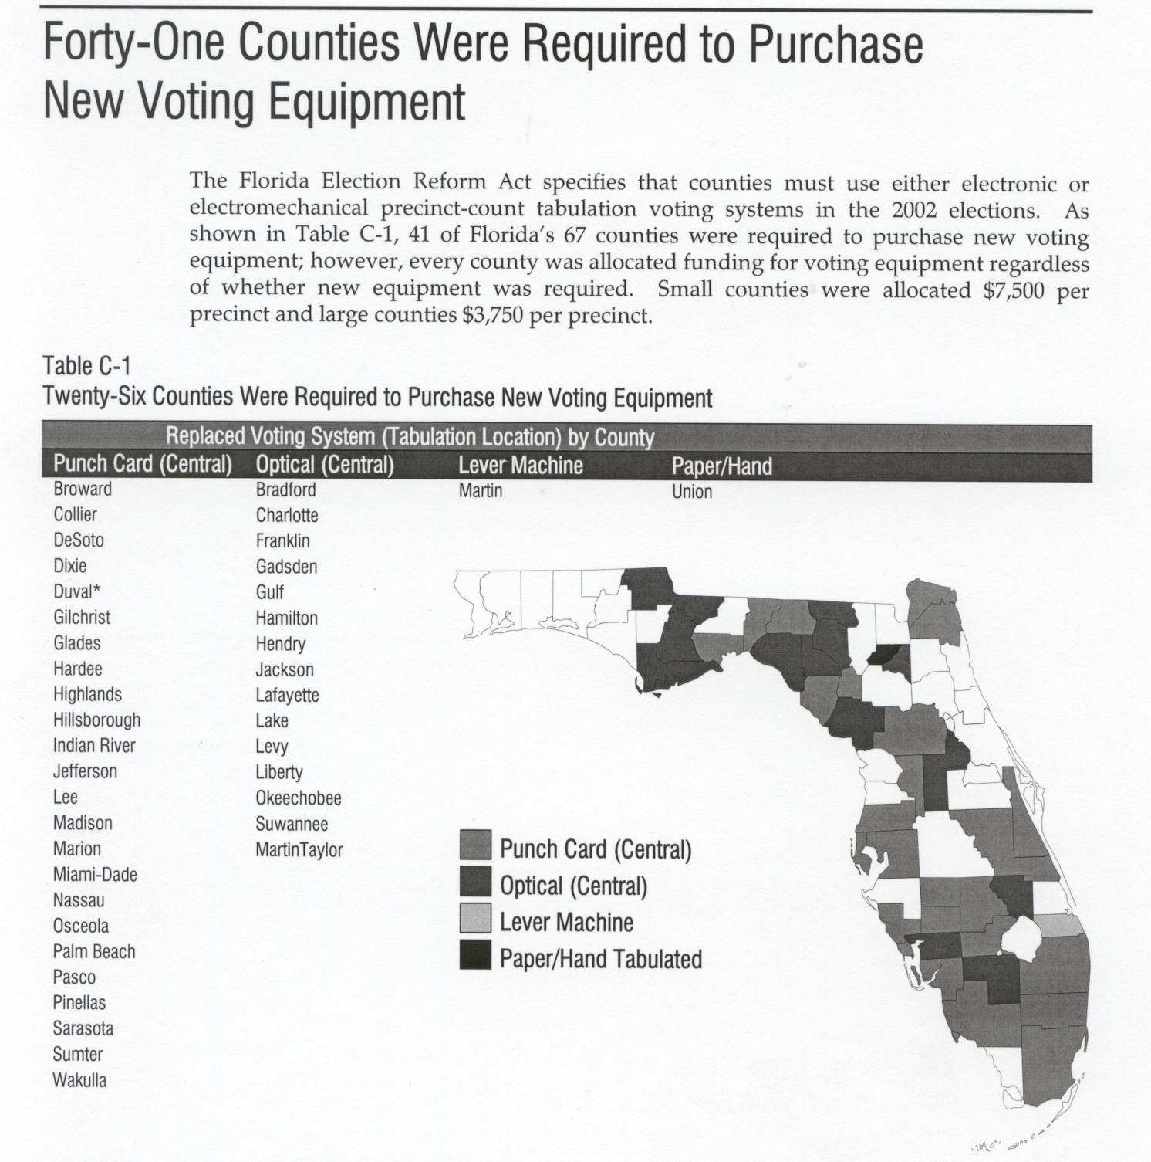Figure 4

Note: Data reported by the Florida Association of Counties, February 26, 2001.
Source: Office of Program Policy Analysis and Government Accountability, OPPAGA Justification Review: Most Election Reforms Implemented: Additional Actions Could Be Considered. Tallahassee: OPPAGA, Florida Legislature, October 2002, p. 20.
Further evaluation of the supervisors’ reports revealed some dissatisfaction with voting system equipment design and with some ballot instructions. Thus, the Division recommended to state leaders in its January 2003 report the need for:

- The Division of Elections to continue monitoring the overvotes and undervotes from each general election.
- The Florida Legislature to provide funding, contingent upon appropriations from Congress through the Help America Vote act, to the counties for voter education efforts.
- The Division of Elections to review recommendations for ballot instructions for incorporation into the uniform ballot rule.
- All voting system vendors to continue to improve the design of their voting systems.

A Legislative Performance Audit of 2001 & 2002 Election Reform Implementation: Good Job But More to be Done

In October 2002, the Florida Legislature’s Office of Program Policy Analysis and Government Accountability (OPPAGA) conducted a program evaluation of the Division of Elections’ implementation of election reforms adopted in the 2001 and 2002 legislative sessions. OPPAGA concluded that the Division had successfully met the Legislature’s requirement to have a new statewide voter database fully operational by June 1, 2002—and done it at a lower cost than the $2 million appropriated for the project.

The OPPAGA evaluation acknowledged that legislative requirements regarding new voter eligibility determination procedures had not yet been fully implemented by county election supervisors because they were awaiting federal approval.

Table 7

Governor/Lieutenant Governor Contest

Overvotes, Undervotes and Invalid Write-ins by Voting System

General Election 2002

 | Undervotes  -  Absentee  Ballots | Overvotes  -  Absentee  Ballots | Undervotes  -  Precinct  Ballots | Overvotes  -  Precinct  Ballots | Invalid  -  Write-ins | Overvotes, Undervotes, & Invalid Write-ins Total | Overvotes, Undervotes, & Invalid Write-ins as % of Turnout
Diebold Accuvote  (Optical Scanner – Precinct) | 1,082 | 115 | 4,963 | 148 | 1,447 | 7,755 | 0.49%
30 Counties | 0.07% | 0.01% | 0.31% | 0.01% | 0.09% | 0.49%
ES&S M100  (Optical Scanner – Precinct) | 377 | 77 | 1,341 | 274 | 178 | 2,247 | 0.89%
14 Counties | 0.15% | 0.03% | 0.53% | 0.11% | 0.07% | 0.89%
ES&S Optech  (Optical Scanner – Precinct) | 375 | 293 | 1,498 | 246 | 374 | 2,786 | 0.56%
7 Counties | 0.08% | 0.06% | 0.30% | 0.05% | 0.07% | 0.56%
Sequoia Optech  (Optical Scanner – Precinct) | 17 | 7 | 32 | 21 | 9 | 86 | 1.30%
1 County | 0.26% | 0.11% | 0.48% | 0.32% | 0.14% | 1.30%
ES&S iVotronic  (Touch Screen – Precinct)  (See Note 2) | 1,882 | 247 | 15,829 | 0 | 1,271 | 19,229 | 1.12%
11 Counties | 0.11% | 0.01% | 0.92% | 0.00% | 0.07% | 1.12%
Sequoia EDGE  (Touch Screen – Precinct)  (See Note 2) | 672 | 382 | 10,074 | 0 | 803 | 11,931 | 1.11%
4 Counties | 0.06% | 0.04% | 0.93% | 0.00% | 0.08% | 1.11%
Total | 4,405 | 1,121 | 33,737 | 689 | 4,082 | 44,034 | 0.86%
67 Counties | 0.09% | 0.02% | 0.66% | 0.01% | 0.08% | 0.86%
Notes: 1. Due to rounding, individual percentages may not add exactly to the summary percentages.
2. Absentee Ballot Undervotes in the ES&S iVotronic and Sequoia EDGE touch screen counties include results from both Marksense absentee ballots and voting prior to election day on touch screen voting terminals.
Source: Florida Department of State, Division of Elections, Analysis and Report of Overvotes and Undervotes for the 2002 General Election Pursuant to Section 101.595, Florida Statutes. Tallahassee: Department of State, January 31, 2003, p.4.

The evaluation unit forwarded to the Legislature its suggestions for measures that could enhance the reforms already adopted, especially with regard to eligibility determination. These included:
- Giving individuals who contend they have been wrongly identified as felons the opportunity to provide a fingerprint to verify their identity (a way to strengthen voter eligibility determination).
- Modifying the provisional voting process to provide individuals who feel they have been wrongly identified as ineligible to vote a final opportunity to prove their eligibility.
- Using U.S. Postal Service information to verify change of addresses for persons who are identified as potentially being registered in more than one county.
- Considering the adoption of new federal standards for voting equipment.
- Preventing simultaneous rulings on the same case by the Division of Elections and the Florida Elections Commission.

A new select task force appointed by Governor Bush in November 2002 also reviewed these suggestions.

A New Task Force Looks at More Reforms & State Compliance With
the Help America Vote Act (HAVA)

On November 18, 2002, Governor Bush created the 2002 Select Task Force on Election Procedures, Standards and Technology (Executive Order Number 02-292). The 15-member Select Task Force was charged with “reviewing the 2002 election cycle and recommending additional improvements to keep Florida a national leader in election reform” (Governor’s Select Task Force 2002:i). The group’s goals were to: (1) make Florida compliant with the 2002 Help America Vote Act and, (2) recommend further election reform improvements after reviewing performance data from the 2002 election cycle (voting technology, early voting, provisional ballots, poll workers, election deadlines, election crisis management, the repeal of the second (runoff) primary, and voting for persons with disabilities).

Staffed by the Collins Center for Public Policy, Inc., the Task Force met in Orlando on December 9, 2002 at which time it heard testimony from Congressional staff, various federal, state, and local officials, local Supervisors of Elections, voters with disabilities, and interested citizens. A report was delivered to the Governor, the President of the Senate, the Speaker of the House, and the Secretary of State on December 30, 2002, making these recommendations:

- Prevent voter fraud by requiring different kinds of driver’s licenses for citizens and noncitizens during the voter registration process.
- Improve voter education by requiring all Supervisors of Elections to mail generic sample ballots to each household with registered voters.
- Improve poll worker recruitment and training by launching a statewide “Be A Poll Worker” campaign and establishing minimum standards for poll worker performance.
- Conduct a formal, independent study to improve state governance and the administration of elections in Florida as a way to conform to the new Help America Vote Act, to troubleshoot election crises, and to reduce the perception of partisanship in election administration.
- Hold voting technology vendors accountable by making it a criminal penalty to violate the certification of Florida’s certified voting machines.
- Position Florida to receive federal voting technology funds by complying with the new standards of the new Help American Vote Act.
- Establish minimum standards for “early voting” and “absentee voting” that will increase voter convenience, reduce fraud, and ensure equal access to the polls.
- Eliminate the requirement for a witness signature on the absentee ballot but continue to require the voter signature on the envelope with a strong warning for voters who act fraudulently.
- Suspend the use of the Second Primary (runoff) through the General Election of 2004.
- Improve the administration of elections by changing several deadlines that cause problems for local supervisors including:
    - Extending the deadline for counting provisional ballots
    - Expanding the time period for candidate qualifying
    - Refining the deadline for candidate withdrawal
    - Shortening the deadline for naming a Lt. Governor running mate after the primary
- Improve voter education by requiring full disclosure and campaign reports for political groups that spend more than $500 directly or indirectly in any election.

The Help America Vote Act (HAVA)

Florida’s share of federal funding set aside by HAVA is projected to be as much as $175 million over the next three years if its statewide election reform plan is approved by the new federal Election Assistance Commission. These funds will reimburse the State for some of the new voting equipment; the remainder will be used to bring the state into compliance with HAVA and help with overall election administration.

Florida’s Help America Vote Act Planning Committee

The federal HAVA legislation mandates the formation of a state planning committee. On April 18, 2003, Florida’s Secretary of State Glenda Hood announced her 18 appointees to the State Planning Committee. Hood selected former Secretary of State and previous select task force co-chair Jim Smith to serve as Chairman. Secretary of State Hood made it clear that successfully completing a HAVA state plan was a critical next step in the state’s major overhaul of its election system:

“Florida set a model for the rest of the nation when it passed the Election Reform Act of 2001 and the Voter Accessibility Act of 2002. In 2003 we will continue our commitment to improve Florida’s election process so that all registered voters in Florida are able to cast their votes with confidence. This is my top priority as Florida’s Chief Election’s Officer.” (Media Advisory, April 18, 2003).

The State Planning Committee, staffed by The Collins Center for Public Policy, Inc., held four hearings designed to seek input from interested constituency groups and citizens (Tallahassee, West Palm Beach, Ft. Myers, Orlando). The Committee’s last public hearing was on May 15, 2003.

UNFINISHED BUSINESS:
Election Reform by 2003 State Legislature:

Refining Reforms & Protecting State’s Eligibility for HAVA Funds

Florida, like so many other states, ended its 2003 regular legislative session without passing a state budget or getting much else done. The Governor called the legislators back into special session beginning May 12 specifically to pass a budget. Meanwhile, HAVA State Planning Committee members began pressuring legislative leaders to pass HAVA-related legislation or face the loss of $48-49 million. At the time this paper was written, legislation was still pending and the Palm Beach Post had published a story detailing the urgency of passing the HAVA bills. And at the final meeting of the State HAVA Planning Committee on May 15, 2003, advocates for the disabled and minority communities hinted at legal action should the Legislature fail to pass HAVA implementation legislation.

Conclusion: Lots of Reasons for Florida’s Electoral Reform Successes

Election reform in Florida has been non-stop since the end of the presidential 2000 chaos. Florida’s approach to reform confirms most, but not all, of the Palazzolo hypotheses. (See Table 8.)

Each successive session of the Florida Legislature has passed sweeping changes in our electoral system. There are 10 major reasons for Florida’s successes at election reform:

- A catastrophic event exposing the state’s electoral system shortcomings to the whole world (presidential election 2000).
- Proactive involvement of the Governor.
- A bipartisan commitment to avoiding another train wreck; neither political party has wanted to be portrayed as the “foot dragging” party on election reform, the exception involving automatic restoration of felon voting rights, an issue currently in litigation; Republicans have been opposed while Democrats have favored it.
- Effective use of select task forces, bi-partisan and diverse in their composition.
- Effective use of public opinion surveys by respected think tanks and designed by state university scholars; these surveys have demonstrated the breadth of the public’s support for reform at key moments in the legislative process.
- Consensus that in spite of budget pressures, the state simply could not afford to do nothing because it would cost more (politically) in the long run; This is particularly the case for the Republicans in control of both houses of the Legislature and for the Republican governor whose brother is president of the United States; executive and legislative leaders had no desire to hang a political “noose around their own necks,” although they might have liked to spend funds for something else.
- The regular session state legislative calendar; spring sessions ahead of fall elections (primary and general) pushed the state legislature to act, fearful that inaction might be used against them and/or their party in their re-election campaigns.
- Accountability devices and timetables built into the election reform legislation
- Some high profile scares from several large south Florida counties—the very ones that created a firestorm in election 2000.
- Always the fear of another close election; it is Florida’s trademark. Florida remains the most partisan competitive large state in the U.S. As of February 2003, 42% of all registrants are Democrats, 39%, Republicans, 2% minor parties, and 16% independents (no party affiliation).

The “Florida Factor” is alive and well as we head toward the 2004 presidential election.

Table 8

Florida’s Reform Experiences Generally Affirm Palazzolo Hypotheses
Palazzolo Hypothesis | Florida
H1: The closer the election, the higher the  stakes for failing to pass election reform | Affirmed  Florida’s election was the closest in the nation and the most controversial; closeness and chaos pushed reforms
H2: The better the state’s election laws prior to 2000, the less likely it will be to enact significant reforms | Affirmed  The inadequacy of Florida’s election laws prior to 2000 made it more likely to enact significant reforms
H3: Republicans are more likely to seek safeguards against fraud in registration & voting; Democrats are more likely to seek equal access to polling places and rules on voter intent on overvotes and undervotes | Rejected  Legislators from both parties voted  overwhelmingly for each of these types of reforms. The omnibus structure of reform legislation created “up or down” choices that were politically impossible to vote “down.”
H4: Reform legislation is more likely to stall altogether in states where the number of Democratic & Republican legislators is almost equal, where there is divided party control of the Legislature and the Governor, and/or where there is divided party control of the two legislative chambers | Affirmed  Florida’s extensive election reforms were aided by the fact that Republicans controlled the Governor’s mansion and both houses of the state legislature by a substantial margin.
H5: States that use ad hoc election reform commissions that report to the Governor and the State Legislature are more likely to implement election reform than those that do not | Affirmed  Florida’s regular use of bi-partisan Select Task Forces with extremely diverse member profiles has been a major factor in the passage of extensive election reforms
H6: The greater the involvement of key vested interests, the more likely the enactment of election reform. | Affirmed  Important stakeholders both inside and outside government pushed for reforms, especially those promoting uniformity across the state’s 67 counties (e.g., Florida State Association of Supervisors of Elections, civil rights groups, influential think tanks from both ends of the ideological spectrum, and the public)
H7: Decentralized election systems are more likely to have a difficult time adopting reform legislation that pulls control away from localities | Rejected  Florida’s election administration system is more highly decentralized than in many states yet the state enacted major election reforms. County supervisors of elections have strongly supported legislation that has given the state more authority and responsibility for establishing uniform standards and rules—authority that previously rested with the county supervisors
H8: States without active leaders, either from the executive or from within the legislature, are less likely to enact significant election reforms | Affirmed  Florida’s Governor and Secretary of State have been very proactive in pushing for election reforms as have the leaders in both houses. Influential legislative leaders have also served on the various Select Task Forces that have offered key recommendations for reform to the Governor and Legislature at-large.
Table 9, Continued.
Palazzolo Hypothesis | Florida
H9: Elected statewide office holders who are responsible for election administration are more likely to push for election reform than appointed state chief elections officials. | Affirmed (Temporarily)  But Suspect in the Long Term  Florida’s elected Secretary of State Katherine Harris pushed hard for election reform and was particularly effective in pushing through reforms related to disabled voters in 2002. But as of January 1, 2003, the position has become an appointive one. By the end of 2003, we will be able to tell whether election or appointment of the chief elections official makes any difference. We hypothesize that it does not in Florida due to the responsibilities assigned to the office by the Legislature and due to the personal leadership skills of Harris and her appointed successor, Glenda Hood—former mayor of Orlando—and a Republican.
H10: States that had not enacted election reforms before September 11, 2001 (9/11) are less likely to have adopted election reforms in post 9/11 | Affirmed  Florida adopted sweeping reforms prior to 9/11 through the Election Reform Act of 2001 (signed into law May 10). It has also enacted more sweeping reforms after 9/11 than many states.
H11: The uncertainty of the availability of funds under the Help American Vote Act has been a major deterrent to election reform in many states. | Rejected  Florida passed election reforms, with expensive price tags, in 2002 and 2003 without specific knowledge of the amount the state would receive from HAVA or when it would receive these funds
Source: Susan A. MacManus, University of South Florida.

REFERENCES

Bennett, George. (2002). “New Voting System a Touchy Subject.” Retrieved from www.PalmBeachPost.com, 3 April.
Bennett, George. 2002. “Ballot Arrows Point Out Problems.” Retrieved from www.PalmBeachPost.com, 31 March.
Bureau of Economic and Business Research. 2001. Florida County Rankings 2001. Gainesville: BEBR, University of Florida. December.
Bush, Jeb. 2001. Jeb.bush@myflorida.com, 4 May.
Colburn, David R. and Lance deHaven-Smith. 2002. Florida’s Megatrends. Gainesville: University Press of Florida.
Corral, Oscar. 2002. “Technician’s Error, Not Machines, to Blame in Dade Election Mix-Up.” Retrieved from www.miami.com , 4 April.
Figueras, Tere and Tanya Wragg. 2002. “Medley’s Touch-Screen Vote Ends With Mix-Up.” Retrieved from www.Miami.com, 3 April.
Florida Department of State, Division of Elections (2001). Uniform Poll Times. Tallahassee: Department of State.
Florida Department of State, Division of Elections (2003). Report on Voter Education Programs During the 2002 Election Cycle Pursuant to Section 98.255(3), Florida Statutes. Tallahassee: Department of State, January 31.
Florida Department of State, Division of Elections (2003). Analysis and Report of Overvotes and Undervotes for the 2002 General Election Pursuant to Section 101.595, Florida Statutes. Tallahassee: Department of State, January 31.
Hammett, Yvette C. 2002. “New Machines Touch Voters’ Fancy.” Retrieved from www.tampatrib.com, 3 April.
Jefferson, Stebbins. 2002. “No Chads, Just Glitches.” Retrieved from www.PalmBeachPost.com, 3 March.
Kleinberg, Eliot. 2002. “Poll Workers to be Reprimanded for Election’s Human Goofs.” Retrieved from www.PalmBeachPost.com , 14 March.
Koch, Kathy. 2002. “Can High Tech Save ‘Lost’ Votes?” The National Voter (March/April).
MacManus, Susan A. 2001. “Floridians Look Back at Election 2000 and Look Forward to Major Reforms,” The Journal of the James Madison Institute, (Summer): 10-19.
MacManus, Susan A. 2003. “Florida Governor: Three Elections in One,” in Larry Sabato, ed. Midterm Madness: The Elections of 2002. Boulder, CO: Rowman & Littlefield: 195-207.
MacManus, Susan A. 2003. “Voter Education: The Key to Election Reform Success, Lessons From Florida,” University of Michigan Journal of Law Reform, vol. 36.
MacManus, Susan A., Dario Moreno, Richard Scher, and Henry Thomas. 2001. Floridians Want Reform of the Election System…Now! Tallahassee, FL: The Collins Center For Public Policy, Inc. and The James Madison Institute, April 16.
MacManus, Susan A., David Colburn, Mark Pritchett, and Bruce Barcelo. 2002. 2002 Voter Satisfaction Survey. Tallahassee, FL: The Collins Center For Public Policy, Inc. and The James Madison Institute. December.
Marshall, J. Stanley and Mark S. Pritchett. 2003. “The Election Reforms of 2002: Did They Work?” The Journal of the James Madison Institute (Winter): 4-9.

NAACP. 2002. “Settlement Reached in Florida Election Lawsuit,” NAACP News, 3 September. Retrieved from www.naacp.org.
National Commission on Election Reform (The Carter-Ford Commission). 2001. To Assure Pride and Confidence in the Electoral Process. The Miller Center of Public Affairs, University of Virginia and The Century Foundation. August.
National Task Force on Election Reform. 2001. Election 2000: Review and Recommendations by the Nation’s Elections Administrators. Houston, TX: The Election Center. July. Retrieved from www.electioncenter.org.
Office of Program Policy Analysis and Governmental Accountability. 2002. Justification Review: Most Election Reforms Implemented, October. Report No. 02-55.
Office of the Inspector General, Miami-Dade County. 2002. Report of Office of the Inspector General Inquiry into Circumstances Surrounding the September 10, 2002, Election in Miami-Dade County. 20 September. Retrieved from www.miamidadeig.org.
Patrick, Kellie. 2002. “Cartridge Problem Casts Pall on Palm Beach County’s New Voting Machines.” Retrieved from www.Sun-Sentinel.com, 14 March.
Peltz, Jennifer. 2002. “County Examines Vote Machines.” Retrieved from www.Sun-Sentinel.com, 3 April.
Peltz, Jennifer. 2002. “County Seeks Advice on Voting Machines.” Retrieved from www.Sun-Sentinel.com, 24 April.
Phillips, Deborah. 2001. Setting The Standard for Election Integrity. Voter Integrity Project, January.
Pritchett, Mark S. 2002. “Bi-Partisan Leadership in Florida’s Election Reform,” Spectrum: The Journal of State Government (Winter): 9-10.
Richey, Warren. 1998. “Florida Makes a Move to Rein in Voter Fraud,” Christian Science Monitor, 4 May. Retrieved from www.csmonitor.com/durable/1998/05/04/p4s1.htm.
Secretary’s Select Task Force on Voting Accessibility.2002. Final Report. Tallahassee: Department of State. 14 January.
The Caltech/MIT Voting Technology Project. Residual Votes Attributed to Technology (Version 2), 20 March.
The Governor’s Select Task Force on Election Procedures, Standards and Technology. 2001. Revitalizing Democracy in Florida. Tallahassee: Office of the Governor, 1 March.
The Governor’s Select Task Force on Election Procedures, Standards and Technology. 2002. 2002 Governor’s Select Task Force on Election Procedures, Standards and Technology. Tallahassee: Office of the Governor, 30 December.
U.S. General Accounting Office. 2001. Elections: A Framework for Evaluating Reform Proposals. October. GAO-02-90.
U.S. House of Representatives Committee on the Judiciary, Democratic Staff. 2001. How to Make Over One Million Votes Disappear: Electoral Sleight of Hand in the 2000 Presidential Election. 20 August.
Varian, Bill. 2002. “Glitch Mars Touch Screen Debut.” Retrieved from www.sptimes.com, 3 April.
Wasson, David. 2001. “Retiring Punch Cards 1 Focus of Task Force,” The Tampa Tribune. 9 January.
Weinstein, Allen and others. 2002. Post Election Report from The Center for Democracy to the Miami-Dade County Commissioners on the Effectiveness of Miami-Dade’s November 5 Election Process. 22 November.
Wickham, Debbie Salamone and Harry Wessel. “What’s a Vote? It Varies by County,” Orlando Sentinel. 28 January.

Appendix A
The Division of Elections is Organized into a Director’s Office and Three Bureaus
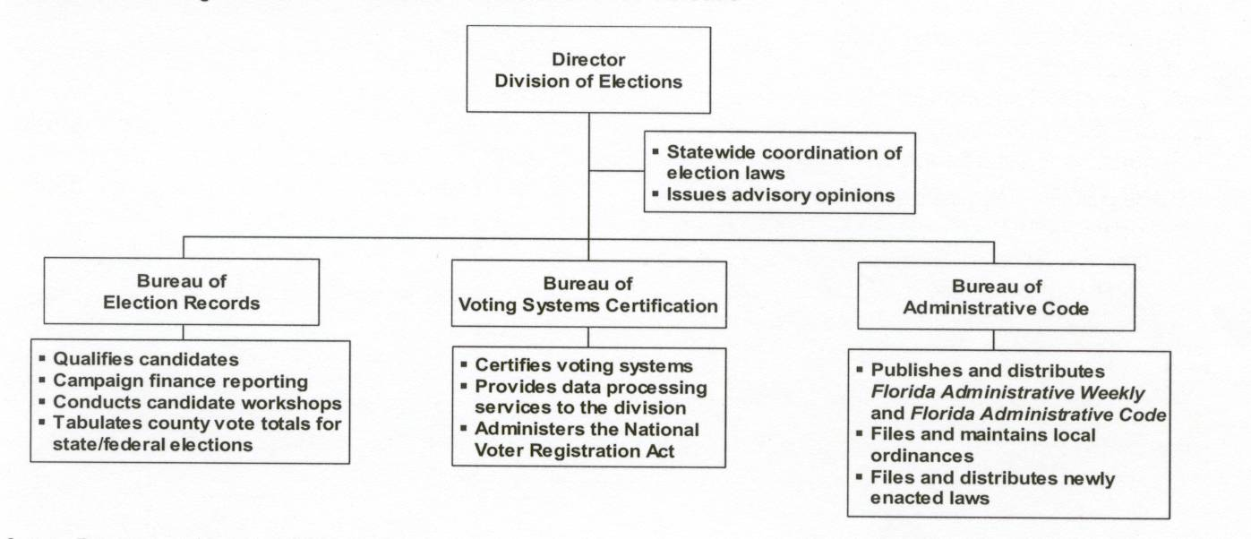
Source: Office of Program Policy Analysis and Government Accountability, OPPAGA Justification Review: Most Election Reforms Implemented: Additional Actions Could Be Considered. Tallahassee: OPPAGA, Florida Legislature, October 2002, p. 3.

Reforms were introduced in the regular legislative session. The legislature adjourned before passing the Help America Vote Act legislation—or the state budget. It has been reintroduced in House in the current special legislative session, which began May 12, 2003.
Compliance is true with regard to statutes. However, key elements of the reforms do not become effective until a period of time after full funding by the Legislature, designated specifically for such purposes.
Following presidential election 2000, various groups including the NAACP, The Lawyers’ Committee for Civil Rights Under Law, People For the American Way, and the American Civil Liberties Union filed litigation against the State and seven Florida counties addressing these concerns. The state and these groups reached a settlement on September 3, 2002, just days before the state’s September 10 primary election.
Hillsborough County Supervisor of Elections Pam Iorio articulated this description in a presentation to the 2001 Governor’s Select Task Force. (2002 Governor’s Select Task Force: 24.)
“The Select Task Force shall be comprised of no more than 21 members, ten of whom shall be Republicans, ten of whom shall be Democrats, and one of whom shall be affiliated with neither party. At least two of the members shall be representatives from a county Supervisor of Elections Office, and four members shall be legislators, a Republican and Democrat from the Florida House of Representatives and a republican and Democrat from the Florida Senate. The Governor shall designate two members, of different parties, to serve as Co-Chairs.” The co-chairs were Edward T. Foote, II (D) and James “Jim” C. Smith (R).
Governor’s Select Task Force 2002: 11.
According to the Select Task Force report, the group received input from: 16 invited speakers, 83 members of the public who chose to testify, hundreds who chose to e-mail or call the task force.
The March 1 deadline was selected precisely “so that the Florida Legislature could consider its recommendations during its Regular Session in March and April 2001.”
The Executive Order charged the task force co-chairs to “identify any issues raised by Select Task Force members which cannot be manageably addressed, but which many merit further study or examination in an alternative forum at a later time.” (Governor’s Select Task Force, 2001: 5).
The survey was conducted April 3-8, 2001. The survey (jointly sponsored by the Collins Center For Public Policy, Inc. and the James Madison Institute) played a major role in getting the will of the people before the Legislature. Four prominent political scientists from state universities were tapped to design and analyze the survey. Dr. Susan A. MacManus, Distinguished University Professor, from the University of South Florida, headed the team. Other team members were: Dr. Dario Moreno, Florida International University, Dr. Richard Scher, Robin & Jean Gibson Professor, University of Florida, and Dr. Henry Thomas, University of North Florida. Schroth & Associates, a Washington, DC-based firm, conducted the telephone survey of 600 adult Floridians April 3-8, 2001. The margin of error is +/-4%.
Survey respondents were presented with a list of suggested reforms, emanating from reforms recommended by The Governor’s 2001 Select Task Force on Election Procedures, Standards, and Technology, and from hearings held by other groups like the U.S. Civil Rights Commission. They were then asked whether they strongly favor, somewhat favor, somewhat oppose, or strongly oppose each reform.
County election supervisors as well as many in the general public have called for eliminating inconsistencies in Florida’s key state laws. See Wasson, 2001; Wickham and Wessel, 2001.
By far the strongest support for restoring the voting rights of felons comes from the African American community (75%). Blacks feel that have been unfairly impacted by our state’s rather difficult process for having one’s voting rights restored. Other breakdowns show less than a majority support for this reform. However, higher than average percentages of Democrats (48%), 18-34 year olds (47%), non-Cuban Hispanics (46%), those who did not vote in the presidential election last Fall (45%), and persons who are undecided about whether they will vote in the 2002 elections in Florida (57%) favor restoring felon voting rights. Republicans are the least likely to favor this reform (17%).
Opposition to this reform is heavy across all demographic categories. But support is slightly higher among younger cohorts (29% of 18-34 year olds) and among those with some college education (24%). The differences of opinion on this reform are generationally and educationally driven, rather than by partisanship.
Jeb.bush@myflorida.com; May 4, 2001.
List taken from Jeb.Bush@myflorida.com.
The law also changed public financing of campaigns in Florida but that is not the major focus of this article.
Bills on both issues were introduced, but not passed, in the 2002 legislative session. In the 2003 session, only bills relating to the felon voting rights issue were introduced, but not passed. The issue is currently in federal court.
See Footnote 2.
The bill amends s97.052, Florida Statutes, allowing reproduction if the application is in the same format as that prescribed by the Department of State.
s.97.057 and s.97.058, Florida Statutes. The previous law was silent on the DHSMV duties relative to the maintenance of unsigned applications. It simply required that the agency retain declined applications for two years.
s. 97.1031, Florida Statutes.
s. 98.0977, Florida Statutes. The initial process, part of the maintenance of the statewide voter registration database, instructed the county supervisor to request that the individual fill out forms to keep his/her name from being dropped from the voter roll. The new process gives the voter an alternative. He/she “may attend a hearing at a time and place specified in the notice. If there is evidence that the notice was not received, notice must be given once by publication in a newspaper of general circulation in the county. The notice must plainly state that the voter is potentially ineligible to be registered to vote and must state a time and place for the person to appear before the supervisor of elections to show cause why his or her name should not be removed from the voter registration rolls.”
Pub.L. No.101-336, 42 U.S.C. ss.12101 et seq. But see Footnote 2.
97.021, 97.026, 98.122, 101.56062, Florida Statutes.
If they do not, they are required to “file a written statement with the qualifying officer setting forth the reasons for not doing so. Failure to file this statement with the appropriate qualifying officer constitutes a violation of the Florida Election Code and is under the jurisdiction of the Florida Elections Commission.”
s. 101.56062, Florida Statutes.
s.101.715, Florida Statutes.
s.102.014, Florida Statutes. Approximately one hour. “The program must be conducted locally by each supervisor of elections, who shall periodically certify to the Department of State whether each poll worker has completed the program. The supervisor of elections shall contract with a recognized disability-related organization, such as a center for independent living, family network on disabilities, deaf service bureau, or other such organization, to develop and assist with training the trainers in the disability sensitivity programs. The program must include actual demonstrations of obstacles confronted by disabled persons during the voting process, including obtaining access to the polling place, traveling through the polling area, and using the voting system.”
The Honorable Katherine Harris, Florida Secretary of State, appointed the Task Force of 21 citizens on August 13, 2001.
The meetings were held from September 2001 to January 2002: Tallahassee-2, Tampa, Orlando, and West Palm Beach. The task forced was charged to: ascertain the obstacles persons with disabilities face in voting in Florida’s elections; develop and implement solutions for overcoming these obstacles; devise a mandatory training program for all elections officials and poll workers which includes instruction from persons with disabilities; and propose a funding mechanism.
The report estimated that one million Floridians with disabilities are not registered to vote (Task Force, 2002: i).
Chapter 101.56063 Florida Statutes states that “all state laws, rules, standards, and codes governing voting systems and polling place accessibility must be maintained to ensure the state’s eligibility to receive federal funds. It is the intent of the Legislature that all state requirements meet or exceed the minimum federal requirements for voting systems and polling place accessibility.”
S.101.031, Florida Statutes. It states: “NOTE TO VOTER: Failure to perform any of these responsibilities does not prohibit a voter from voting.”
s.101.5611, Florida Statutes. It reads: “The supervisor of elections shall provide instruction at each polling place regarding the manner of voting with the system. In instructing voters, no precinct official may favor any political party, candidate, or issue. Such instruction shall show the arrangement of candidates and questions to be voted on. Additionally, the supervisor of elections shall provide instruction on the proper method of casting a ballot for the specific voting system utilized in that jurisdiction. Such instruction shall be provided at a place which voters must pass to reach the official voting booth.”
The statement that must be signed by the person receiving the provisional ballot includes this language: “I understand that if I commit any fraud in connection with voting, vote a fraudulent ballot, or vote more than once in an election, I can be convicted of a felony of the third degree and fined up to $5,000 and/or imprisoned for up to 5 years.” There was already a requirement that such information be prominently posted at each precinct.
Fraud was rampant in the 1997 mayoral contest. The Florida Legislature passed election reforms in its 1998 session tightening rules on absentee voting and increasing penalties for election fraud from misdemeanors to felonies. See Richey, 1998..
Deborah Phillips (2001) of the Voter Integrity Project states: “There actually is no such thing as a ‘perfect’ voting system.” The League of Women Voters’ magazine, The National Voter, also concludes: “There’s no such thing as an error-free election.” The same article affirms: “voter education—always an important component [of reform]—becomes even more critical when adopting new voting technologies” (Koch, 2002: 19). Other studies acknowledging the impossibility of an error-free election (for a variety of reasons, including a highly decentralized election system), include National Task Force on Election Reform (2001:10); United States General Accounting Office, 2001; National Task Force on Election Reform (2001): National Commission on Election Reform, 2001. Some studies acknowledge a 2 percent error, or residual vote, as average; other studies find that error rate tolerable, but not optimal: See The Caltech/MIT Voting Technology Project, 2001:18; and the National Commission on Election Reform, 2001:54. The Carter-Ford Commission study concludes: “Residual vote rates at or below 1% should be considered good. Residual vote rates between 1 and 2% can be viewed as adequate, but citizens should consider local circumstances and decide what is possible. Rates between 2 and 3% should be viewed as worrying. Rates higher than 3% should be considered unacceptable.” A fifty-state report prepared for Rep. John Conyers, Jr. by the Democratic investigative staff of the House Committee on the Judiciary (2001:14) stated “…statisticians have estimated that as many as 2% of all ballots cast for the office of President nationwide were discarded because of machine error and voter errors.”
The National Task Force on Election Reform (2001:8) report that analyzed the causes of problems in the 2000 general election concludes: “Only a small percentage of the problems were directly related to any failure by vote tally devices themselves. The problems were created by people, not machines, and any reform of substance will deal with what people do or don’t do, rather than focusing on a machine that can only do what it is designed to do.” (emphasis added by author).
Jefferson(2002).
See Bennett (April 2, 3002). The error rate (voters not recording a vote for either candidate in a runoff election) in one small municipality, Wellington, was 3.1 percent. Commissioner Tony Masilotti said, “There seems to be as high a rate of error as there was with the old chad system.” Other problems included poll workers not collecting cartridges from unused voting machines (see Patrick, March 14, 2002; Kleinberg, March 14, 2002). Across the County, 2.8 percent of the 1,957 absentee ballots cast in the March 12 municipal elections were bad. Absentee balloting was done using a new optical-scan balloting system that replaced the old punch card system (Bennett, March 31, 2002).
Palm Beach County Commissioners disagreed about “whether to blame election difficulties on the machines, voter-education efforts, poll worker training or some combination of all these elements” (Bennett, April 3, 2002; Peltz, April 3, 2002; Peltz, April 24, 2002).
Many of these problems were equipment-oriented and/or a technician’s error. For example, in Plant City (Hillsborough County), technicians were unable to transmit election results by computer from Plant City to the Brandon election service center. There were also incidences of remote sites not being able to read the touch screen voting system cartridges (Hammett, April 3, 2002; Varian, April 3, 2002.). In the town of Medley, in Miami-Dade County, software, which was used to combine 45 absentee votes with ballots cast at City Hall, changed the order of the candidates’ names and caused election officials to announce the wrong winner (Figueras and Wragg, April 3, 2002). It was attributed to a programming error by a software technician (Corral, April 4, 2002).
This discussion is from MacManus (2003).
S.102.014 Florida Statutes addresses poll worker recruitment and training. Under the law, supervisors are responsible for conducting training for inspectors, clerks, and deputy sheriffs prior to each primary, general, and special election. No person shall serve as an inspector, clerk, or deputy sheriff for an election unless such person has completed the training as required. The minimum training requirements for clerks are a minimum of six hours of training during a general election year, at least two hours of which must occur after June 1 of that year. Inspectors must have a minimum of three hours of training during a general election year, at least one hour of which must occur after June 1 of that year. The Department of State is required to create a uniform polling place procedures manual and adopt it by rule. Each supervisor of elections shall insure that the manual is available in hard copy or electronic form in every precinct in the supervisor’s jurisdiction on election day. The manual shall guide inspectors, clerks, and deputy sheriffs in the proper implementation of election procedures and laws. The manual shall be indexed by subject, and written in plain, clear, unambiguous language. The manual shall provide specific examples of common problems encountered at the polls on election day, and detail specific procedures for resolving those problems. The manual shall include, without limitation: regulations governing solicitation by individuals and groups at the polling place; procedures to be followed with respect to voters whose names are not on the precinct register; proper operation of the voting system, ballot handling procedures, procedures governing spoiled ballots, procedures governing spoiled ballots, procedures to be followed after the polls close, rights of voters at the polls, procedures for handling emergency situations, procedures for dealing with irate voters, the handling and processing of provisional ballots, and security procedures. The Act gives the Department of State the right and responsibility to revise the manual as needed. It mandates that “Supervisors of elections shall work with the business and local community to develop public-private programs to ensure the recruitment of skilled inspectors and clerks.” And it allows inspectors, election clerks, and deputy sheriffs to be paid to attend required poll worker training sessions.
From funds appropriated from the General Revenue Fund to the Division of Elections of the Department of State in specific appropriation 2898B of the 2001-2002 General Appropriations Act, notwithstanding the provision language to that specific appropriation, the division shall distribute the sum of $5,949,375 in fiscal year 2001-2002 to the counties to fund comprehensive voter education programs and poll worker recruitment and training programs provided in this act. The Division shall divide the total amount of funds appropriated by the total number of registered voters in the state for the 2000 General Election to establish a funding level per individual voter. Each county shall receive an amount equal to the funding level per individual voter multiplied by the number of registered voters in the county, as certified by the Department of State for the 2000 General Election. No county shall receive any funds pursuant to subsection (1) until the county supervisor of elections provides to the Department of State a detailed description of the voter-education programs to be implemented pursuant to s.98.255, Florida Statutes, for the 2002 election cycle.
In Florida, county supervisors of elections are elected constitutional officers, with one exception. Miami-Dade County’s supervisor is appointed.
Chapter 98.255, Florida Statutes.
The counties actually submitted their plans before the Rule had been adopted in order to meet a timetable for disbursement of funds. The Department of State reviewed the plans to help with the development of Rule 1S-2.033, Florida Administrative Code, entitled “Standards for Nonpartisan Voter Education.” This rule became effective on May 30, 2002.
102.014, Florida Statutes addresses poll worker training. County elections supervisors are responsible for conducting training for inspectors, clerks, and deputy sheriffs. The Election Reform Act of 2001 created minimum training requirements: for clerks, a minimum of six hours of training during a general election year and for inspectors, three hours. However, the Legislature changed the requirements in 2002: for clerks, a minimum of 3 hours of training prior to each election, for inspectors, 2 hours prior to each election--s.102.014(4)(a)(b)(c), Florida Statutes. The first and second primary elections are considered one election; the general election, another.
The Department of State, upon receipt of such information, shall prepare a public report on the effectiveness of voter-education programs and shall submit the report to the Governor, the President of the Senate, and the Speaker of the House of Representatives by January 31 of each year following a general election.
Post-primary analyses by the Office of the Inspector General of Miami-Dade County and by The Center for Democracy (for the Miami-Dade County Commissioners) both affirmed the need for better poll worker training and better voter education before the November 5, 2002 general election.
The survey was conducted by Barcelo & Company, a research firm that specializes in services relating to public opinion, research, strategy, and planning. The telephone survey sample had a margin of error of +/- 3.5% at the 95% confidence level for the 801 voters and +/- 4.0% at the 95% confidence level for the 666 non-voters.
The survey instrument was developed by Dr. Susan MacManus from the University of South Florida and chair of the Florida Elections Commission, Dr. David Colburn from the University of Florida and member of Governor Bush’s election task force, and pollster Bruce Barcelo.
Among the survey respondents, 87% voted at the polls, 6% by mail in absentee ballot, and 6% voted early. Early voting was a reform adopted in 2001.
See Bureau of Economic and Business Research, University of Florida (2001); Colburn and deHaven-Smith (2002).
Section 101.595, Florida Statutes, as enacted in 2001 and amended in 2002.
Among the problems cited were: problems with optical scanner ballot boxes jamming, insufficient voter prompts, low-pitched alarms, overheating of touch screen machines, software shortcomings, no reports for absentees, provisionals, and precincts when breaking out overvotes and undervotes.
The 2001 election reforms required the Department of State to adopt a uniform ballot rule for each voting system (Rule 1S-2.032). Some supervisors complained that the Department’s ballot instructions relating to the marking device and instructions for absentee ballots were confusing.
Florida law (Section 11.513(3) requires OPPAGA to complete a justification review of each state agency that is operating under a performance-based program budget. Each program evaluation and justification review is required to address nine issue areas: the identifiable cost of the program; the specific purpose of the program, as well as the specific public benefit derived therefrom; The consequences of discontinuing the program; Determination as to public policy, which many include recommendations as to whether it would be sound public policy to continue or discontinue funding the program, either in whole or in part; Progress towards achieving the outputs and outcomes associated with the program; An explanation of circumstances contributing to the state agency’s ability to achieve, not achieve, to exceed it projected outputs and outcomes, as defined in s. 216.011, FLORIDA STATUTES, associated with the program; Whether the information reported pursuant to s. 216.031(5), Florida Statutes, has relevance and utility for the evaluation of the program; Whether state agency management has established control systems sufficient to ensure that performance data are maintained and supported by state agency records and accurately presented in state agency performance reports, and; Alternative courses of action that would result in administering the program more efficiently and effectively.
The Division of Elections has adopted its own voting equipment standards. OPPAGA recommended the Division conduct a comparison of the state’s standards with the new federal standards to determine which is best. The evaluation group speculated that adopting new federal standards might reduce costs associated with equipment certification at both the state and local levels.
The Task Force included 7 Democrats, 7 Republicans, and one unaffiliated member. The co-chairs, Edward T. Foote II (D) and James “Jim” C. Smith (R), were the same ones who co-chaired the 2000 Select Task Force.
The Act was signed by President George W. Bush on October 29, 2002.
The legislation states that “the Chief State election officials shall develop the State plan under this subtitle through a committee of appropriate individuals, including the chief election officials of the 2 most populous jurisdictions in the State, other local election officials, stakeholders (including representatives of groups of individuals with disabilities), and other citizens, appointed for such purpose by the chief State election official.”
Smith has served as Florida’s Secretary of State four times (appointed twice and elected twice), co-chair of the governor’s Election Reform Task Force following the 2000 election, and co-chair of the 2002 select task force created after election 2002.

