Risk Adjustment and the Assessment of Disparities in Dialysis Mortality Outcomes
John Kalbfleisch, PhD*,§, Robert Wolfe, PhD§, Sarah Bell, MPH*,§, Rena Sun, PhD*, Joseph Messana, MD*,¶, Tempie Shearon, MS*,§, Valarie Ashby, MA*,§, Robin Padilla, MS*,§, Min Zhang, PhD*,§, Marc Turenne, PhD^{ǂ}, Jeffrey Pearson, MS^{ǂ}, Claudia Dahlerus, PhD*,§ and Yi Li, PhD*,§
*Kidney Epidemiology and Cost Center, University of Michigan, Ann Arbor, MI; ¶Division of Nephrology, Department of Internal Medicine, University of Michigan, Ann Arbor, MI; ^{ǂ}Arbor Research Collaborative for Health, Ann Arbor, MI; §Department of Biostatistics, University of Michigan, Ann Arbor
Running title: Dialysis Outcome Disparities (26 characters, limit 30)
Word count for unstructured abstract: 200, Max: 200
Word count for manuscript text: 1,312 (excluding title page, concise methods, figure legends, tables and references). Max: 1,500
Corresponding author:
Yi Li, PhD
Professor of Biostatistics, Department of Biostatistics, School of Public Health
Director, University of Michigan-Kidney Epidemiology and Cost Center
1415 Washington Heights, Suite 3645 SPH I, Ann Arbor, MI 48109-2029
Phone: 734-763-6611
Fax: 734-763-4004
E-mail: yili@umich.edu

Abstract
Standardized Mortality Ratios (SMRs) reported by Medicare compare mortality at individual dialysis facilities to the national average. SMRs currently adjust for race. It is important to study the impact of race adjustment, to better understand if the adjustment obscures or clarifies disparities in quality of care for minority groups.
We computed Cox-model based SMRs for each facility with and without adjustment for patient race. The study population included virtually all dialysis patients treated in US dialysis facilities during 2010.
Without race adjustment, facilities with higher proportions of black patients have better survival outcomes: facilities with the highest percentage of black patients (top 10%) have overall mortality rates approximately 7% lower than expected. After adjusting for within-facility racial differences, facilities with higher proportions of black patients have poorer survival outcomes among both black and non-black patients: facilities with the highest percentage of black patients (top 10%) have mortality rates approximately 6% worse than expected.
Accounting for within-facility racial differences in the computation of SMR helps clarify disparities in quality of health care among ESRD patients. The adjustment that accommodates within-facility comparisons is key, as it could also clarify relationships between patient characteristics and health care provider outcomes in other settings.

Introduction
The Standardized Mortality Ratio (SMR), which compares mortality at each dialysis facility to the overall mortality of US dialysis patients, is reported in the annual US Dialysis Facility Reports and as a public measure on the Centers for Medicare and Medicaid Services (CMS) Dialysis Facility Compare website. These reports are used by government agencies and dialysis facilities with the goal of improving the quality of health care to more than half a million US dialysis patients.

Our purpose in this paper is to explain the rationale for the inclusion of race in the SMR model. In 2011, the rationale led to the National Quality Forum’s approval of this race adjusted measure despite that organization’s standing policy and general concern about adjustments that obscure disparities in outcomes for disadvantaged populations.

The SMR for a given facility is computed as the ratio of the observed number of deaths at that facility to the number of deaths expected under a national norm, where the expectation is adjusted to reflect characteristics of that facility’s patients. Risk adjustment is performed using a two-stage Cox regression model., Race and ethnicity are included as adjustments in the model. A key feature of our approach is that we assess risk factors by comparing outcomes of patients with varying race and ethnicity attributes, within facilities. Applying these within facility adjustments in the SMR then allows comparison of outcomes between facilities. This approach avoids confounding between patient characteristics and facility effects.

Adjustment for race can potentially mask racial disparities when racial minorities tend to receive poor health care, leading to poorer outcomes than other patients on average. Some authors have suggested that black dialysis patients tend to have better survival outcomes than white patients and other racial groups., At least in these cases, not adjusting for within-provider racial differences may conceal underlying disparities in care provided by specific health care providers.^{,6} We illustrate this potential with a careful analysis of the race adjustment in the SMR for dialysis facilities and discuss implications for data interpretation and policy in the Discussion section.

Results
Our research utilizes CMS national data on dialysis patients to evaluate dialysis facilities with respect to patient survival. Table 1 summarizes demographic characteristics for the population of patients included in these comparisons. The comorbidity index is computed for each patient based on comorbidities reported at the onset of dialysis. The index is described in detail in the Dialysis Facility Reports.¹

Comparisons among facilities are based on the SMRs for the calendar year 2010. The analyses were performed with and without race and ethnicity adjustments. However, we concentrate here on the differences in SMRs between facilities related to the proportion of blacks in the facility. Facilities were grouped into deciles according to their percent of black patients. Figure 1 displays the combined SMRs for each decile, with and without adjustment for within facility differences in race and ethnicity. Figure 2 gives a similar display of SMRs, adjusted for within facility differences in race and ethnicity, but separately for black patients and non-black patients.

As noted, and in contrast to many other health care settings, black dialysis patients have better survival rates than non-black patients.^{7,8,} When SMRs are unadjusted for the racial composition of patients in the facility, facilities with more black patients tend to have observed mortality rates lower than the expected mortality from the predictive model. Overall, mortality at the 10% of facilities with the highest percentage of black patients was approximately 7% lower than expected (SMR=0.93 for the decile) and the SMRs generally decreased as the percent of black patients increased (Figure 1, dashed line).

When SMRs are adjusted for the within facility effect of race, expected mortality is based on the race of each patient. With this adjustment, facilities treating higher percentages of black patients have observed mortality rates higher than the expected mortality. Overall, mortality at the 10% of facilities with the largest percentages of black patients was approximately 6% higher than expected (SMR=1.06 for the decile; Figure 1). These changes occur since the expected mortality at these facilities differs markedly based on the inclusion or exclusion of patient race in the predictive model. The race and ethnicity adjusted SMRs of both black and non-black patients generally increased as the proportion of black patients in the facility increased (Figure 2), even more so for non-black patients. Similar analyses showed no important effects relating facility ethnic composition to SMR.

Table 2 compares several facility characteristics of the 10% of facilities with the highest proportion of black patients with all other facilities. Those with the highest proportions of black patients had a lower average of the median household income in the zip code of residence by about $11,000. Other less marked differences lay in average age, time since onset of ESRD and percent of rural facilities.

Discussion
The observation that black dialysis patients tend to have better survival outcomes than non-black patients has been noted in the literature and reported in the USRDS.^{7,8,10,} The reasons are not entirely clear. Some studies suggest underlying genetic and biologic differences may determine kidney disease pathways in blacks compared to other race and ethnic groups., Similarly, specific biologic or genetic factors may provide protective benefits for certain clinical outcomes, when compared to whites or other race groups.^{7,} For example, some have observed an association with high BMI and better nutritional status that may account for the survival advantage among blacks. Others have postulated that blacks with CKD who progress to ESRD tend to be healthier and therefore start chronic dialysis with a survival advantage.14
In the results unadjusted for race (Figure 1), it is unclear whether lower mortality at facilities with greater percentages of black patients occurs because black dialysis patients have lower mortality, or because these facilities tend to provide better care. However, the analysis adjusted for race and ethnicity indicates that facilities with a higher percentage of black patients tend to have higher mortality than would be expected given their case mix including race. Further, as Figure 2 illustrates, this elevation in mortality is observed for both black and non-black patients. This may be due to an underlying relationship with socioeconomic status or other environmental variables.,

Our objective is to clearly identify facilities whose outcomes are below the national average. With this approach, the race-adjusted analyses do not obscure disparities in health care, but tend to clarify the disparities. Without adjustment, we may erroneously conclude that those facilities with a high concentration of black patients have outcomes better than the national norm. As demonstrated, when taking account of facility level racial composition, this does not appear to be the case.

As a general principle, serious consideration should be given to the potential role of patient race and other sociodemographics when evaluating quality of care.^{9,} When typically disadvantaged minorities appear to have better outcomes at the patient-level,^{7,8} adjustment for these demographic variables may be particularly important as in the example discussed in this paper. However, even if minority outcomes are associated with poorer facility performance, it may still be informative to estimate and adjust for within-facility effects, and then evaluate between facility differences for potential disparities.

Table 2 suggests that socioeconomic factors may play an important role in explaining the differences between facilities based on racial composition. It may relate, for example, to insufficient resource allocation to facilities with a high proportion of black patients.^{16,17} Alternatively, because facilities with many black patients tend to have a higher proportion of patients with low socioeconomic status, these facilities work with a population that has more resource intensive chronic conditions due to limited access to health care, in turn resulting in poorer outcomes., However this may only be a partial explanation. We considered an alternative model that adjusts for patient socioeconomic status measured at the zip code level but this had negligible impact on the results for race.

Concise Methods
In our study, we used 2007- 2010 CMS ESRD data along with mortality data from the Social Security Death Master File. The SMR is based on a two-stage survival model applied to four years of data. At Stage 1, a Cox model with facility-defining strata is fitted to estimate the coefficients of patient-level covariates, including age, race, etc., as well as two-way interactions. Stratification by facility has the advantage of allowing estimation of covariate effects, while controlling for facility differences. This effectively accounts for any confounding that might occur between facility effects and the covariates. At Stage 2, the estimated log relative risk for each patient from the first stage is used as an offset to estimate a national average (across facilities) baseline hazard rate. At this stage, the model also adjusts for variations in state wide mortality rates.¹ Combining the predicted relative risk from the first stage and the national baseline hazard rate from the second stage, we can estimate the expected number of deaths for each patient. More details are given in the Online Supplemental Material and in the Dialysis Facility Reports.¹
The estimated model is then used to obtain SMRs for each of 5,920 dialysis facilities during calendar year 2010. In Figures 1 and 2, the SMRs for a given decile are computed by summing the observed numbers of deaths in 2010 for each of the facilities in that decile and dividing that by the corresponding sum of the expected numbers of deaths. In Figure 2, an SMR is computed in this way for blacks and non-blacks separately.
There has been discussion relating the SMR and facility characteristics in the literature. There has also been a critical review and a response., Other methods of computing SMRs were discussed and compared in Kalbfleisch and Wolfe.²¹

Acknowledgements
The authors would like to thank Ruth Shamraj for help in editing the manuscript.
This research is partially supported under the Department of Health and Human Services Centers for Medicare and Medicaid Services contracts (Contract HHSM-500-2013013017l; Contract HHSM-500-2011-00091C). The content of this publication does not necessarily reflect the views or policies of the Department of Health and Human Services, nor does mention of trade names, commercial products, or organizations imply endorsement by the US Government. The author assumes full responsibility for the accuracy and completeness of the ideas presented.
The University of Michigan Kidney Epidemiology and Cost Center (UM-KECC) produces the Dialysis Facility Reports (DFR), Dialysis Facility Compare (DFC) measures, and supporting documentation under contract to CMS. Information regarding the DFR and the DFC measures is available at https://dialysisdata.org/content/methodology. Note: Before September 2014 this documentation was available at http://www.dialysisreports.org which previously supported previews of the DFR and DFC data to facilities.
Neither the manuscript nor any significant part are under consideration for publication elsewhere or have appeared elsewhere that might be construed as prior publication or duplicate work. A previous version of this work was presented at the AcademyHealth Annual Research Meeting in 2012.
Kalbfleisch, J.D., Sun, R.J., Messana, J.M., Shearon, T., Ashby, V., Li, Y., Sands, R., Zhang, M.,
Casino, S., Turenne, M., Pearson, J., Wolfe, R.A. Separating Patient and Facility Effects in Assessing Racial Disparities in Dialysis Mortality Outcomes. Poster presentation at AcademyHealth Annual Research Meeting, 2012.

Disclosures
The authors do not have financial conflicts of interests to disclose.

References
Table 1. Patient demographics of 514,357 ESRD patients who contribute to the comparisons of SMRs for the year 2010 (entries are percentages or sample means.)
Patients by age group (%)
< 18 | 0.5%
18-64 | 55.9%
65+ | 43.6%
Female patients (%) | 44.6%
Patients by race (%)
White | 57.1%
Black | 35.6%
Asian/Pacific Islander | 4.8%
Native American | 1.4%
Other | 1.1%
Patients by Hispanic ethnicity (%)
Hispanic | 15.2%
Non-Hispanic | 83.2%
Unknown | 1.6%
Average incident comorbidity index | 0.23
Diabetes as cause of ESRD (%) | 44.1%
Patients by duration of ESRD (%)
< 1 year | 34.0%
1-2 years | 14.9%
Table 2. Average facility characteristics for the 10% of facilities in 2010 with the highest percentage of black patients and for the remaining 90%
Characteristic | Lowest 90% of percentages  (N= 5,328) | Highest 10% of percentages  (N= 592) | P-valueª
Average age | 61.2 | 58.0 | <0.0001
Average incident comorbidity index | 0.24 | 0.21 | <0.0001
Average income^{b} | $50K | $39K | <0.0001
In nursing home the previous year | 7.4% | 6.3% | 0.0014
Diabetes as cause of ESRD | 44.3% | 38.6% | <0.0001
Female patients | 43.9% | 47.0% | <0.0001
Average duration of ESRD (years) | 3.6 | 4.3 | <0.0001
Rural facility^{c} | 22.4% | 17.4% | 0.0054
ª Test for difference based on independent samples t-tests for all except rural facility characteristic, which was based on a chi-square test.
^{b} Average income for each facility was based on the median household income for each patient’s zip code of residence (income data source: American Community Survey 2007-2011, Social Explorer, and U.S. Census Bureau; if a patient was missing zip code of residence he/she was assigned the facility’s zip code).²⁵
^{c} Table reports the percentage of facilities in the “percentage of black patients” category that are rural.

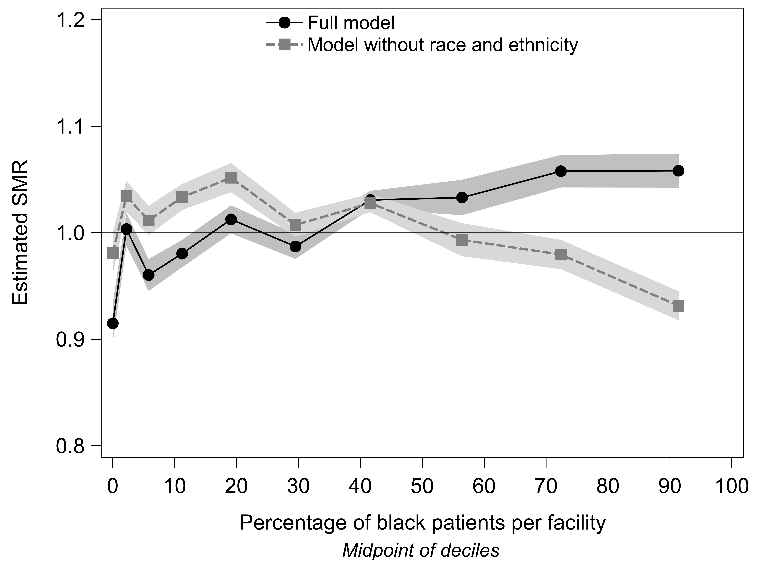
Figure 1. Comparison of 2010 SMRs from models adjusted and unadjusted for race and ethnicity. The x-axis is the percent of black patients at facilities grouped into deciles. Plotted points are the estimated SMR versus the average percentage of blacks for the decile. Shaded areas are 95% confidence intervals.

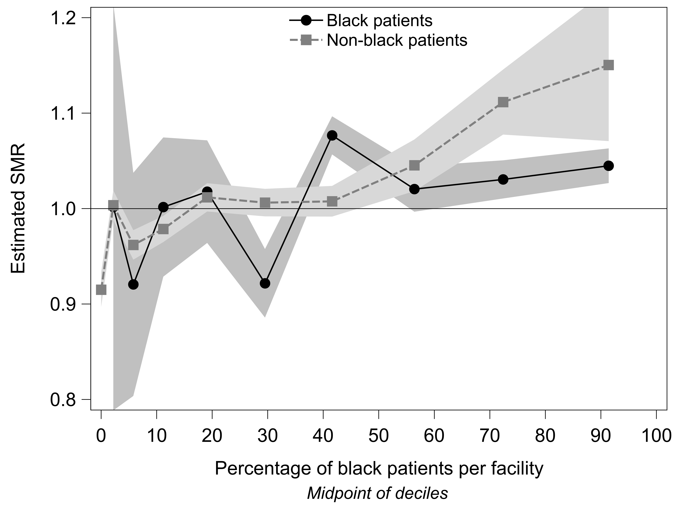
Figure 2. Comparison of 2010 estimated SMRs for black and non-black patient adjusted for race and ethnicity. The x-axis is the percent of black patients at facilities grouped into deciles. Plotted points are the estimated SMR versus the average percentage of blacks for the decile. Shaded areas are 95% confidence intervals.

The University of Michigan Kidney Epidemiology and Cost Center (UM-KECC) produces the Dialysis Facility Reports (DFR) under contract to the Centers for Medicare and Medicaid Services (CMS). Information regarding this report is available at: https://dialysisdata.org/content/methodology. Before September 2014 this documentation was available at http://www.dialysisreports.org, which previously supported preview of DFR and DFC data to facilities.
Centers for Medicare and Medicaid Services (CMS) Dialysis Facility Compare. Available at: http://www.medicare.gov/dialysisfacilitycompare/search.html
National Quality Forum. Guidance for measure testing and evaluating scientific acceptability of measure properties. Available at: http://www.qualityforum.org/WorkArea/linkit.aspx?LinkIdentifier=id&ItemID=59116. 2011. Accessed March 28, 2014
Cox DR: Regression models and life tables (with discussion). J R Stat Soc 34: 187–220, 1972
Kalbfleisch JD, Prentice RL: The statistical analysis of failure time data. Hoboken, New Jersey: John Wiley & Sons, Inc., 2002
National Quality Forum. Final technical report: Risk adjustment for socioeconomic status or other sociodemographic factors. Available at: http://www.qualityforum.org/Risk_Adjustment_SES.aspx. Accessed August 28, 2014
Powe, NR. Reverse race and ethnic disparities in survival increase with severity of chronic kidney disease: What does this mean? Clin J Am Soc Nephrol 1: 905–906, 2006
Cowie CC, Port FK, Rust KF, Harris MI: Differences in survival between black and white patients with diabetic end-stage renal disease. Diabetes Care 17: 681–687, 1994
Fiscella K, Franks P, Gold MR, Clancy CM: Inequality in quality: Addressing socioeconomic, racial, and ethnic disparities in health care. JAMA 283: 2579–84, 2000
Waikar SS, Curhan GC, Ayanian JZ, Chertow GM: Race and mortality after acute renal failure. J Am Soc Nephrol 18: 2740–2748, 2007
U.S. Renal Data System: USRDS 2012 annual data report: Atlas of chronic kidney disease and end-stage renal disease in the United States. Bethesda, MD: National Institutes of Health, National Institute of Diabetes and Digestive and Kidney Diseases, 2013
Freedman, BI. End-stage renal failure in African Americans: Insights in kidney disease susceptibility. Nephrol Dial Transplant 17: 198–200, 2002
Freedman BI, Parekh RS, Kao WHL. Genetic basis of nondiabetic end-stage renal disease. Semin Nephrol 30: 101–110, 2010
Crews DC, Sozio SM, Liu Y, Coresh J, Powe NR: Inflammation and the paradox of racial differences in dialysis survival. J Am Soc Nephrol 22: 2279–2286, 2011
Ricks J, Molnar MZ, Kovesdy CP, Kopple JD, Norris KC, Mehrotra R, Nissenson AR, Arah OA, Greenland S, Kalantar-Zadeh K: Racial and ethnic differences in the association of body mass index and survival in maintenance hemodialysis patients. Am J Kidney Dis 58, 574–582, 2011
Johns TS, Estrella MM, Crews DC, Appel LJ, Anderson CAM, Ephraim PL, Cook C, Boulware LE: Neighborhood socioeconomic status, race, and mortality in young adult dialysis patients. J Am Soc Nephrol 25: 2649–2657, 2014
Volkova N, McClellan W, Klein M, Flanders D, Kleinbaum D, Soucie JM, Presley R: Neighborhood Poverty and Racial Differences in ESRD Incidence. J Am Soc Nephrol 19: 356–364, 2008
Trivedi AN, Zaslavsky AM, Schneider EC, Ayanian JZ: Trends in the quality of care and racial disparities in Medicare managed care. N Engl J Med 353: 692–700, 2005
Williams DR: Race, socioeconomic status, and health: The added effects of racism and discrimination. Ann N Y Acad Sci 896: 173–188, 1999
Perneger TV, Whelton PK, Klag MJ: Race and end-stage renal disease. Socioeconomic status and access to health care as mediating factors. Arch Intern Med 155: 1201–1208, 1995
Kalbfleisch JD, Wolfe RA: On monitoring outcomes of medical providers. Stat Biosci 5: 286–302, 2013
Spiegel B, Bolus R, Desai AA, Zagar P, Parker T, Moran J, Solomon MD, Khawar O, Gitlin M, Talley J, Nissenson A: Dialysis practices that distinguish facilities with below- versus above-expected mortality. Clin J Am Soc Nephrol 5: 2024–2033, 2010
Lacson E Jr, Teng M, Lazarus JM, Lew N, Lowrie E, Owen W: Limitations of the facility-specific standardized mortality ratio for profiling health care quality in dialysis. Am J Kidney Dis 37: 267–275, 2001
Wolfe RA, Held PJ, Port FK: Letter to the Editor: Calculation and public use of the unit-specific standardized mortality ratio. Am J Kidney Dis 38: 212–224, 2001 25 Social Explorer. American Community Survey (ACS) 2007-2011 (5-Year Estimates) [Data file]. Available at: http://www.socialexplorer.com/explore/tables. Accessed September 1, 2014

