Managing Emails in Outlook 2007

You can manage your Exchange mailbox in a variety of ways:
- Remove large attachments from messages. Open the message and right click the icon for the attachment and select Remove.
- Use the Large Mail Search Folder to review large email messages. (See below, Large Mail Search Folder)
- Empty Deleted Items (See below, Empty Deleted Items)
- Move email to your “<uniquename> IMAP Archive” folder. You can select multiple emails by using Ctrl + click or Shift + click. (See below, “Move Email Messages to IMAP Archive folders)

About Mailbox Storage
To ensure that you receive all your email messages, it is important that you regularly clean out your Exchange server Mailbox. Each user is limited to 500 MB of storage space on the Exchange server. This limit is for all information stored in your Mailbox, which includes Inbox & subfolders, Contacts, Calendar, Tasks, Notes and Sent Items.
The size of your Mailbox can be determined with three mouse clicks:
- Right click the Mailbox icon in the folder list, click Properties.
- Click the Folder Size button in the Properties dialog form.
- Click on the Server Data tab will show you how much space your e-mails are currently taking up.
In order to keep your store smaller than the size limit, you will need to move certain messages from the server to your IMAP storage area and delete others.

Large Mail Search Folder
Outlook automatically has a Search folder configured which will list the mail messages in your Inbox displayed by size categories. The Large Mail Search folder can be found under your Inbox in the Mail Navigation pane.
Looking at the Large Mail Search folder can help you to easily identify emails that have large attachments that could be saved off to manage your mailbox size.
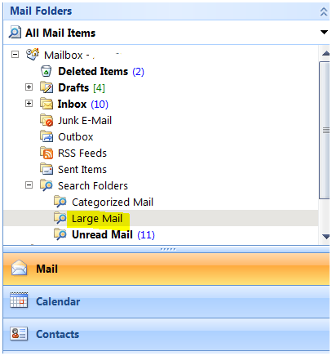

Empty Deleted Items
Do not keep important email messages in the Deleted Items folder. Instead, save these messages to an IMAP Archive folder (See next section) and frequently Empty Deleted Items.
To manually empty the deleted items folder, right click on the Deleted Items folder and select, Empty “Deleted Items” folder.

Move Email Messages to IMAP Archive Folders
Move Email message to your IMAP Archive folder to move them out of your Exchange mailbox.
Organizing your email in this way will keep your email messages organized into logical folders and also keep your Exchange mailbox from running out of space. (Notice the “<uniquename> IMAP Archive” folder under your inbox in the Mail Navigation pane).
ALWAYS MOVE INDIVIDUAL EMAIL MESSAGES. DO NOT MOVE FOLDERS from Outlook to your IMAP Archive folder
Email Messages can be moved in two ways:
- Right click on the mail message you want to move,
Select Move to Folder
Navigate to the proper sub-folder in your “<uniquename> IMAP Archive” folder
- Highlight the mail message you want to move,
Drag the message to the proper sub-folder under your “<uniquename>IMAP Archive” folder

Create IMAP Archive Sub-Folders for Saving Email Messages
To create a sub-folder under your “<uniquename> IMAP Archive” folder
- Locate your “<uniquename> IMAP Archive” folder
- Navigate to the folder where you would like the sub-folder to appear under
- Right click
- Select New Folder
- Give the new folder a name

