Yin and Yang Theory of Competition:
Social Comparison and Evaluation Apprehension Reciprocally Drive Competitive Motivation
Patricia Chen & Stephen M. Garcia
University of Michigan

Abstract
Since organisms have faced the challenge of survival, competition for resources and status has been an important outcome-determinant in the game of life. Thus far, psychology research has yet to yield a clear picture of exactly how we are driven by the force we term “competitiveness.” Examining social comparison and evaluation apprehension, this paper aims to reconcile how the active comparison with others and the anxiety of being evaluated, respectively, reciprocally interact to mediate competitive motivation. We call this model the Yin and Yang Theory of Competition: (1) social comparison and evaluation apprehension are individual mediators of competitive motivation and (2) social comparison and evaluation apprehension are reciprocally affecting mechanisms. Three studies were conducted to test these two hypotheses. Implications for theory and practice are discussed.
Keywords: social comparison, evaluation apprehension, competitiveness

Yin and Yang Theory of Competition:
Social Comparison and Evaluation Apprehension Reciprocally Drive Competitive Motivation
By virtue of its natural selection theory, Darwinian evolution has put the term “competitive advantage” on a pedestal. Since the dawn of time, organisms have survived to pass on their genome by outcompeting each other for resources. One organism’s competitive advantage in a certain environment, determined by its phenotypical superiority, led to preferential selection over another’s. Although modern medicine has ensured that we as humans no longer have to necessarily possess phenotypical advantage over each other to survive, our market systems of resource allocation are still very much governed by the same rules of competition. No longer are genetics the only contributing factor to competitive success. Rather, society has long since turned its attention to the psychological underpinnings of competitive motivation, in hope of grasping the crux of the cognitive-behavioral competitive advantage. Hence, the exploration of what psychological factors spur on competitiveness, when basic survival needs are no longer a primary concern, began with researchers in social motivation.
In his 1898 paper, Norman Triplett observed that bicycle racers had faster timings when racing alongside other cyclists than when racing alone. He reproduced this effect in the laboratory, by demonstrating that children reeled in fishing lines faster when performing alongside another (whom he termed a “coactor”), as compared to when they were reeling on their own (Triplett, 1898). To explain this phenomenon, two board streams of research emerged: social comparison and social facilitation (Rosenbloom, Shahar, Perlman, Estreich, & Kirzner, 2007) emerged. More specifically,
two cognitive-behavioral mechanisms particularly stood out – namely that (1) social comparing one’s performance to another (Festinger, 1954) and (2) evaluation apprehension in the presence of others (Cottrell, 1972) could each precipitate competitive behavior .
Thus, within the two distinctly separate literatures, namely social comparison and social facilitation, respectively, the processes of social comparison and evaluation apprehension were established as independent mediators of competitive performance, in the presence of other conspecifics.
Despite the success of both fields in demonstrating this facilitative effect on coactive performance separately, they lacked a consideration of the synchronicity of both processes. In other words, in an effort to find strong support for each of their individual claims, the previous literature had mostly overlooked the possibility of interaction between these two mechanisms of social comparison and evaluation apprehension. Attempting to bridge what both the social comparison and evaluation apprehension literatures say about competition, this paper re-examines the two processes in tandem within the same competitive context. We put forth the Yin and Yang Theory of Competition as a novel model representing how both these processes work together to drive competitive motivation at the baseline personality level, the behavioral level, and the cognitive-affective level. This dipartite model proposes the following two hypotheses: the first suggests that both social comparison and evaluation apprehension are individual mediators of competitive motivation. The second asserts that social comparison and evaluation apprehension are reciprocal, mutually enhansing mechanisms that produce competitive motivation.
Social Comparison Fuels Competition
Since Triplett’s groundbreaking study, Leon Festinger proposed the concept of social comparison as a driving force behind competitive motivation (Festinger, 1954; Garcia & Tor, 2009; Garcia, Tor, & Gonzalez, 2006; Johnson & Stapel, 2007). According to Festinger (1954), we have an innate drive to evaluate our own opinions and abilities. To assess where we stand in the absence of an objective measurement system, we base our comparisons against others in a competitive setting. These social comparisons throw light on any discrepancies with the target rival, and motivates the individual to behave in a competitive manner, aimed at reducing or eliminating such discrepancies that might be damaging to one’s ego.
Festinger (1954) theorized two main factors that support this innate need for social comparison: firstly, people need subjective appraisal of their opinions and abilities. This appraisal is done by comparing to similar others, such as coactors, when an objective measure of abilities and opinions is absent. Secondly, a “fear of invalidity” (Kruglanski, 1989) develops when one is uncertain about the validity of self-evaluation. Social comparisons become necessary in these situations to ascertain validity of one’s own subjective judgment.
Goethals and Darley (1987) furthermore proposed that, in the absence of other performance-related attributes, we attribute performance differences to differences in ability when drawing social comparisons. Focusing on coaction scenarios similar to those in Triplett’s (1898) studies, Seta (1982) argued that coactors are motivated to socially compare among themselves so as to anticipate and/or modify the potential outcomes of the competition. By manipulating the perceived differences in performance between coacting participants, Seta (1982) managed to induce different levels of performance motivation. He concluded that “social comparison processes are active components of coaction” (Seta, 1982). His studies also showed that feedback frequency, a proven moderator of performance level, only functioned as a competitive cue when it facilitated social comparison processes (Seta, 1982).
Since Festinger and Seta, some other researchers have further explored social comparison processes in competitive settings (Hertel, Niemeyer, & Clauss, 2008; Light, Littleton, Bale, Joiner, & Messer, 2000; Munkes & Diehl, 2003; Muller, Atzeni, & Butera, 2004; Sanders, Baron, & Moore, 1978; Todd, Seok, Kerr, & Messe, 2006). However, most of this research has dealt with directional social comparisons (such as upwards or downwards social comparisons), comparison-driven self-evaluation, and competition versus collaboration.
Evaluation Apprehension as an Alternative Model
Offering a slightly different explanation to Festinger’s social comparison theory, Cottrell, Wack, Sekerak, and Rittle (1968) put forth another possible mechanism behind competitive motivation. He proposed that the fear of being assessed by another facilitates competitive performance, and coined this term ‘evaluation apprehension’ (Cottrell, 1972). Thus, individuals perform well-learned tasks better in social groups, rather than alone, when evaluative potential is present. When in the presence of experimenters, passive audiences, or coactors, people should be motivated to enhance their execution of a dominant action (Cottrell, 1972).
In his 1987 paper, Harkins empirically validated this evaluation apprehension model. Using a 2 (Alone vs. Coaction) x 2 (Evaluation vs. No Evaluation) design, Harkins had participants take part in a vigilance task either singly or in pairs. Each subject was to report the number of times a dot was flashed on a TV screen by pressing a button. In the Evaluation condition, the participants responded normally to the flashing dots. In the No Evaluation condition, participants were given a “Response Recording Error” message after each dot presentation during their practice session, and were informed by the experimenter that the response recorder had malfunctioned, and hence would be disabled during their actual experiment. Not only did Harkins reproduce the social facilitation effect by showing that coactors outperformed single participants, but he furthermore validated the evaluation apprehension model by proving that participants whose outputs could be evaluated did better than those whose outputs could not be (Harkins, 1987). Thus, to the extent that we are under evaluation apprehension, we experience an increase in competitive motivation.
Reciprocal Mechanisms in Competition
While these studies examined social comparison and evaluation apprehension as separate processes mediating competitive motivation, others alluded to a possible connection between the two mechanisms. Friend and Gilbert (1973) previously observed that participants scoring high on the Fear of Negative Evaluation (FNE) Scale tended to avoid potentially threatening social comparison information to a greater degree than those lower on FNE; Salovey and Rodin (1984) also noticed that upward social comparison engendered more anxiety towards interacting with the comparison other, as measured by the State-Trait Anxiety Inventory. Considered together, these two studies suggest that not only does the fear of evaluation affect social comparison processes, but also that the directionality of social comparison also reciprocally influences the anxiety experienced towards a comparison other. As these experiments suggest, social comparison and evaluation apprehension processes do not exist in isolation, but rather, are possibly related to each other in a reciprocally affecting fashion within the same individual and context.
For example, imagine that you are at the gym, jogging on a treadmill beside another similar jogger. Both of you take notice of each other’s progress. Once, you catch sight of this other coactor eyeing you, and feel a spike of adrenaline stemming from the anxiety of being under possible evaluation. You jog faster and correct your posture, while trying to monitor this person’s progress from the corner of your eye. Consciously or subconsciously, and very subtly, you and your coactor have begun experiencing how social comparison and evaluation apprehension processes work in tandem. Exactly how these two mechanisms work together to drive competitiveness, however, has not been explicitly examined, leaving further investigation of such a theory to be desired.
We posit that, as we actively compare ourselves to others, we are assessing their performance for comparison purposes, placing them (the current targets of social comparison) under appraisal, with all its accompanying anxieties. At the same time, concerns about being under evaluation are engendered when we become aware of others drawing similar comparisons with us. Hence, this research suggests that social comparison and evaluation apprehension are two mediators of competitiveness. Also, they are further suggested as reciprocally affecting processes that interact by driving each other in a mutually enhancing manner. Thus, we posit the Yin and Yang Theory of Competition.

The following two predictions are tested in three studies within this paper: (1) social comparison and evaluation apprehension are mediators of competitive motivation, and (2) the inclination to socially compare with one’s competitor is influenced by the fear of being evaluated by the other party, and vice versa. In other words, both processes are reciprocal mechanisms that fuel competitiveness.
The first study examined both hypotheses of the Yin and Yang Theory of Competition at the baseline personality level, using the Social Comparison Orientation, Fear of Negative Evaluation Scale, and the Competitiveness Index. The second study tested the first hypothesis of the Yin and Yang Theory of Competition at the behavioral level under a controlled setting in the laboratory using a dominant task. In this study, competitiveness was measured by performance accuracy on the task. Lastly, the third study used a mixed factorial design priming paradigm test both hypotheses at the subjective self-report level. Participants’ self-reported levels of competitiveness, inclinations to socially compare, and feelings of being evaluated were all measured. We also note that competitiveness is measured at the baseline personality, behavioral, and subjective self-report levels to give a comprehensive picture of how these two processes operate within the individual in different competitive settings.
Study 1: Two Pillars of Competition
This study examined the correlational relationships among competitive motivation, social comparison, and evaluation apprehension. To achieve this, the personality measures of each of these variables were used. Competitiveness Index (CI) measured trait competitiveness, while the Social Comparison Orientation (SCO) and the Fear of Negative Evaluation (FNE) scale measured social comparison and evaluation apprehension, respectively. This follows the line of reasoning that the contextual effects of social comparison inclinations, concerns of being evaluated, and competitiveness are considered to be manifest among people with such dispositional behaviors. It further provides an understanding of how each of these mediators and competitiveness are fundamentally related to one another at the baseline trait level in individuals.
To test the first hypothesis expounded by the theory, this study first examined the relationship between each of the mediators and competitiveness in a regression analysis. If both of these mediators contribute to driving competitiveness, as proposed in the first hypothesis, then SCO and FNE scores should be predictive of the individual’s scores on the CI. If the second hypothesis is also true, such that social comparison and evaluation apprehension are reciprocally affecting processes, then scores on the SCO and FNE would be expected to be significantly correlated and predictive of each other. Thus the predicted results would reflect a linear relationship between social comparison and the fear of evaluation at the baseline personality level, illustrating that an increase in one is associated with a corresponding increase in the other, and vice versa.
Participants
37 participants (13 male, 19 female, 5 unreported, Mage = 20.94 years, age range: 18–27 years) were recruited from among competitive ballroom team dancers on the University of Michigan Ballroom Dance Team. This not only controlled for the participants’ competitive context, but also lent more credibility to the results, which were based on a real life sample of individuals who actually apply their competitiveness to sport. Each participant was compensated $5 each for taking a 10-minute online survey. Of the 37 recruited, 2 did not complete all the questions in all three personality measures within the survey, hence their data was not included in the analysis.

Procedure
Participants were first primed with the following vignette: “Imagine that you are competing in a dance competition against your greatest rival of the same gender as you. Please write down this competitor's initials here.” The purpose of this prime was to activate a mental concept of a competitive scenario and to narrow focus on a particular rival, rather than leave open the possibility of different numbers of competitors. They were then asked to fill out some filler questions before these three personality measures were presented: Social Comparison Orientation (SCO) measure, the Fear of Negative Evaluation (FNE) scale, and the Competitiveness Index (CI). The SCO measure was obtained from Gibbons and Buunk (1999), while the FNE scale is the one designed by Leary (1983). Trait competitiveness was measured using the Competitiveness Index designed by Smither and Houston (1992). Participants completed all three scales as part of the questionnaire.
Results
Regression and correlation analyses were used to assess the relationship between participants’ scores on the Social Comparison Orientation scale, Fear of Negative Evaluation scale, and the Competitiveness Index. As predicted by the Yin and Yang Theory of Competition, the results obtained confirmed each of the hypotheses put forth in the theory.
Testing the first hypothesis that both social comparison and evaluation apprehension mechanisms work in concert to drive competitiveness, a regression was carried out to examine how predictive each of these traits were of competitiveness. Results showed that SCO scores significantly predicted CI scores, β = .67, t(33) = 5.26, p < .001. Similarly, FNE scores were virtually significantly predictive of CI scores too, β = .31, t(33) = 1.87, p = .07. This marginal significance could be due to the small sample size used, accounting for the low statistical power in the analysis. Taken together, these findings support hypothesis 1 that both social comparison and the fear of evaluation are predictive of competitive feelings.
The results also supported the second hypothesis in the Yin and Yang Theory of Competition by demonstrating a reciprocal relationship between social comparison and evaluation apprehension. Results yielded a strong, positive correlation between social comparison orientation (a trait measure of social comparison) and the fear of negative evaluation (the equivalent measure of trait evaluation apprehension), r = .48, n = 35, p < .01. This relationship was still significant even when controlling for CI scores in a bivariate correlation,
r = .38, n = 35, p < .05. Hence, someone who scores high on SCO also scores high on FNE, and vice versa. Regression analyses also showed that both social comparison and evaluation apprehension measures were significantly predictive of each other, β = .51, t(33) = 3.42, p = .002. These findings show that SC and FNE are deeply inter-related, reinforcing the second concept introduced in the Yin and Yang Theory of Competition that they are reciprocally affecting mechanisms.
Discussion
Both mechanisms of comparison with others and the anxiety of evaluation inherently contribute to driving competitiveness within an individual. Thus, someone who has stronger innate tendencies to socially compare with others, or who fears negative evaluation to a greater extent, has more competitive personality traits. In addition, the mechanisms of social comparison and evaluation apprehension are fundamental, innate levers of competitiveness that reciprocally influence one another within the individual’s personality. Hence, the Yin and Yang Theory of Competition is established at the trait level within this first study.

Study 2: Behavioral Illustration
While the first study established the correlational and predictive pattern among the variables at the personality trait level, the second and third studies confront the issue of causality. In this second study, the first hypothesis is tested behaviorally, using competitive performance as a measure of competitive motivation.
Participants
Fifty-eight participants (28 male, 30 female, Mage = 20.89 years, age range: 18–30 years) from the University of Michigan volunteered for either course credit or pay. For all participants, their primary language was English. The purpose of this was to ensure that all participants were of similar familiarity with the language that the passages used were written in.
Passages
For every practice and experimental session, the same passages were given to each pair of participants to type out. These passages came from Rag Linen (http://raglinen.com/), an online educational archive of rare and historic newspapers. The purpose of selecting highly uncommon English passages was to reduce the chances that either subject might have had prior exposure to the sources, and hence receive an unfair advantage.
Procedure
Participants were randomly assigned to one of the following three conditions: coaction (C), coaction without evaluation apprehension (C without EA), and coaction without social comparison (C without SC). They arrived for the experiment in pairs and were seated at two tables placed side-by-side. A measuring tape was used to ensure that the computers on the tables were the same distance from each edge of the table, and hence, equidistant from every participant. After which, the participants were each provided with the same passage to type out as quickly and accurately as possible. They were instructed to audibly announce, “Done!” loud enough for the other coactor to hear, upon completion of each paragraph.
A 2-minute practice round was administered to every subject before the actual experimental round. The practice passage was always the same for all participants. During the practice round, the experimenter was present to give the participants feedback as to whether they were announcing, “Done!” loudly enough for the other participant to hear.
At the start of the experimental round, participants were told that they were competing against each other, and that the fastest and most accurate subject of the week would win a monetary performance-based bonus. They were given 4 minutes to type as much of the experimental passage out as accurately as possible. The experimenter announced the start of time and left the room during this entire 4 minutes. This was to minimize experimenter effects. At the end of the 4 minutes, the experimenter would re-enter the room and announce the end of the session. Participants were told to stop typing at this point in time.
Participants randomly assigned to the C condition competed against each other in typing out the passages in a normal coaction setting (see Figure 2a). Those in the “C without EA” and “C without SC” conditions were one of each of the participants making up concurrently participating pairs. In other words, for every pair of participants in either of these conditions, one would be in the “C without EA” condition while the other was in the “C without SC” condition. Those in the “C without SC” condition were asked to put on sound-blocking earplugs covered by headphones before the start of their experimental round. This prevented them from hearing the progress of the other coactor, thereby effectively preventing social comparison. Seated next to these “C without SC” participants in the same pairs, the “C without EA” participants could still hear the formers’ progress, by keeping track of how quickly the other person was announcing, “Done!” Hence, people in the “C without EA” condition could still draw performance comparisons, but knew that they were not under such evaluation (see Figure 2b).
Results
An ANOVA was conducted to test the differences in accuracy across the three conditions. Error rate was chosen over reaction time because reaction time is confounded with skill and did not significantly vary by condition (F<1). The error rate was found to be significantly different across conditions, F(2,55) = 4.18, p = .02, even when controlling for reaction time, F(2, 54) = 4.54, p = .02. Participants in the “Coaction” condition had a mean error rate of .42, those in the “Coaction without EA” condition had a comparatively higher error rate of .64, and participants in the “Coaction without SC” condition produced the highest error rate, a mean of .96 (see Figure 3). To test the prediction that both the “Coaction without EA” and “Coaction without SC” were significantly different from “Coaction,” we conducted a contrast analysis (Rosenthal & Rosnow, 1991) using a linear regression with the following contrast weights: 2 (Coaction), −1 (Coaction without EA), and −1 (Coaction without SC). This contrast was significant (B = −.13, β = -.30, p = .022), while controlling for the orthogonal contrast, 0 (Coaction), 1 (Coaction without EA), and −1 (Coaction without SC), which was not significant (B = −.17, β = -.21, p = .102). This suggests that both “Coaction without EA” and “Coaction without SC” were significantly different from “Coaction,” but not significantly different from each other.
Discussion
The significantly larger error rates in the “C without EA” and “C without SC” conditions, as compared to the “C” condition, demonstrated that competitive performance was compromised when the subject was deprived of the chance to either feel evaluation apprehension or to socially compare. Performance under normal coaction conditions, with both mechanisms at work, proved to be optimal.
The fact that performance accuracy was not significantly different in the “C without EA” and “C without SC” conditions possibly reflects no significant differences in mediation strength in this particular competitive context. However, it does leave open to future research the possibility of context-dependent, differing mediation strengths among these mechanisms, which is not explored in this paper.
Hence, the following conclusions can be reached: both social comparison and evaluation apprehension are processes that drive competitive behavior under competitive coaction settings. These results replicate previous studies that have already established this within separate competitively and non-competitively primed contexts. Yet, further adding to previous theory, this study confirms the contribution of each mechanism to competitive behavior within the same competitive coaction setting.
Study 3: Reciprocal Mechanisms
The third study was designed as a more comprehensive experiment to address the limitations inherent in the design of its precursor, and to establish the reciprocal relationship between social comparison and evaluation apprehension, as laid out in the second hypothesis. This study sought to overcome the following limitations of study 2: firstly, competitiveness is a subjectively experienced state that cannot always be measured by objective performance measures. Secondly, while study 2 showed that social comparison and evaluation apprehension do drive competitiveness within the same context, it neglected to show exactly how these two mechanisms interact to do so. Thirdly, the laboratory manipulation only accounted for this particular competitive scenario, and may not be generalizable to other competitive settings.
Study 3 addressed the three core limitations of the previous study by using a mixed factorial design priming paradigm situated in a competitive cycling setting. Self-report measurements were obtained for the dependent variables, namely social comparison inclinations, feelings of evaluation apprehension, and feelings of competitiveness. Both hypotheses in the Yin and Yang Theory of Competition were tested here. Self-reported feelings of competitiveness were expected to be significantly higher when either social comparison or evaluation apprehension were primed. In accordance with the second hypothesis in the theory, higher social comparison inclinations were expected to correspond to greater feelings of evaluation apprehension.
Participants
181 participants (67 male, 95 female, 19 unreported, Mage = 22.04 years, age range: 18–40 years) from the University of Michigan were recruited through an email solicitation. They took the online survey on a voluntary basis. The response rate was approximately 20%.
Previous research by Gosling, Vazire, Srivastava, and John (2004) support the reliability and generalizability of web-based studies, such as this. Their study demonstrated that web-based studies are as reliable and generalizable as their paper-and-pencil counterparts (Gosling, Vazire, Srivastava, & John, 2004). Contrary to the criticism that web-based studies may be self-selective in nature, Gosling et al.’s (2004) findings show that potential nonserious or repeated responders do not significantly affect the results, and that data is still consistent with that of traditional methods.
Procedure
This study used a 2 (SC versus EA) x 2 (present versus control) mixed factorial design. Participants who took part in this mixed factorial design were randomly assigned to either the social comparison (SC) or evaluation apprehension (EA) conditions. These two conditions were the between subjects factor. Presentation order of the “present” and “control” primes within each of these between subjects conditions were counterbalanced among participants. The same picture prime (see Figure 4) was used to prime all 4 conditions. Only the accompanying descriptive vignettes, as described below, varied across conditions.
In the SC condition, participants were presented with the “SC control” and “SC present” primes, in counterbalanced order. In the “SC control” condition, the following vignette was presented:
Put yourself in the shoes of the blue cyclist on the right of the picture. You are vying for the top position in this cycling race against your closest rival in red (on the left). In this instance, you are taking a glance at the flags that are being waved in the background.
The “SC present” condition vignette was as follows:
Put yourself in the shoes of the blue cyclist on the right of the picture. You are vying for the top position in this cycling race against your closest rival in red (on the left). Throughout the competition, you are constantly comparing your progress and performance timing with your competitor because you want to come out on top. In this instance, you are directly watching your competitor as he gears in for the final leg of the race.
Similar vignettes were used in the EA condition, in which participants were presented with the “EA present” and “EA control” primes in counterbalanced order. In these conditions, evaluation apprehension degree was manipulated rather than social comparison. Participants in the “EA control” condition read the following scenario:
Put yourself in the shoes of the red cyclist on the left of the picture. You are vying for the top position in this cycling race against your closest rival in blue (on the right). In this instance, your competitor is taking a glance at the flags that are being waved in the background.
Those in the “EA present” condition were presented with the following vignette:
Put yourself in the shoes of the red cyclist on the left of the picture. You are vying for the top position in this cycling race against your closest rival in blue (on the right). Throughout the competition, your progress and performance timing are constantly being evaluated by your competitor because he wants to come out on top. In this instance, your competitor is directly watching you as you gear in for the final leg of the race.
After presentation of each picture prime with its accompanying vignette, participants answered three questions: social comparison inclinations were measured by responses to the question, “To what extent do you feel inclined to compare your own progress to your competitor’s progress?” (1 = Not At All, 7 = Very Much); degree of evaluation apprehension was ascertained in the query, “To what extent do you feel evaluated by your competitor?” (1 = Not At All, 7 = Very Much). Lastly, competitiveness was measured by the question, “How competitive do you feel towards your competitor?” (1 = Not At All, 7 = Very Much). One of the questions served as a manipulation check, depending on whether the participants were in the SC (SC question as manipulation check) or EA (EA question as manipulation check) condition.
Results
Paired t-tests were conducted to compare between participants’ mean responses on each dependent variable in the within subjects conditions (present versus control conditions).
Consistent with the SC primes, the self-reported inclinations to socially compare yielded a significantly higher mean in the “SC present” condition (M = 5.91, SD = 1.15), as compared to the “SC control” condition (M = 5.16, SD = 1.65), t(77) = 5.34, p < .001. These manipulation check results supported the effectiveness of the primes used. As predicted, feelings of competitiveness were significantly higher in the “SC present” condition (M = 6.35, SD = .96), as compared to the “SC control” condition (M = 5.61, SD = 1.55), t(77) = 5.07, p < .001. Most importantly, participants reported stronger feelings of being under evaluation in the “SC present” condition (M = 4.70, SD = 1.71), as compared to those in the “SC control” condition (M = 4.13, SD = 1.89), t(77) = 3.51, p = .001. This is captured in Figure 5.
Consistent with the primes in the EA condition, the feelings of being evaluated that participants reported were significantly higher in the “EA present” condition, which had primed evaluation (M = 5.88, SD = 1.28), than in the “EA control” condition (M = 4.45, SD = 1.58), t(74) = 8.96, p < .001. Hence, the primes were concluded to be effective, as shown in this manipulation check. These results corresponded to the self-report results on the other measures of social comparison and competitiveness, as predicted. Participants reported feeling significantly more competitive in the “EA present” condition (M = 6.56, SD = .68) than in the “EA control” condition (M = 6.23, SD = .98), t(75) = 3.89, p < .001. In addition, participants were more inclined to socially compare themselves in the “EA present” condition (M = 6.16, SD = 1.18), rather than in the “EA control” condition (M = 5.67, SD = 1.29), t(75) = 3.59, p = .001. This is captured in Figure 6.
Discussion
When social comparison and evaluation apprehension were primed, subjective self-reports of competitiveness were significantly higher than in the control conditions. Also, priming either of these mediators enhanced subjective feelings of the other, illustrating how they both worked together in a reciprocally enhancing relationship to drive competitive feelings.
Taken together, Studies 1 and 2 demonstrated how competitiveness is concurrently driven by social comparison and evaluation apprehension processes, and how these mediators work in a mutually enhancing manner to achieve this. Thus, establishing the Yin and Yang Theory of Competition at the behavioral and context-dependent state levels. Study 3 further built on these findings to show how the mechanisms of social comparison and evaluation apprehension also affect dispositional competitiveness.
General Discussion
Both the following hypotheses proposed in the Yin and Yang Theory of Competition were supported by these three studies. In the first study, this model of competitive motivation was tested using personality measures of each of the variables. The results showed that an individual who tends to compare with others is more sensitive to feelings of anxiety when under evaluation, and vice versa. Those who score high on the Social Comparison Orientation or Fear of Negative Evaluation scale tend to be more competitive people who correspondingly also score high on the Competitiveness Index. Hence, both hypotheses were corroborated here. In the second study, as either the capacity to socially compare or to feel evaluation apprehension were removed, error rates measured reflected a drop in competitive performance from its optimal level in the normal coaction condition. This demonstrated that social comparison and evaluation apprehension processes are each essential ingredients to the melting pot that is competitively driven behavior – as put forth in the first hypothesis. The last study differentially primed concepts of either social comparison or evaluation apprehension, and measured subjective self-reports of social comparison inclinations, the fear of being assessed, and feelings of competitiveness. The results reinforced the previous studies’ findings, and were consistent with both hypotheses proposed in the Yin and Yang Theory of Competition. Taken together, the three studies established the Yin and Yang Theory of Competition at the behavioral, subjective state, and trait levels of competitiveness.

Limitations and Future Directions
Notwithstanding, this paper acknowledges possible limitations inherent in the studies: Firstly, there are possibly other mediators of competitiveness, apart from evaluation apprehension and social comparison, which might also come into play. These other variables may also interact or be essential components of either process, but have not been explored in this paper, including the participants’ arousal levels, the degree of attentional distraction caused by the coactor, and the degree of awareness involved in both processes.
Moreover,
while one may ask the intriguing question of whether social comparison or evaluation apprehension is a relatively stronger mediator of competitive motivation, the answer to that question undoubtedly depends on contextual factors. Context effects might affect the degree of salience of either mechanism in different competitive settings. For example, swimming tends to be a more objectively timed, comparison-oriented sport than competitive ballroom dancing, which involves an audience of judges subjectively evaluating one’s performance on the floor. For our purposes in this paper, we do not compare the mediation strengths of our focal mechanisms, as such the relative strengths change with every context.
Nevertheless, context-dependent mediation strength might have implications on how the mechanisms come into play under competitive settings, and hence may be a possible future direction for this research.
New research might also explore how cultural factors come into play in affecting what processes drive competitiveness. Perhaps more individualistic cultures are less affected by evaluation apprehension, as compared to collectivistic ones, in which conformism is emphasized? Since similarity drives comparison processes, does social comparison operate at a higher level among cultures that have more similar members, much as in collectivistic Asian cultures, as compared to individualistic Western ones? Questions like these may be answered in the future.

Theoretical Implications
Nevertheless, the Yin and Yang Theory of Competition bridges what has been previously very divergent fields of study, namely social comparison literature and social facilitation literature. First put forth by Festinger (1954) and Cottrell (1972), social comparison and evaluation apprehension, respectively, have been implicated as two core processes that drive competitive behavior. While previous research has implicitly associated social comparison processes with the fear of evaluation, through measures such as the Fear of Negative Evaluation Scale (Friend & Gilbert, 1973) and the State-Trait Anxiety Inventory (Salovey & Rodin, 1984), this research now throws light on exactly how these two mechanisms interact within the same competitive context. On top of this, the theory is shown to apply to competitiveness at the behavioral, context-dependent (subjective state), and baseline personality levels.
Within the social comparison literature, this research offers a new perspective of the affective consequences of upwards and downwards social comparison. According to Collins (2000) in the Handbook of Social Comparison, social comparison literature makes the crucial assumption that “the evaluative implications of comparison are intrinsic to its direction.” Social comparisons often evoke negative feelings of envy and self-depreciation (in upwards social comparison) or hubris (in downwards social comparison), which are seen as indicators that one should stop such detrimental comparisons. They do also lead to positive emotions such as determination, in the case of upwards social comparison, and self-confidence when downward social comparisons are drawn. With the Yin and Yang Theory, these feelings can now be possibly explained in a new light.
Comparing upwards could potentially increase feelings of evaluation anxiety towards the comparison other, which could prompt increased self-evaluation and hence, self-scrutiny. This could either heighten feelings of envy and jealousy, or lead to stronger determination on one’s part to close the performance gap. The latter phenomenon is in line with social facilitation findings that identify evaluation apprehension as a facilitative mechanism of performance on easy, well-rehearsed tasks (Cottrell, 1972). In downwards social comparison, comparisons lead to the evaluative conclusion that the comparison other does not stand up to one’s ability. Such knowledge is a double-edged sword, in that it could lead to either more self-confidence or hubris – which the Greeks defined as excessive arrogance. Hence, this research offers the social comparison “direction” literature a fresh take on an age-old problem.
Practical Implications
Apart from such theoretical contributions, this line of study has very real-world applications too. The Yin and Yang Theory of Competition proposed here has wide-ranging implications for our social and organizational lives. It suggests that when we compete, our motivation level is simultaneously bolstered by the active process of social comparison and its counterpart, evaluation apprehension.
Motivating employees within a firm entails acknowledging that both mediators of competition must be activated at the same time to ensure optimal performance. To achieve this, the organizational reward system should be in line with identifiable individual performance. These suggestions are in line with previous research by Harkins (1987), which proposed that the identifiability in individuals’ contributions enhances evaluation apprehension, and is hence, essential in preventing social loafing and facilitating performance. At the same time, it is advisable to use discretion in applying these principles to the organizational setting. Friendly comparisons and performance evaluation may be achieved through healthy competition in a workplace that has employees carrying out autonomous and independent tasks in particular, for example, a sales force. Such inter-employee rivalry may sometimes backfire if the employees work on collaborative and interdependent tasks, as they might withhold information, know-how, or other resources to preempt their co-worker from besting them. Thus, to avoid sabotage and ill feelings within the workplace, the systems of comparison and evaluation must be applied with due consideration towards the organizational structure already in place.
Interesting too, applied to groups and teams, the Yin and Yang Theory of Competition might also overturn the belief in what many perceive as a psychological advantage in asymmetrical information flow, or in other words, that having more information about rivals’ performance than they do is beneficial. This present theory suggests that team leaders should instill in their group members the belief in the possibility that the rival group has full information regarding performance evaluations – whether or not they actually do. Despite seeming counterintuitive, this move triggers group members’ concerns about evaluation and social comparison inclinations, enhancing their competitive feelings and performance. Therefore, perceiving unidirectional information flow as advantageous is not only self-delusional, but further serves as a counterproductive psychological handicap when it comes to the crunch in competition.
Conclusion
In sum, the Yin and Yang Theory of Competition provides a fresh perspective that bridges the gaps within and among existing social psychology literatures. It shows that social comparison and evaluation apprehension are not disjunct and unrelated process in competition, as previously thought. Rather, they are highly correlated to one another, working in concert and in a reciprocally affecting fashion to drive competitive behavior, state, and traits. Given the ubiquity of competitive settings in everyday life, the Yin and Yang Theory of Competition affords us a more comprehensive understanding of how our drive to compete is influenced by these interconnected and interdependent forces within us.

References
Collins, R.L. (2000). Among the better ones: Upward assimilation in social comparison. In J. Suls & L. Wheeler (Eds.), Handbook of Social Comparison: Theory and Research (pp.159-172). New York: Kluwer Academic/ Plenum Publishers.
Cottrell, N.B., Wack, D.L., Sekerak, G.J., & Rittle, R.H. (1968). Social facilitation or dominant responses by the presence of an audience and the mere presence of others. Journal of Personality and Social Psychology, 9(3), 245-250.
Cottrell, N.B. (1972). Social facilitation. In C. McClintock (ed.), Experimental Social Psychology (pp. 185-236). New York: Holt, Rinehart & Winston.
Festinger, L. (1954). A theory of social comparison. Human Relations, 7, 117-140.
Friend, R.M., & Gilbert, J. (1973). Threat and fear of negative evaluation as determinants of
locus of social comparison. Journal of Personality, 41, 328-340.
Garcia, S.M., Tor, A., & Gonzalez, R. (2006). Ranks and rivals: A theory of competition.
Personality and Social Psychology Bulletin, 32, 970-982.
Garcia, S.M., & Tor, A. (2009). The N-Effect: More competitors, less competition.
Psychological Science, 20, 871-877.
Gibbons, F. X., & Buunk, B. P. (1999). Individual differences in social comparison:
Development of a scale of social comparison orientation. Journal of Personality and
Social Psychology, 76(1), 129-142.
Goethals, G.R., & Darley, J.M. (1987). Social comparison theory: Self-evaluation and group life.
In B. Mullen & G. R. Goethals (Eds.), Theories of Group Behavior (pp. 21-47). New York:
Springer-Verlag.
Gosling, S., Vazire, S., Srivastava, S., & John, O. (2004). Should we trust web-based studies? A comparative analysis of six preconceptions about internet questionnaires. American Psychologist, 59(2), 93-104.
Harkins, S. (1987). Social loafing and social facilitation. Journal of Experimental Social
Psychology, 23, 1-18.
Hertel, G., Niemeyer, G., & Clauss, A. (2008). Social indispensability or social comparison:
The why and when of motivation gains of inferior group members. Journal of Applied
Social Psychology, 38(5), 1329-1363.
Johnson, C.S., & Stapel, D.A. (2007). No pain, no gain: The conditions under which upward
comparisons lead to better performance. Journal of Personality and Social Psychology,
92, 1051-1067.
Kruglanski, A.W. (1989). Lay epistemics and human knowledge. New York: Plenum Press.
Leary, M.R. (1983). A brief version of the fear of negative evaluation scale. Personality and
Social Psychology Bulletin, 9(3), 371-375.
Light, P., Littleton, K., Bale, S., Joiner, R., & Messer, D. (2000). Gender and social comparison
effects in computer-based problem solving. Learning and Instruction, 10, 483-496.
Munkes, J., & Diehl, M. (2003). Matching or competition? Performance comparison processes in an idea generation task. Group Processes Intergroup Relations, 6, 305-320.
Muller, D., Atzeni, T., & Butera, F. (2003). Coaction and upward social comparison reduce the illusory conjunction effect: Support for distraction-conflict theory. Journal of Experimental Social Psychology, 20, 659-665.
Rag Linen. (Date published unknown). Retrieved 2009, March 10, from raglinen.com/category/1800s/page/2/
Rag Linen. (Date published unknown). Retrieved 2009, March 10, from raglinen.com/.../george-washington-elected-first-us-president-newspaper-includes-three-letters-written-by-washington/
Rosenbloom, T., Shahar, A., Perlman, A., Estreich, D., & Kirzner, E. (2007). Success on a practical driver's license test with and without the presence of another testee. Accident Analysis and Prevention, 39(6), 1296-1301.
Rosenthal, R., & Rosnow, R. (1991). Essentials of behavioral research: Methods and data
analysis. New York: McGraw- Hill.
Sanders, G.S., Baron, R.S., & Moore, D.L. (1978). Distraction and social comparison as mediators of social facilitation effects. Journal of Experimental Social Psychology, 14, 291-303.
Salovey, P., & Rodin, J. (1984). Some antecedents and consequences of social comparison
jealousy. Journal of Personality and Social Psychology, 47, 780-792.
Seta, J.J. (1982). The impact of comparison processes on coactors’ task performance. Journal of
Personality and Social Psychology, 42(2), 281-291.
Smither, R. D., & Houston, J. M. (1992). The nature of competitiveness: The development and validation of the Competitiveness Index. Educational and Psychological Measurement, 52, 407-418.
Todd, A.R., Seok, D.H., Kerr, N.L., & Messe, L.A. (2006). Social compensation: Fact or social-comparison artifact? Group Processes & Intergroup Relations, 9(3), 431-442.
Triplett, N. (1898). The dynamogenic factors in pacemaking and competition. American Journal of Psychology, 9, 507-533.
Zajonc, R.B. (1965). Social facilitation. Science, 149(3681), 269-274.

Social comparison
1
Competitive motivation
2
2

Evaluation apprehension
1

Figure 1. The Yin and Yang Theory of Competition is represented by this model: (1) social comparison and evaluation apprehension are individual mediators of competitive motivation and (2) social comparison and evaluation apprehension are reciprocally affecting mechanisms.



Figure 2a. Participants in the Coaction (C) condition both do the competitive typing task simultaneously. They are given 4 minutes to type out the same passage as quickly and as accurately as possible.



Figure 2b. The subject on the left with the sound-blocking headphones is the in Coaction without Social Comparison (C without SC) condition. The subject on the right without the headphones is in the Coaction without Evaluation Apprehension (C without EA) condition.

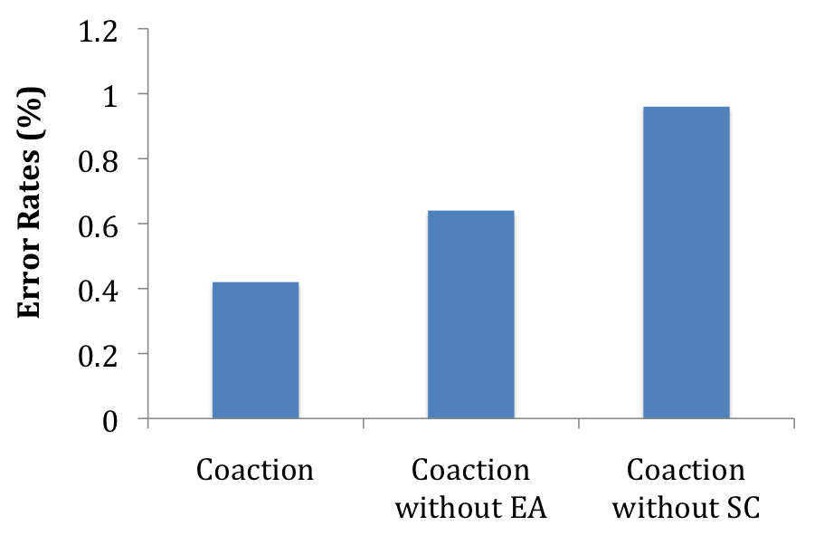

Figure 3. Error rates in percentages across conditions in Study 2. Those in the Coaction condition had the lowest competitive performance error rates, followed by those in the Coaction without EA condition, and the Coaction without SC condition. In other words, performance accuracy decreases as the two mechanisms, evaluation apprehension and social comparison, respectively, are removed from a normal coaction setting.



Figure 4. Picture prime accompanied by different vignettes for all 4 conditions in Study 2.

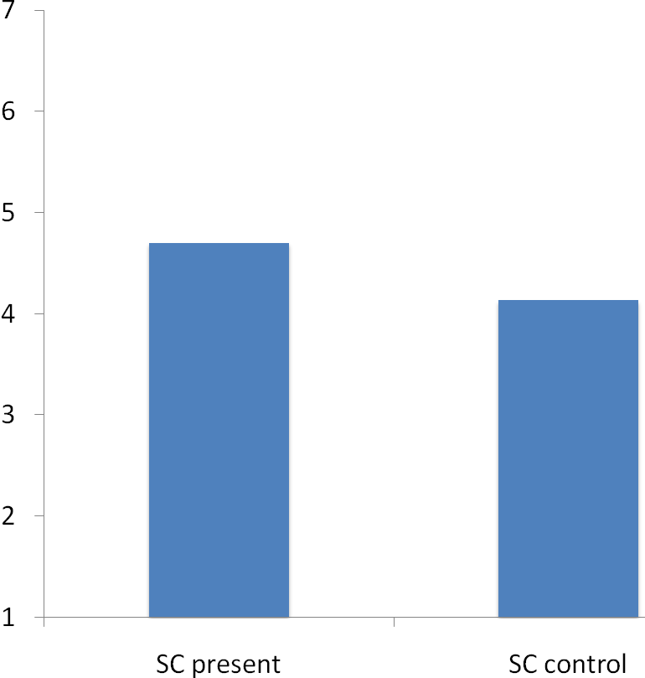
Mean self-reported evaluation apprehension

Figure 5. Paired t-test results for the means of the evaluation apprehension DV in each of the “SC present” and “SC control” conditions. Mean self-reported feelings of evaluation apprehension were significantly higher when social comparison was primed in the “SC present” condition than in the “SC control” condition.

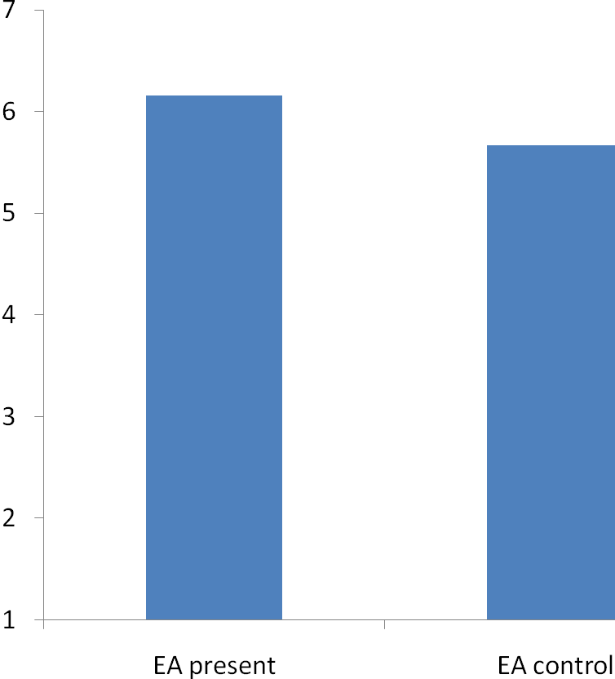
Mean self-reported social comparison

Figure 6. Paired t-test results for the means of the social comparison DV in each of the “EA present” and “EA control” conditions. Mean self-reported social comparison inclinations were significantly higher when evaluation apprehension was primed in the “EA present” condition than in the “EA control” condition.

