This is a hands-on exercise for introducing the scientific, four-step "Improvement Kata" pattern. The purpose is to help you teach scientific thinking and adaptiveness. This exercise can be run remotely. No PowerPoint is needed. For background information visit www.katatogrow.com.

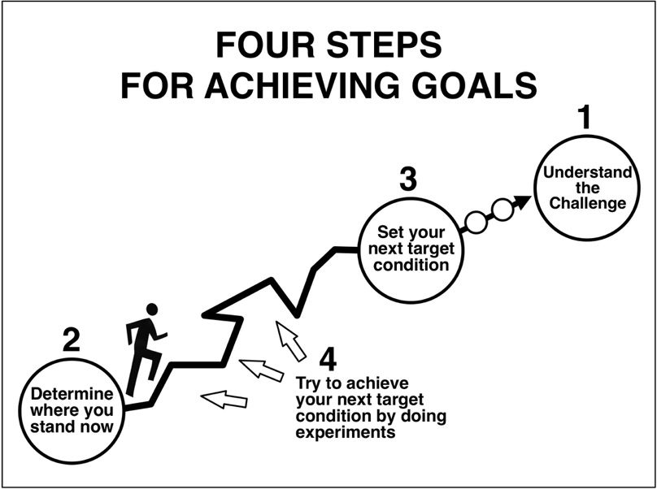

This exercise has two main lessons:
- Introduce the four steps of the Improvement Kata ... a simple scientific-thinking pattern that is easy to apply in everyday life. It is used in many K-12 and college courses.
- Recognize that ideas need to be tested, no matter how certain we might feel about them.

In the exercise teams of students (a) face a challenge --> (b) establish a baseline --> c) develop a next target condition on the way to the challenge and --> (d) conduct experiments toward that target condition. While the students are engaged in the hands-on game they are practicing these universal STEM skills for achieving challenging goals along uncharted paths:
- Scientific & Creative Thinking - generate and refine solutions to obstacles through experimentation.
- Collaboration - work in a team to accomplish a next goal on the way to a larger challenge.
- Communication - organize thoughts, data & findings, and share them effectively.

The exercise consists of two files. The TEACHER uses this "instructions" file, while each remote TEAM uses the materials in the "forms" file, plus a deck of cards.

The teacher should run the exercise at home once, for instance with their family, to get familiar with the exercise. Then the teacher can do it with remote participants. Send the remote participants the "forms" file and prep instruction in advance. Ideally do a 1st Zoom meeting with the remote participants to prep, and a 2nd Zoom meeting to run the exercise.

After you run the exercise, you can use the four-step Improvement Kata pattern as a working pattern, or overlay, for other student activities. Where else might your students apply and practice the four-step pattern of the Improvement Kata? Visit www.katatogrow.com for examples of how educators are applying the Improvement Kata pattern with their students.

KiC Exercise with Playing Cards

+ Follow-On Homework Activity

An easy-to-run exercise that helps teach scientific thinking and adaptiveness. For background information visit www.katatogrow.com.

Time: 45 - 60 minutes (Can be run remotely)

Materials for each team: (Ask the teams if they have these things)
- One deck of regular playing cards per team. Use only the cards from 7 to King.
- Stopwatch-style timer (can be a cellphone stopwatch).
- Team forms (file = Team_Forms.pdf):
  - Image of the target building order for the cards. (Notice both the numerical order and the suit order.)
  - 'Four Steps for Achieving Goals' poster. (Can be taped on the wall nearby.)
  - Baseline & Experimenting timesheet form.
  - Reflection card. (Cut the cards out. One card per participant.)

Setup for each team: (Read this to the teams.)
- Ideally each team has at least 3 people. Participants can be students and their family members. One parent should be on the team as the timekeeper.
- Each team sits at a table with the materials.
- Any number of players can participate in moving the cards, and the team can change this and other factors as part of its experiments in STEP 4.
- One person will be the timer and one the recorder. The parent can be the timer, but have a student be the recorder.

Instructions for running the exercise: (Do a test run to familiarize yourself with the exercise, before going live.)

(Say:) STEP 1 - THE CHALLENGE (refer to the poster)
- Explain to the teams their job is to get the cards into the layout shown. The big challenge is to do it in 15 seconds. That's not the goal for today, but a longer-term goal.
- Quality Constraint: There should be roughly equal space between the rows and columns of this layout.

(Say:) STEP 2 - GRASP THE CURRENT CONDITION (refer to the poster)
- Teams, please get into starting position: Start every round with the deck shuffled and placed face down on the table. Team member hands are flat on the table and no talking. Teacher then calls "START." The parent starts the timer and the team builds. Student recorder notes the elapsed time on the form.
- We'll do two baseline rounds and record how long it takes on the form. The time for the second baseline round = the current condition for your team. (Times will differ from team to team. That's fine. Teams are competing against themselves, not against each other.)

(Say) STEP 3 - YOUR TEAM'S NEXT TARGET CONDITION (refer to the poster)
- The teams should now discuss and define their target condition for today. We have time for doing five (5) rounds of experimenting. What build time (between the current condition time and the challenge time) would they like to reach by the end of those 5 rounds? There is no need to get to 15 seconds today, but we do need to improve. (Give the teams 90 seconds to discuss).
- Have the student draw a line across the experimenting bars on the form at that build time. Label the line "TC," for "target condition." This is today's goal line for the team.

(Say) STEP 4 - EXPERIMENTING TOWARD THE TARGET CONDITION (refer to the poster)
Before the first experimenting round each team should decide and write down what ideas it wants to test in the 1st round. They can choose anything, so long as they start with the deck shuffled and face down, hands flat on the table, and they keep to the quality constraints. Teacher should allow 90 seconds for each planning phase (teacher times this, saying, "OK, planning time is up!")

- Teams run their experiment and record the elapsed time and the +/- change from the last round.
- Based on what happened, each team should discuss and write down what ideas it wants to test in the next round. (90 seconds. Do this before reflection.)
- Teacher now asks the reflection questions of one team. Walk that team through the reflection questions one at a time and have them answer the questions one at a time. The other teams follow along with their reflection cards. Pick a different team to respond after each round.

Go back to A. and repeat four more times.

Debrief:
- (Ask) "What are the four steps for reaching a goal?"
- "Notice how you needed to test your ideas. Things often don’t go the way we think they will!"

Follow-on homework projects:
After doing the playing-card exercise to introduce the 4-step Improvement Kata pattern, the students can utilize the same 4-steps as a framework for other activities. For instance, the teacher can ask the students to apply the 4-step pattern + the reflection questions to a home activity over the next days and schedule a report-out. Give some example activities, such as preparing a meal, washing the dishes, etc. Chores can be an excellent activity to turn into challenges! See these videos for examples:
--> https://www.youtube.com/watch?v=NnaQ1Zha0eg
--> https://www.youtube.com/watch?v=m23dbcSaqDw

Photos of the exercise in progress:
