A Position Sensing and Control System for a
Cochlear Prosthesis
Jianbai Wang, Danielle Merriam, and Kensall D. Wise
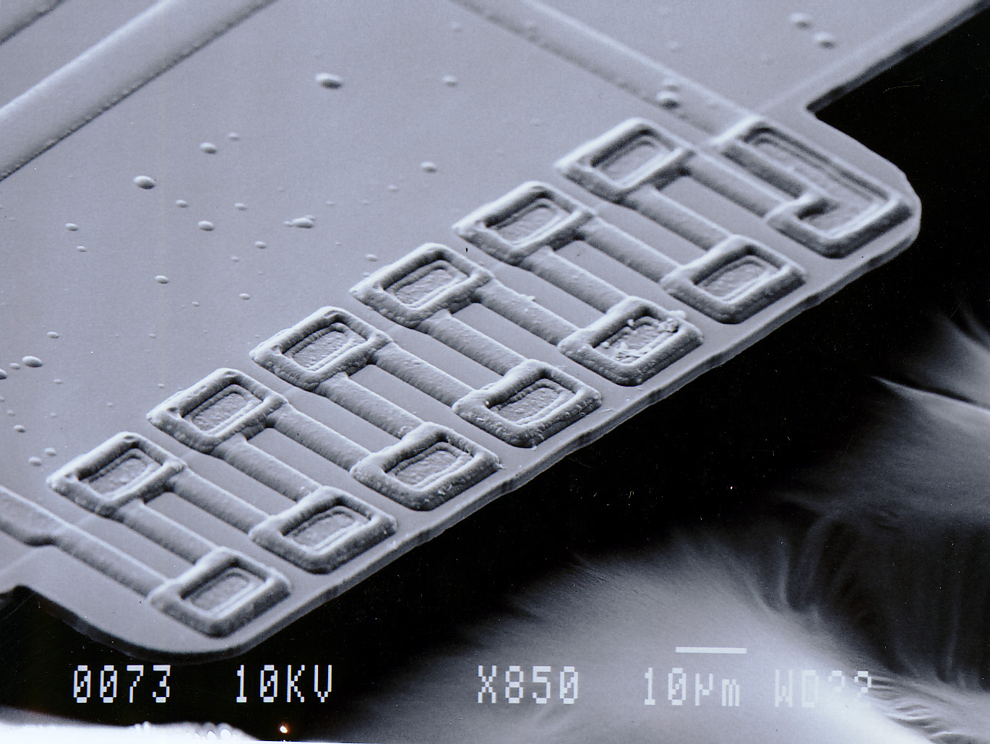
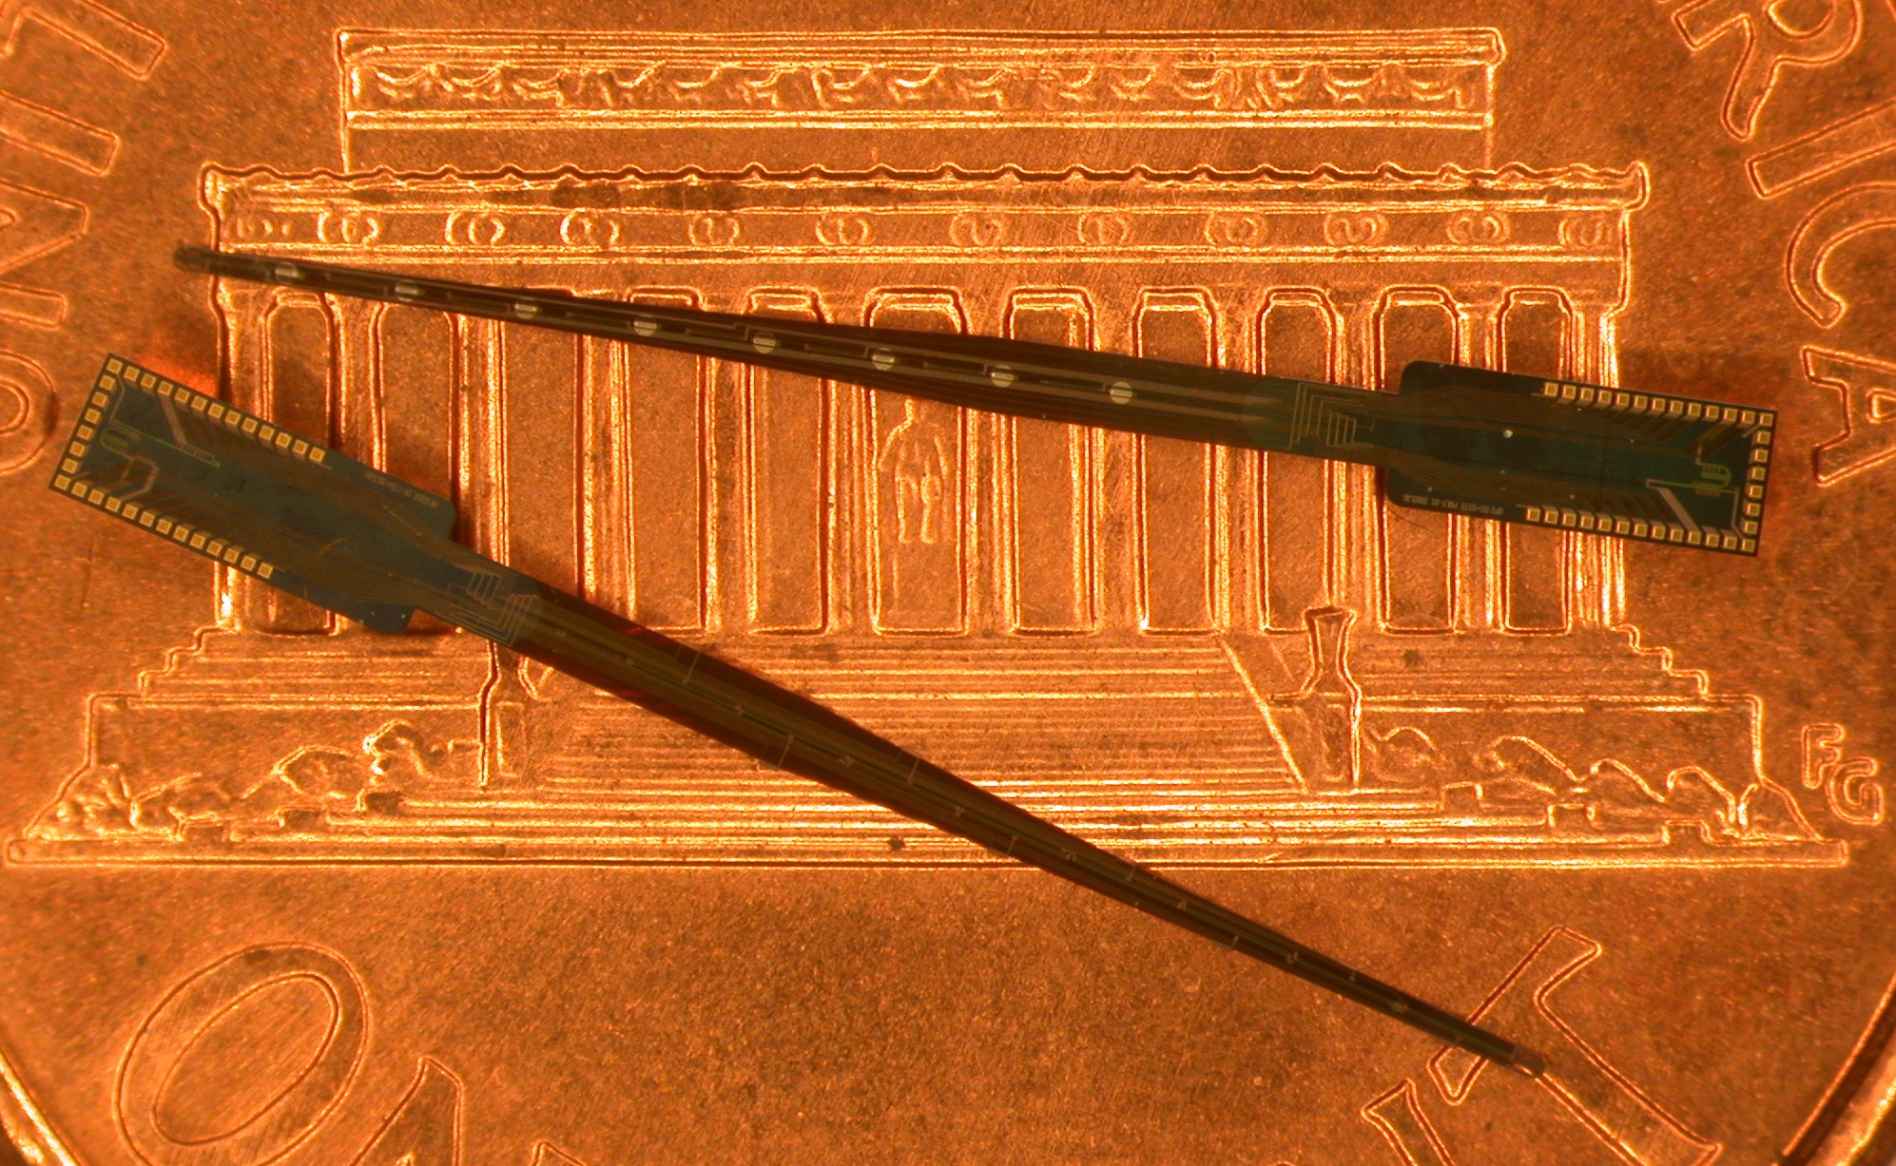

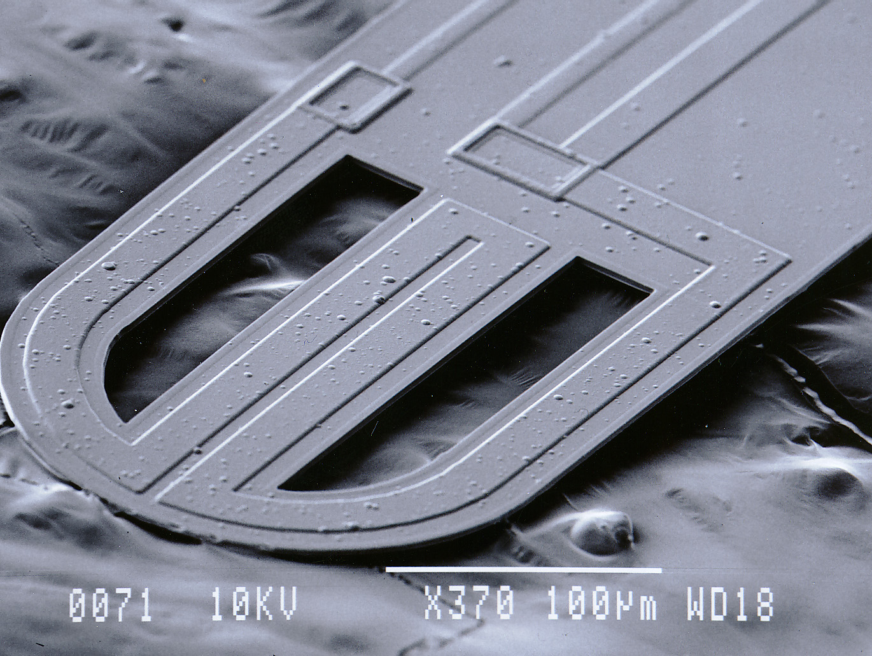

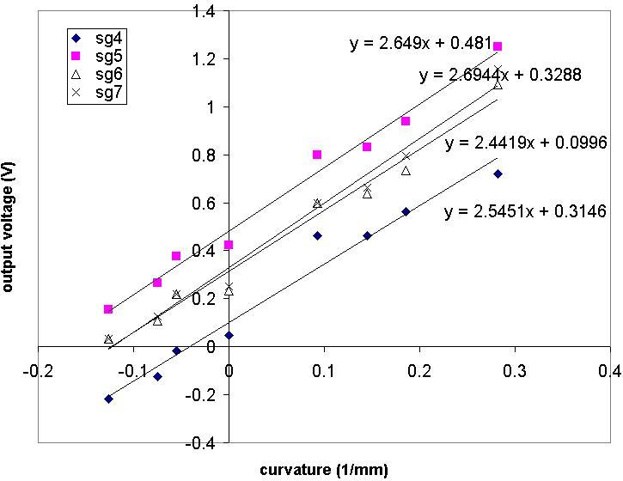

A top view of several cochlear probes containing sensors for bending position and wall contact. At left is a tip sensor for wall contact on a US penny.

In cochlear prostheses, the distance between the electrode array and the neural receptors along the cochlear wall is critical not only in determining stimulus levels and frequency resolution but also in protecting the remaining neurons from damage during the implant. This project seeks to develop sensors for position and wall contact inside the cochlea to allow closed-loop control of stimulus levels and minimize insertion damage. The devices will eventually form the front-end of a closed-loop position control system that will be built into the high-density electrode array.
At present, a passive position-sensing system composed of polysilicon piezoresistive sensors, analog multiplexing and amplification circuit and LabVIEW interface was set up. A linear relationship between the output voltage and the curvature of the probe was demonstrated; thus, the gauge factor of the polysilicon piezoresistive sensors averages 26, allowing the array position to be determined to within about 40µm. These results are used to develop an active 32-site CMOS cochlear array that features eight position sensing segments. For implementation of a full closed-loop system, multi-segment pneumatic and thermopneumatic array position control is being explored in conjunction with Michigan Tech University.
This work is supported by the Engineering Research Centers Program of the National Science Foundation under Award Number EEC-9986866 and by a gift from Ms. Polly Anderson.

