Problem Set 6
Tariffs - Answers

- The graph below shows domestic supply and demand for a good in a small country. Suppose that it faces a world price of the good of $4 per pound. Show the effects on this market of a 25% ad valorem tariff on the good by drawing the equilibria with and without the tariff, then using the grid lines in the figure to calculate the changes in quantities supplied, demanded, and imported, and the welfare effects of the tariff on suppliers, demanders, government, and the country as a whole.

Reading from the figure, quantity supplied rises from 2000 to 4000 pounds, quantity demanded falls from 9500 to 9000 pounds, quantity imported falls from 7500 to 5000 pounds. Suppliers gain area “a”, which is $3000, demanders lose area “a+b+c+d”, which is $9250, government gains revenue of area “c”, which is $5000, and the country as a whole therefore loses (9250–3000–5000) = –$1250.

- Use the partial equilibrium, small-country model of a tariff to work out the effects of an increase in a tariff that was already positive. For each case below, find the effects on domestic price, domestic quantities supplied and demanded, quantity of imports, and the welfare of suppliers, demanders, government, and the country as a whole. Also note, by comparing with your notes from class, whether any of these results differ from the effects of a positive tariff starting from a zero tariff.
  - 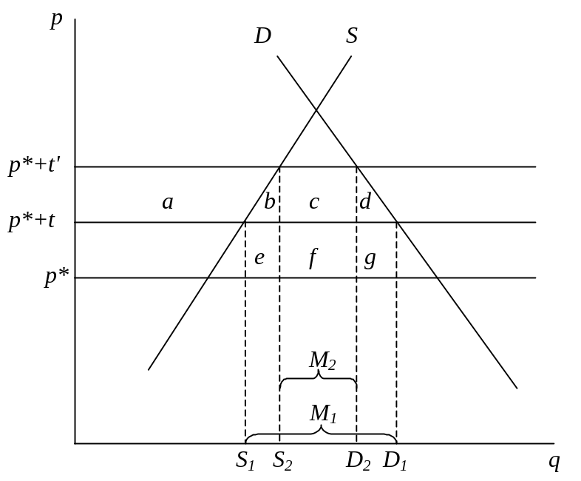A tariff increase that is small enough so that the quantity of imports remains positive.
Since this is a small country, the domestic price rises from p*+t to p*+t'. Supply increases from S₁ to S₂; demand decreases from D₁ to D₂; and imports decrease from M₁ to M₂. Suppliers gain area “a”, demanders lose area “a+b+c+d” and the government’s tariff revenue changes from “e+f+g” to “c+f”, the change therefore being “+c–e–g”. This may be an increase or a decreases in revenue, depending on the sizes of these areas. If the initial and new tariffs are both not too high (below the revenue-maximizing tariff), then the tariff increase will increase revenue. Otherwise, the higher are these tariffs, the more likely it is for the revenue to fall. For the country as a whole, the net effect on welfare is a loss of “b+d+e+g”. It is the possibility of lost tariff revenue that is the main difference in these effects as compared to levying a tariff starting from zero, and also the portion of that loss, “e+g”, that is an addition to the net loss to the country, since it is a loss to government that is not a gain to anybody else.
  - A tariff increase that is large enough to reduce the quantity of imports to zero.
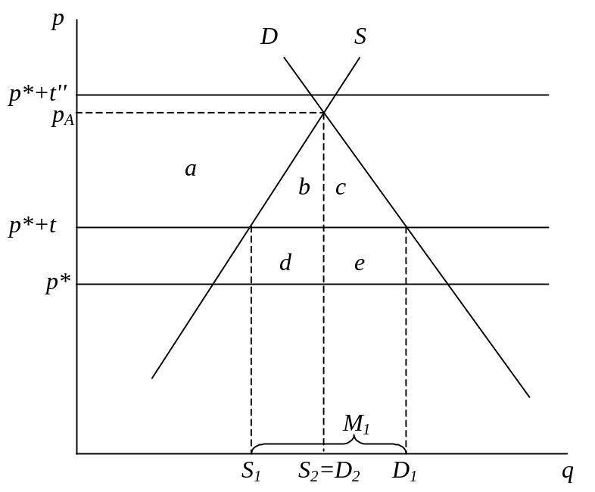The price now rises to the level where domestic supply and demand are equal, p_{A}, for any t'' such that p*+ t''>p_{A}. In the diagram below, quantities supplied and demanded rise and fall respectively to S₂=D₂, which are their levels in autarky. Quantity of imports falls to zero. Suppliers gain area “a”, demanders lose area “a+b+c”, and the government loses its entire initial tariff revenue, “d+e”. The country as a whole therefore loses “b+c+d+e”. Compared to the case of a tariff starting from zero, the main difference is this extra and now necessary loss of tariff revenue.

- Suppose that, in a partial equilibrium model, a country’s autarky price is $10, while its price with free trade is $8. What will be the domestic price if the country levies a specific tariff of $3 and the country is
  - Small?
In a small country, this greater-than-prohibitive tariff will just raise domestic price to its autarky level, $10, much as in the figure above for tariff t''.
  - Large?
In a large country, since the tariff pushes down the world price, it may achieve equilibrium without eliminating trade. The figure below, showing just the market for imports, shows such a case:
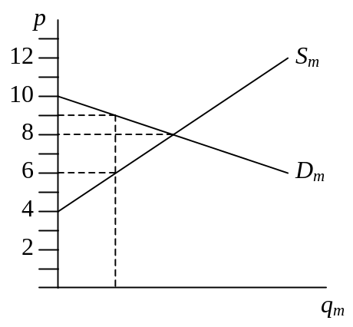Here, the $3 tariff pushes the domestic price up only to $9, while lowering the foreign price to $6. For a tariff in a large country to be prohibitive, it would have to be at least equal to the difference between the two countries’ autarky prices, in this case $10 – $4 = $6.
- In the partial equilibrium, large-country model, show how the import supply curve can be derived as the excess supply in the Foreign country’s domestic market. Then use this to show how a tariff levied by the Home country affects prices, quantities, and welfare (of Foreign suppliers, demanders, and government) in the Foreign economy.
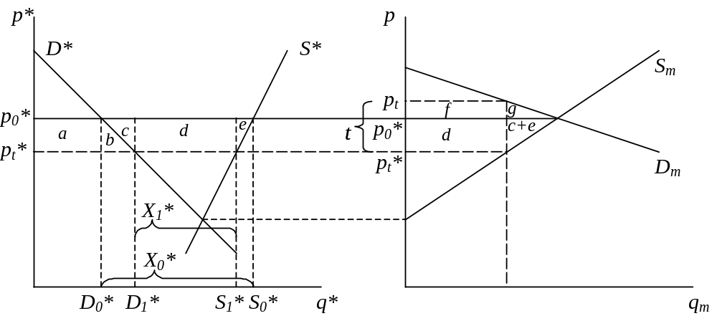The supply of imports curve on the right is derived as the horizontal distance between the Foreign country’s domestic supply, S*, and its domestic demand, D*.
When the Home country, whose demand for imports is shown as D_{m}, levies a tariff, t, this drives a wedge between its domestic price, p_{t}, and the Foreign country’s domestic price, p_{t}*, such that p_{t} − p_{t}* = t, and such that the quantities supplied and demanded of imports are the same. That is, we look for a place where the D_{m} curve is above the S_{m} curve by the distance t. This pushes the price in Foreign down, from p₀* to p_{t}*. Within the Foreign country, demanders gain from this fall in price, an increase in consumer surplus equal to “a+b”. Suppliers lose, however, a loss of producer surplus equal to “a+b+c+d+e,” for a net loss to the country of “c+d+e,” which is also shown as the area to the left of the S_{m} supply curve on the right. This net loss by the Foreign country is due to the worsening of its terms of trade. The Foreign government is not involved, since it is not taxing anything.
- Using the partial equilibrium model of a large importing country, suppose that the country is initially in equilibrium with a certain non-prohibitive tariff.
  - Assuming that the tariff is a specific tariff and that its size does not change, what will be the effects on prices, quantities, and welfare of
    - A shift to the right in the domestic demand curve (more of the good demanded at each price).
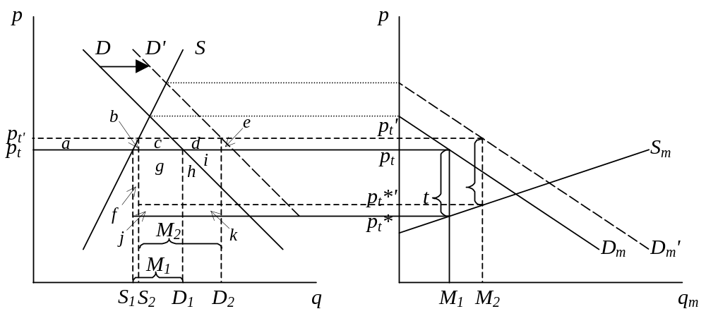The initial equilibrium has domestic price p_{t}=p_{t}*+t. The shift to the right of the domestic demand curve, from D to D', also shifts the import demand curve to the right by the same amount, from D_{m} to D_{m}'. New equilibrium requires again two prices differing by the amount of the (unchanged) tariff, t, and as shown, this causes both p_{t} and p_{t}* to increase, by the same amount, to p_{t}' and p_{t}*' respectively. Imports rise from M₁ to M₂.
Back in the home market, the price rises, domestic supply increases, and domestic demand also increases, by more. This benefits home suppliers in the amount of area “a”. We can’t tell how it affects home demanders, however, because their preferences have changed. We can, however, see that the government’s revenue has increased, since it is now levying its unchanged tariff, t, on increased imports. Formally, the government’s revenue changes from “f+g+ j” to “c+d+g+h+i”.
    - A shift to the right in the foreign supply curve (more imports of the good supplied at each price).
Here it is the supply of imports curve in the world market, S_{m}, that shifts to the right, as shown in the figure below. Once again, a new equilibrium is found where the D_{m} curve is above S_{m}' by exactly the distance t, and this must be at a higher level of imports, M₂, and lower levels of both prices, p_{t}' 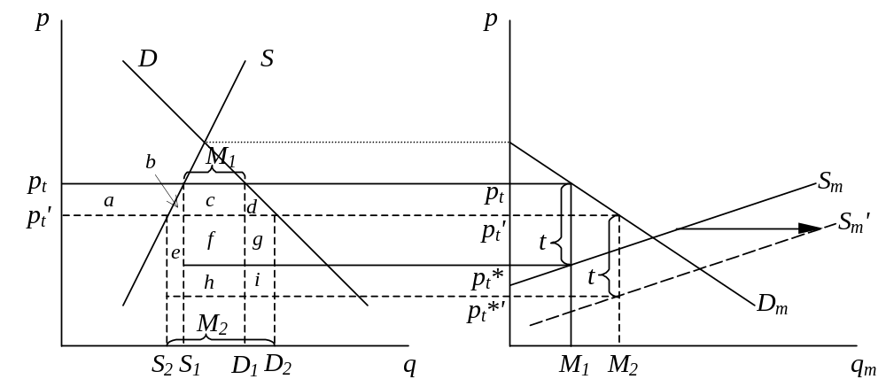and p_{t}*'.
In the domestic market, the price therefore goes down, as shown, causing quantity supplied to fall and quantity demanded to increase. Suppliers lose area “a”, while demanders gain areas “a+b+c+d.” Government also gains, collecting the same tariff on each unit of imports, but with now a largere quantity of imports. Formally, tariff revenue rises from “c+f” to “e+f+g+h+i”, for a net change of “e+h+i+g–c”=”e+i+g” since c=h. Net welfare for the home country rises by “b+d+e+g+h+i”.
  - How, if at all, would part (a) be different if the tariff were fixed in ad valorem instead of specific terms?
Had the tariff been ad valorem instead of specific, then in both problems of part (a) we would look for a new equilibrium where D_{m} is the same percentage above S_{m}, rather than the same absolute distance.
In problem (i), because p_{t}* is rising, this will require a slightly larger increase in p_{t}, smaller increase in p_{t}*, and smaller increase in imports. The qualitative conclusions will be the same, since domestic suppliers will now gain more, and the government will still collect more revenue.
In problem (ii), because p_{t}* is falling, (p_{t}–p_{t}*) must fall as well, and therefore p_{t} falls more, p_{t}* falls less, and M rises more than shown above. The increase in government revenues is now, I think, uncertain, since it will be a fixed fraction of the value of imports, which may rise or fall with a fall in price depending on the elasticity of demand for imports. However the importing country as a whole will still necessarily gain an amount analogous to “b+d+e+g+h+i” above.
- In the partial equilibrium model, when a tariff reaches a certain level it becomes prohibitive. Does that happen also in the general equilibrium small-country model? If not, what happens instead as the size of the tariff becomes ever larger? If so, how would you identify the prohibitive level of the tariff?
Yes, it is true also in the small-country general equilibrium model that if a tariff becomes large enough, trade will stop, meaning that is it “prohibitive.” One way to see this is to note that, as long as there are positive imports, a rise in the size of the tariff (either ad valorem or specific) increases the domestic relative price of the imported good and lowers the domestic relative price of the exported good. For a sufficiently high tariff, if imports did not stop, the relative price of the exported good could be reduced to the point that production of it would stop entirely (given by the slope of the PPF where it hits the axis), which of course means that importing is after all impossible.
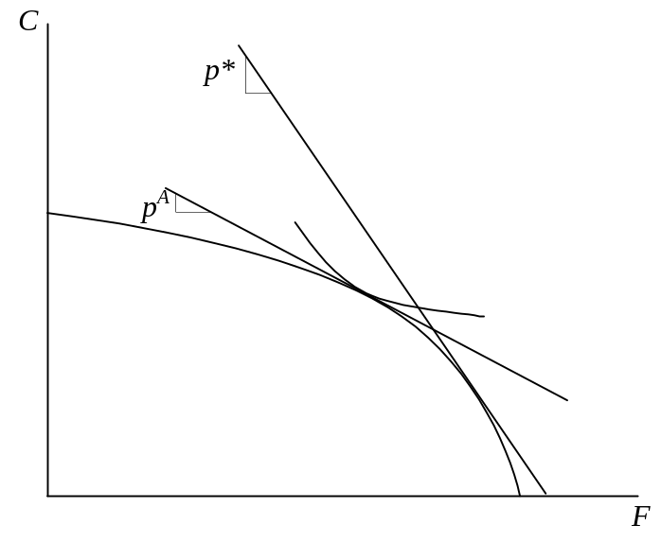To identify the size of the prohibitive tariff, simply look at the autarky price and compare it to the world price. With p* being the relative price of food on the world market, and p^{A} being the autarky relative price of food in a country where p^{A}<p*, so that it exports food under free trade, the prohibitive tariff, t^{P}, requires that p^{A} = p_{tP}=p*/(1+t^{P}) and therefore t^{P}=(p*/p^{A})–1.

- Use the two-good Heckscher-Ohlin Model to work out how a country’s PPF is expanded when it experiences equal percentage increases, say 10%, in both its labor force and its capital stock. Then, assuming homothetic preferences and the presence of a fixed, positive but non-prohibitive, ad valorem tariff on its imports of (relatively labor-intensive) Food, work out the effects of this growth on its tariff revenue (in units of Cloth) and also on the real wage of labor under the assumption that the country is
  - Small.
  - Large.

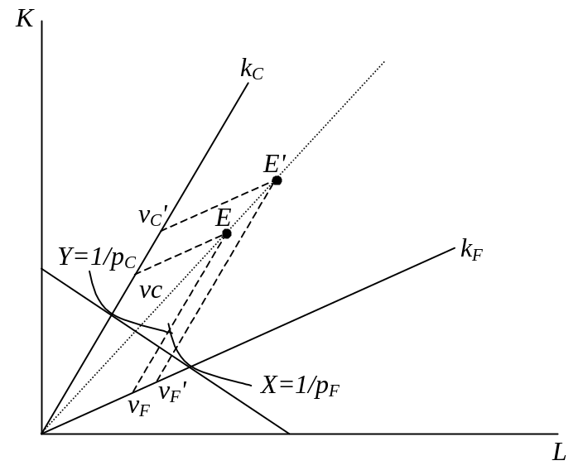Using the Lerner diagram below, for any given prices, it is easily shown that an equal percentage expansion of the endowments of both factors, moving the endowment point out from E to E' along a the ray from the origin, will cause an expansion of the same percentage in the outputs of both goods. By the similarity of triangles, v_{F} and v_{C} both expand by the same proportion as the endowments.
It follows that the country’s PPF also expands outward by that proportion and, if prices do not change, that income of consumers expands by that proportion as well. If preferences are homothetic, then the consumption point, D, also expands along a ray from the origin. The result is that at constant prices the quantities of both goods supplied, demanded, and thus traded, all increase by the percentage that endowments have increased. This is shown in a diagram above. The important point here is that the country will, if prices do not change, increase both its exports and its imports.

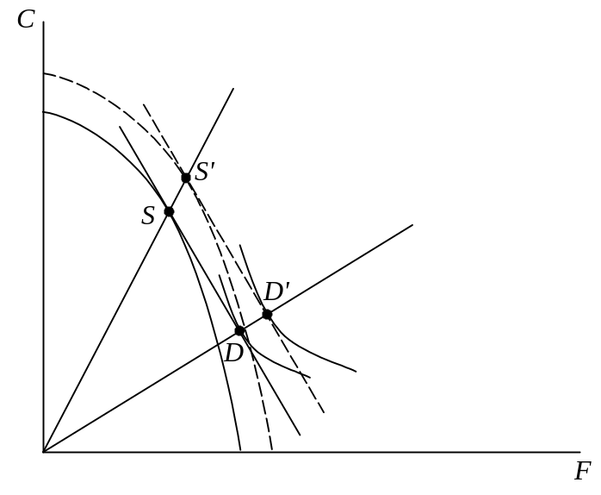Now suppose the country is small. Then prices of goods really are constant in the face of this growth. With a constant tariff, and more trade, the country’s government will collect more tariff revenue. As for factor prices, if the country is producing both goods as shown above, then its factor prices will not change, since they are determined by the usual mechanism of factor price equalization. (If on the other hand the country were completely specialized, contrary to what is shown above, these answers would be the same. In that case the factor prices would remain unchanged because the proportional expansion of both factors would not change the factor ratio employed in the only sector producing.)
If instead the country is large, then its attempt to increase its exports and imports at the initial price will causes prices to change. Since it is importing food, the relative price of food will rise on world markets (and correspondingly, since it is exporting more cloth, the relative price of cloth will fall). Since the price of food rises, and the tariff is ad valorem, the government will collect somewhat more tariff on each unit of food that is imported. However, the quantity of imports will be less than if the price of food had remained constant, and may conceivably be even less than before the growth, if the demanders’ response to prices is strong enough. So we cannot say for sure what happens to tariff revenue.
We can be sure about the real wage, though. Since the relative price of food is rising, the Stolper-Samuelson Theorem tells us that the real wage goes up.
- The diagram below shows the PPF of a small, two-sector economy, together with points representing the goods that it consumes under free trade, D_{f}, and those that it consumes under a certain tariff, D_{t}. Perhaps surprisingly, this should be enough information for you to derive the free-trade relative price of food, the domestic relative price of food under the tariff, and therefore the quantities of food and cloth produced both with and without the tariff. In addition, if you assume homothetic preferences, you can make a good guess at what the indifference curves look like through D_{f} and D_{t}. Do all this. And then, with the help of a ruler, estimate the ad valorem size of the tariff.
I will show this in steps. First, construct the straight line through point D_{f} that is also tangent to the PPF. The slope of this line is the world price, p*, and the point where it is tangent to the PPF is the production point with free trade, S_{f}.
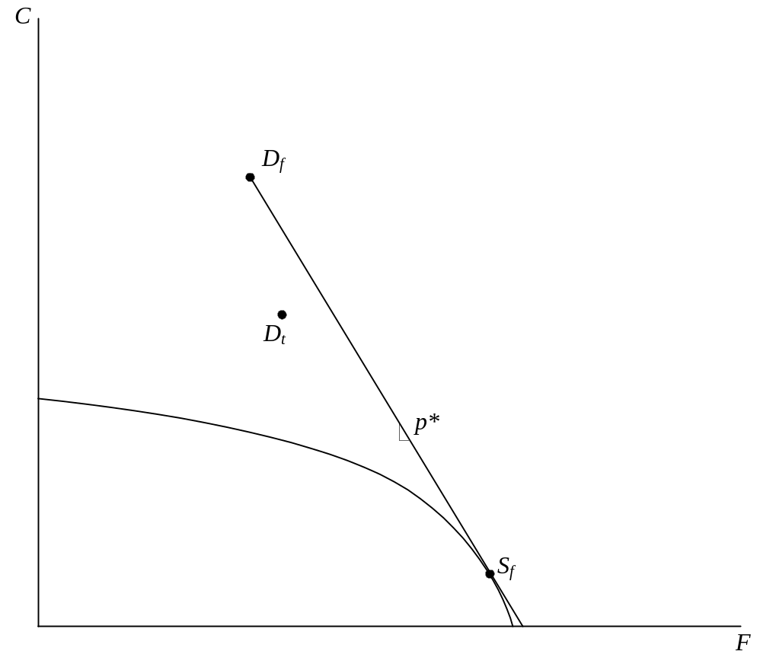
Next, draw a second line parallel to the one you just found, passing through point D_{t}. Its intersection with the PPF is the production point under the tariff, S_{t}:

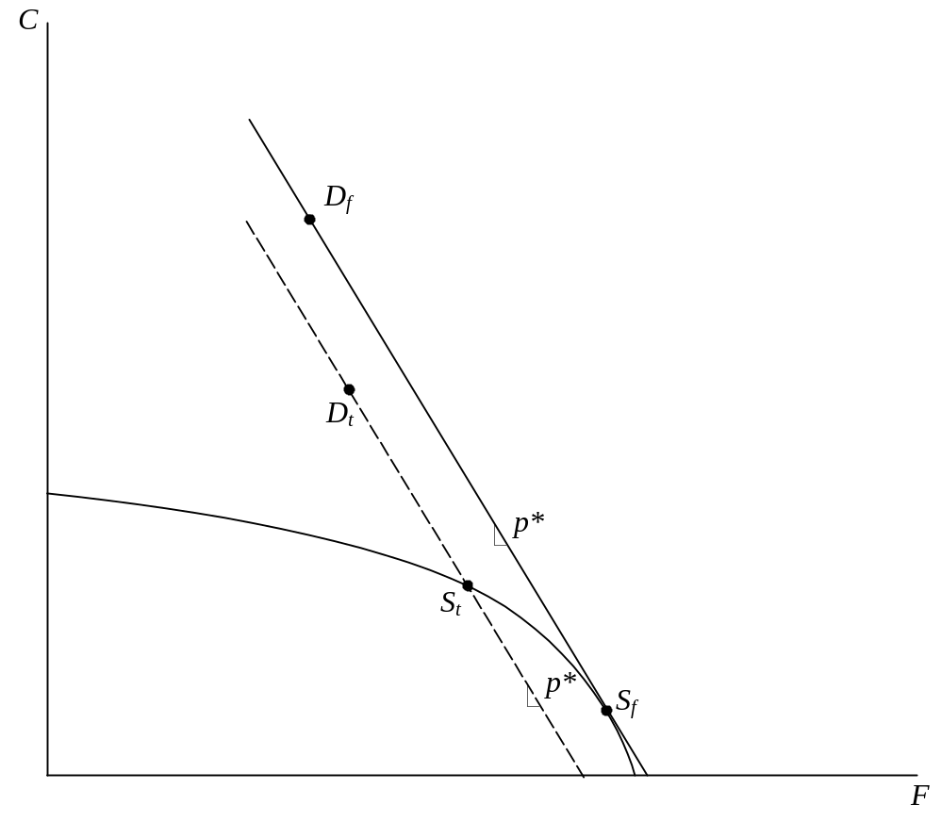

Production at S_{t} requires that domestic prices equal the slope of the PPF at that point, so draw another straight line tangent to the PPF as S_{t}. Its slope is the domestic price under the tariff, p_{t}.
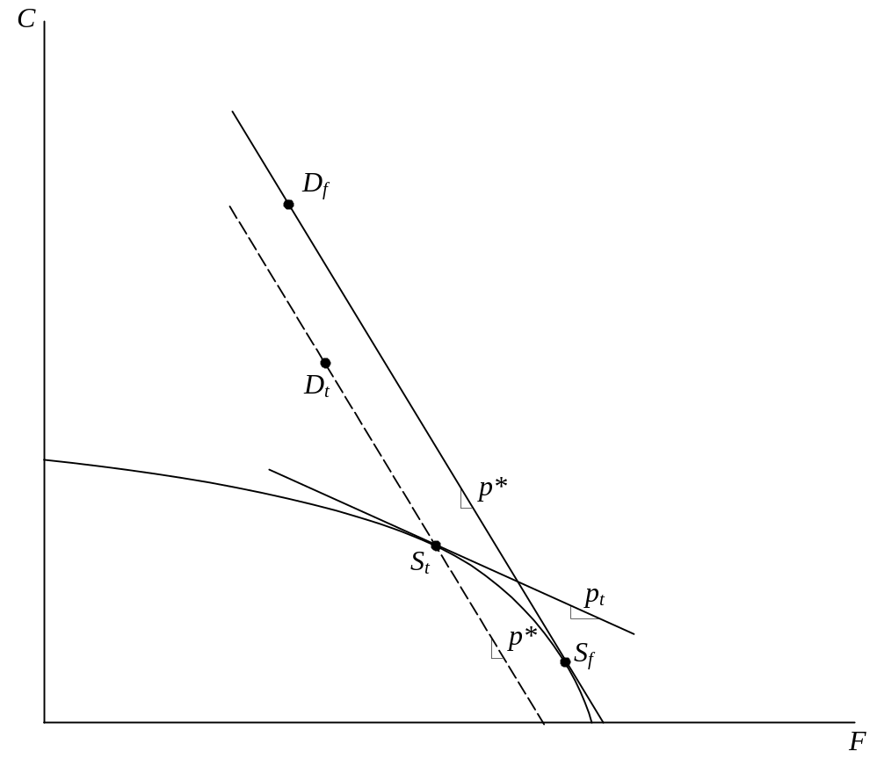
The budget line of consumers also must have slope equal to p_{t}, and so it is a straight line parallel to the one just drawn but passing through the consumption point D_{t}:
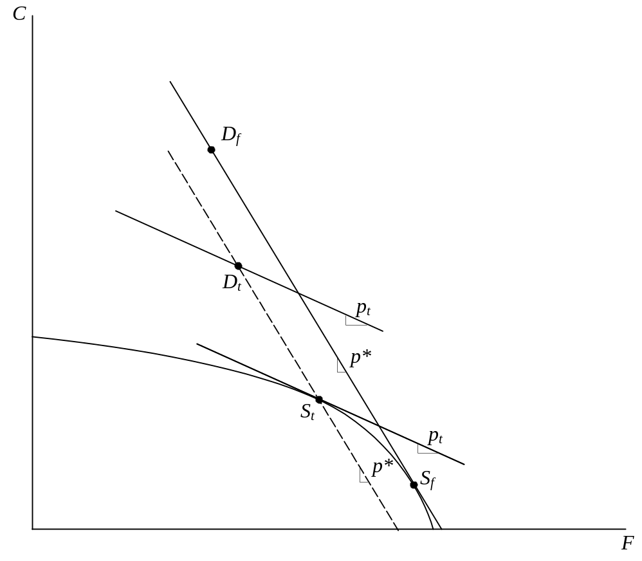
Finally, two indifference curves can be drawn into the figure, one tangent to the p_{f} line at D_{f}, and the other tangent to the p_{t} line at D_{t}.
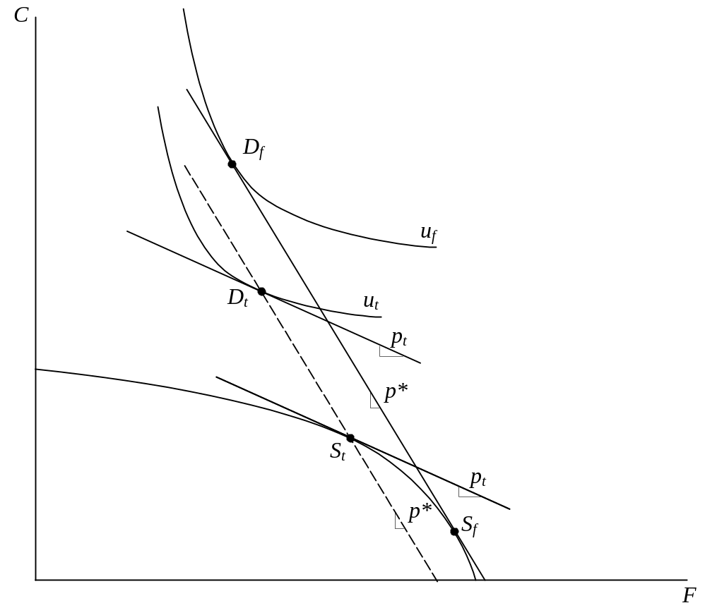
To estimate the ad valorem size of the tariff, measure the slopes of the p_{f} and p_{t} lines by drawing right triangles under them. I’ve done that below using a triangle with a common one inch base to the left of point S_{t}. I found the slopes of p_{f} and p_{t} to be, respectively, about 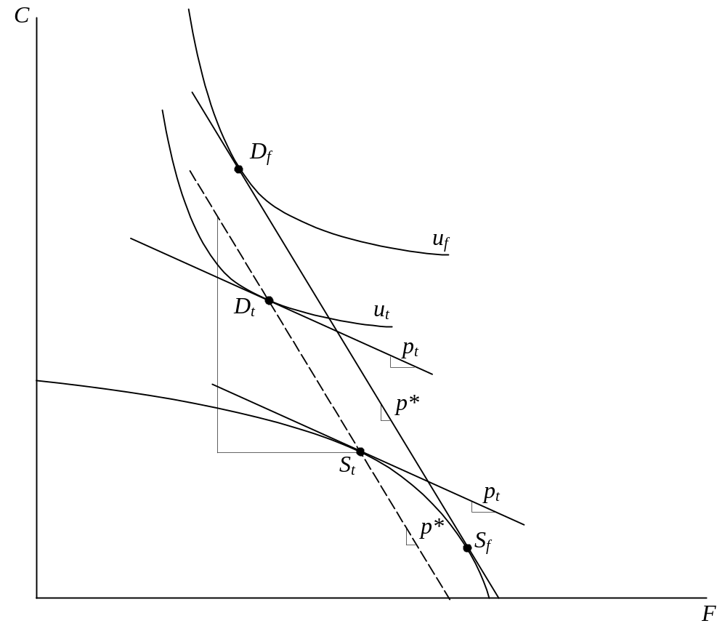1.65 and 0.45. Since p_{t} = p_{f} /(1+t), t = (p_{f} / p_{t}) – 1 = (1.65/0.45) – 1 = 2.67. That is, the ad valorem tariff depicted here is about 267%!

