Problem Set 5 - Answers

Imperfect Competition, Increasing Returns, etc.

- Consider a monopolist in partial equilibrium who initially faces the demand curve D₁ shown below, and whose marginal cost is constant at c.
- 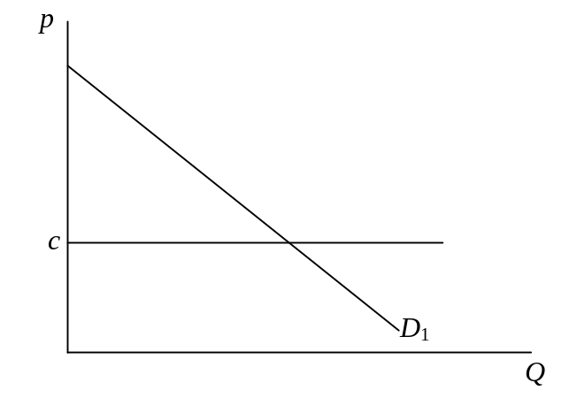Construct the profit-maximizing equilibrium for this monopolist.

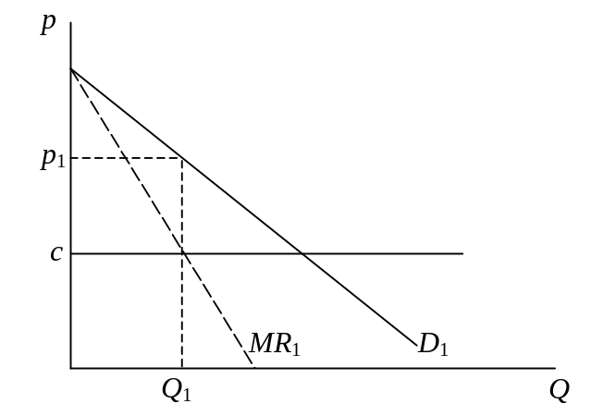This is found from the marginal revenue curve, MR₁, drawn as the straight line half the distance between the vertical axis and the demand curve D₁. Where that MR₁ curve cuts the marginal cost line, c, determines the output Q₁ that the monopolist will produce. Vertically above that on the demand curve is the price, p₁, that will clear the market at that quantity, and p₁ is therefore the price that the monopolist will charge.
- Suppose now that the demand curve becomes everywhere more elastic, but continues to pass through the same price-quantity point that you found to be optimal in part (a). (That is, if the profit-maximizing monopolist was producing Q₁ and selling it for p₁ in part (a), quantity Q₁ still has price p₁ on the new, more elastic, demand curve.) Construct the new equilibrium for the monopolist and compare it to the old, in terms of quantity, price, and profit.

Becoming more elastic, the demand curve rotates counter-clockwise through point A. The new marginal revenue curve, being half the distance between the vertical axis and this new curve, intersects MR₁ directly to the left of A, since this point is half way between the axis and both curves. It therefore must lie to the right of MR₁ everywhere below p₁, and from this it follows that it crosses the c line at some Q₂>Q₁. From the new demand curve, then, it is also true that p₂<p₁, as shown.
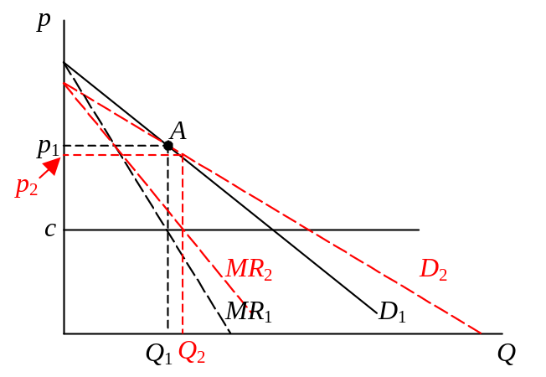
Thus quantity rises and price falls, due to this particular change in the demand curve. Profit, which was (p₁–c)Q₁ and is now (p₂–c)Q₂, may seem at first to be ambiguous in its change, since the markup falls but the quantity rises. However, the firm could continue to produce Q₁ and charge p₁ if it wanted to, and that would give it the same profit as before. Since it chooses instead to increase output, this must be because that yields it a larger profit. So we can be sure, after all, that profit rises in this case.

- Explain what your answer to part (b) could have to do with international trade.

This exercise is relevant to international trade because in general the opening to trade causes firms to face more elastic demand, due to the competition from foreign suppliers. If competition is great enough, demand elasticity would become infinite, which is more extreme than shown above. But even with just a few additional competitors, switching from a monopoly to a duopoly or oligopoly, the elasticity faced by the firm will increase. Now whether it will rotate around the particular point shown above is another question. So all that we can really take from this example that may be general is that the price (and thus the markup) will fall, just as we saw from the algebra in class.

- Explain why the gains from trade with imperfect competition may be larger than they are with perfect competition. Does it therefore follow that, if a country is going to trade in any case, then it would be better off if its industries were imperfectly competitive instead of perfectly competitive, so as to enjoy those larger gains? Explain and illustrate using production possibility frontiers and community indifference curves.

The gains from trade with imperfect competition include the “pro-competitive gains” that arise when imperfectly competitive firms reduce their markups over marginal cost – markups that cause imperfect competition to be less than optimal. That is, the increased competition from foreign firms reduces the dead-weight loss due to monopoly and other imperfectly competitive behavior. This reduction in deal-weight loss is then added to whatever gain from trade would otherwise arise if the firms were already competitive, yielding a larger gain from trade.

No, it does not follow that a trading country is better off having imperfectly competitive firms. The converse is true, however: that a country with imperfectly competitive firms is better of trading, since trade reduces the costs to it of the imperfect competition.

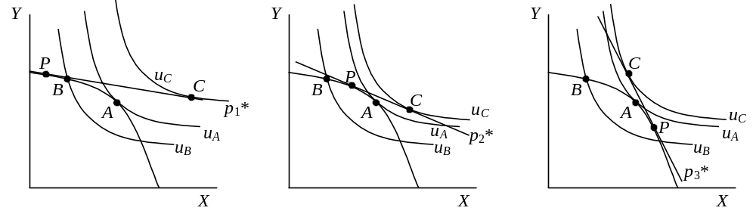To illustrate, consider the three graphs below showing PPFs and three different possibilities for the world price. In each case, as in the text, good X is produced by a monopolist that charges a markup over cost in autarky, but becomes a price taker under free trade. In autarky, therefore, the relative price of X to consumers is higher than the slope of the PPF, at points B in each diagram. If there were no monopoly, and also no trade, the country would produce and consume at point A, reaching utility u_{A}. But the monopoly lowers autarky utility to u_{B}.

In each case, free trade at the world price p* causes the monopolist to lose any monopoly power, so that the value of output is maximized at price p*, moving production to point P. Consumers also face this price, so consumption moves to point C, and utility rises to u_{C}. In each case, the country reaches utility u_{C} whether or not its own industry has just a single firm, since that single firm has no monopoly power when there is free trade. Thus adding imperfect competition does not help it.

Would these countries be better off, with free trade, if their X industries were imperfectly competitive? Well, simply having a single firm does not actually hurt them, since under free trade it has no monopoly power, but it doesn’t help them either. The larger gain from trade with monopoly reflects the lower welfare in autarky, not a higher welfare in trade. And of course if imperfect competition were to distort markets even with trade (as for example if the world market were an oligopoly), then they would lose from that.

- The graph below shows an economy in which industry Y is a monopoly that charges a markup over marginal cost of 50% (I know the graph is not drawn to scale), and autarky production and consumption take place at point A_{m}. (This is just like Figure 11.1 in the text, except that the monopoly here is in good Y instead of X, to give you practice.) Autarky equilibrium with a competitive Y industry would be at A. The country is small, and the world price is given by price line p*, which happens coincidentally to be tangent to the PPF at A.
- 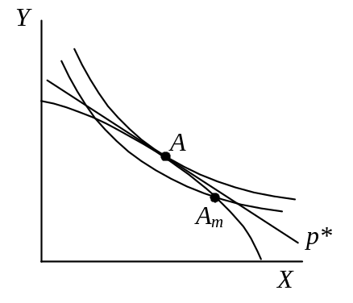How does the autarky relative price of Y paid by consumers to the monopoly compare to the free trade price?

The indifference curve at A_{m} is flatter than at A, which is also the slope of p*, so the relative price of X is lower, and thus the relative price of Y is higher, than the free trade price.

- If the country now opens to free international trade, the single producer of good Y in the country now becoming a price-taker at world prices, what will happen to production and consumption of X and Y, to the relative price of Y paid by consumers, to the profits of the firm that produces Y, and to consumer welfare?

When the firm becomes a price taker, it no longer charges a markup and instead behaves as a perfect competitor, so production moves to A, which happens to maximize output at world price p*. Since this happens to be the undistorted autarky point, consumption moves there too. Thus both production and consumption of X fall, while production and consumption of Y rise. Prices facing both producers and consumers become the world prices, so, from the answer to (a), the relative price of Y to consumers falls. The monopolist no longer makes a profit. And consumer welfare rises to the higher indifference curve shown in the figure above.

- Consider an initial free-trade equilibrium in the External Increasing Returns to Scale (EIRS) model in which the Home country produces only M, the Foreign country produces only F, and the world relative price of M is about half way between the minimum average cost of Home and the maximum average cost of Foreign. Suppose now that the labor force in the Home country expands. (For simplicity, and probably incorrectly, assume the demand curve does not shift.) Find the effect on equilibrium price, and also on outputs and welfare in each country, under each of the following assumptions:

As described, the initial equilibrium looks something like the following:

  - The expansion is small enough that both countries continue to completely specialize.

This increase in 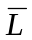 increases the maximum output of M (more than in proportion to the increase in actually, due to the increasing returns to scale), from 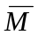 to 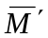. This extends to the right the average cost curve of Home, therefore also shifting to the right, by the same amount, the portion of the world average cost curve, AC^{W}, that is the Foreign country’s AC*. All of this is shown above, with the shift here being small enough that the world demand curve, D^{W}, continues to intersect AC^{W} in its vertical portion. As shown, price falls to 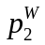.

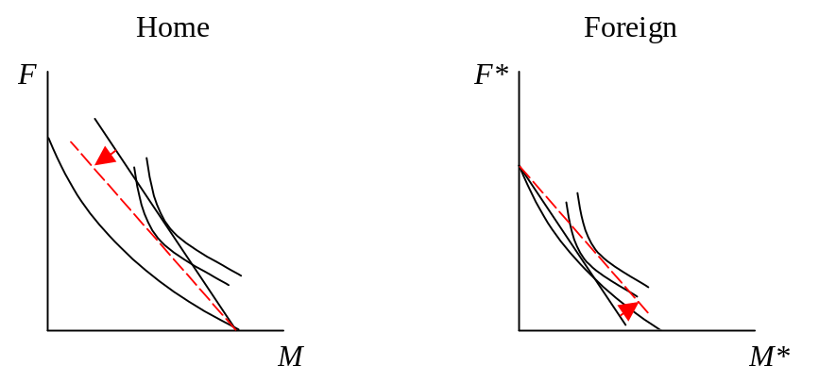Since in this case both countries continue to specialize, the output of Food, produced only in Foreign, does not change, while the output of Machines rises with the additional labor producing it in Home. To see the effects on welfare in the two countries, insert these changes into their respective PPF diagrams, as below. Foreign clearly gains, since the price of its import, machines, falls. Home may gain or lose, depending on the amount of the fall in price, since this is a worsening of its terms of trade. Had price not fallen, Home’s income would have risen with its output of M, more than in proportion to its increased labor force, which would be a gain in per capita terms. But the fall in price seems likely to offset this, causing welfare to fall.

(You may wonder whether D^{W} should also shift right, even though you’re told to keep it fixed, since world income is expanding here. Actually it is more complicated than that. At the initial output 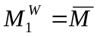, the extra labor in Home is producing F, not M, so the world ratio of M/F is somewhat reduced and requires a higher relative price of M to clear the market. But at 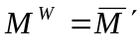, world output of M is up, while output of F is not, raising M/F and requiring a lower price than shown on D^{W}. Thus the demand curve actually needs to rotate, which is more complicated than I wanted you to deal with. And I don’t think it matters much for the answer.)

  - The expansion is large enough that one country (which?) changes to producing both goods.

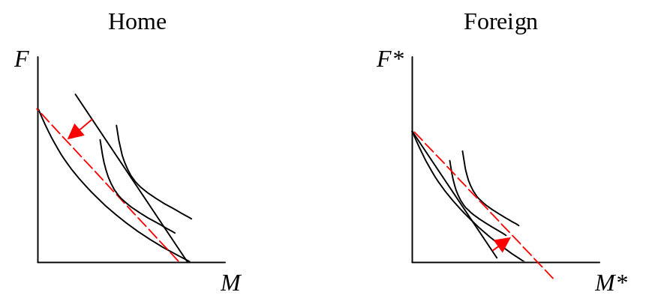For a larger increase in than in part (a), 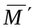 will extend AC to the right beyond D^{W}. This means that equilibrium is found in the interior of AC, and that the Home country now produces both goods. The relative price of M still falls, and indeed by more than in part (a). Now the output of both goods rises in Home, and since the output of F in Foreign remains unchanged, the world outputs of both goods also rise. Welfare effects are almost the same as before, with Home probably losing and Foreign certainly gaining. However the Home PPF diagram looks somewhat different since it now produces some F and the price equals its average cost.
- In the EIRS Handout, I pointed out that the model may possess multiple equilibria, and I showed in particular that if you interchanged the roles of Home and Foreign countries in Figure 6, you would get the alternative equilibrium shown in Figure 9, in which both the equilibrium price and the equilibrium pattern of specialization are quite different. Do the same sort of interchange for each of the equilibria shown below, in both of which Foreign does not produce good M, and determine whether in fact there exists another equilibrium in which Foreign does produce good M. If the answer is yes, then also compare levels of output, trade, and welfare in the two countries to their values in the other equilibrium.

a.

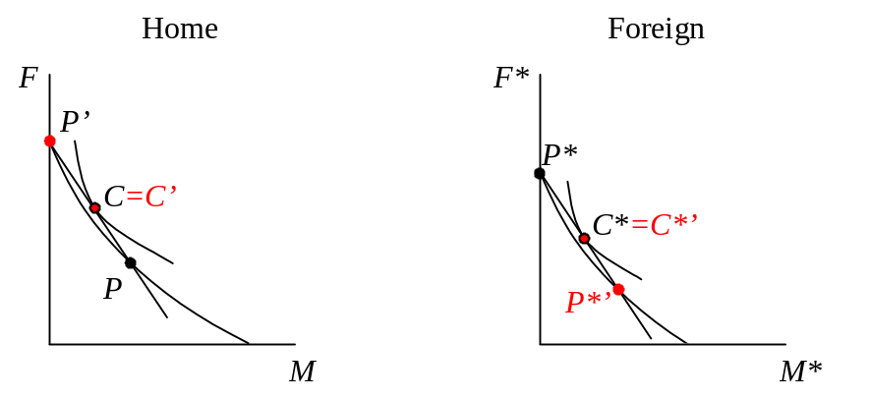Since the AC and AC* curves are exactly the same up to the point at which AC* stops, the initial portion of the AC^{W} curve is unchanged by this interchange. The new curve, shown above, cuts 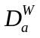 at the same place as before, and thus yields the same equilibrium price 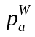. However, it is now Foreign, rather than Home, that produces both goods, while Home now specializes on Food. Instead of importing Food, as it did before, Home now exports Food. In the PPF diagrams below, the original equilibrium had the countries producing and consuming at P, P*, C, and C*, while now they produce and consume at P’, etc. However, because price does not change, in this case consumption does not change for either country, and neither does welfare.

b.

In this case when we interchange the AC and AC* curves, as above, we get an intersection with the demand curve at a price that is below the lowest average cost of AC*. That can’t be an equilibrium, since it would require that machines be produced in Foreign at a loss. Therefore in this case there is no equilibrium in which the Foreign country produces machines.

- Suppose the world consists of two countries, North and South, producing and consuming two goods, Food and Machines, where demand for Machines is income-elastic and demand for Food is income-inelastic. Production possibilities in North and South are the same, except that North is three times more productive than South, so that it can produce three times as much of either or both goods. Assume free trade between these countries.

  - Which country will export Food and which will export Machines?

The free-trade equilibrium is shown below, with PPFs 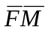 for South and 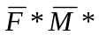 for North. South produces at P, while North produces three times as much, at P*. Because South’s income is lower, it consumes relatively more Food, at point C, while North consumes relatively more machines, at C*. Also noted are the autarky equilibria at A and A*. Because South produces more machines than it consumes, it exports these, while North exports Food.

  - Suppose that now South catches up to North in terms of productivity. How will this affect the welfare of consumers in North and South?

South’s increased productivity turns it into an exact replica of North, with PPF . The two countries are now identical in all respects, and they will not trade, reverting instead to the autarky equilibrium A*. Thus, while South gains a huge amount, due to its threefold productivity improvement, North actually loses a small amount. That is, it loses what had been its gains from trade, since it no longer has anybody different than it to trade with.

  - Suppose instead that South were able to eliminate North’s productivity advantage, not by becoming more productive itself as in (b), but by somehow reducing North’s productivity to South’s level. How would this affect welfare in both countries?

Again, the two countries become exactly alike, this time with South’s PPF, . Again they don’t trade, but revert to autarky, now at point A. Now both countries lose, North a lot and South a little.

