Midterm Exam No. 1 - Answers
October 6, 2008

Answer all questions on these sheets. Plan and budget your time. The questions are worth a total of 60 points, as indicated, and you will have 80 minutes to complete the exam.

- (6 points) There are two ways to justify the use of community indifference curves to represent the quantities of goods that an economy of many consumers will demand. One way uses a single assumption, which you should indicate in column 1 below. The other uses two assumptions together, both of which you should indicate in column 2 below. Thus, you should insert one check mark (✓) in the column labeled 1 and two check marks in the column labeled 2, in order to indicate the two ways of justifying community indifference curves.

 | 1 |  | 2
a. Consumers require a positive quantity of each good, regardless of prices.
b. Preferences are homothetic |  |  | ✓
c. Consumers wish to consume more of the capital-intensive good than the labor-intensive good.
d. The value of consumption equals income
e. The distribution of income is fixed. | ✓
f. Consumers are willing to substitute one good for another when prices change.
g. Preferences of all consumers are the same. |  |  | ✓

- (4 points) The table shows output per unit labor for two countries and two goods. If these are the only countries and only goods in the world, indicate the country that…
 |  |  |  |  |  | Output produced per unit of labor
 | …has comparative advantage in good X: | B |  |  |  |  | Country
 |  |  |  |  |  | Good | A | B
 | …has absolute advantage in good Y: | B |  |  |  | X | 50 | 100
 |  |  |  |  |  | Y | 500 | 600
- (6 points) The figure below shows a production Edgeworth Box, with origins indicated for the inputs of capital, K, and labor, L, into production of goods X and Y. Eight isoquants are shown, reflecting standard constant-returns-to-scale production functions. These are labeled ,…, at the left ends of the isoquants, but it is left to you to know which good, X or Y, these refer to and which of these quantities are larger or smaller than others.

  - (2 points) In the figure, draw the efficiency locus that is implied by these isoquants.
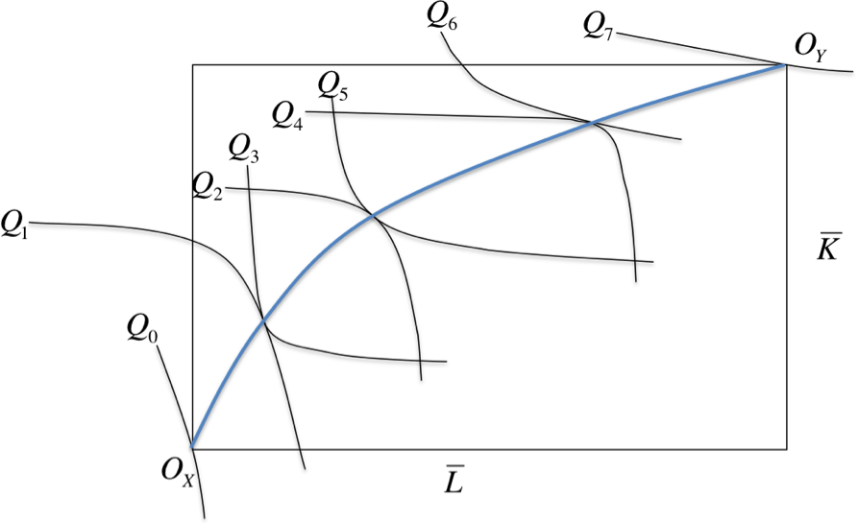
  - (4 points) On the axes below, draw the production possibility frontier for this economy, and identify along the appropriate axes the eight quantities ,…,.
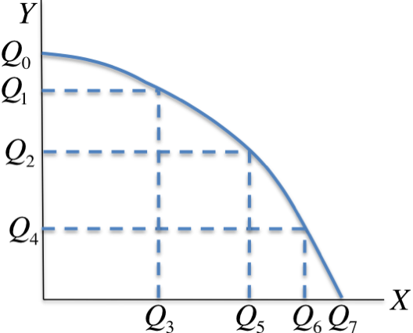
- (10 points) Consider an economy that produces and consumes two goods, X and Y, in autarky and free trade. In autarky it produces quantities and consumes quantities , at prices . In free trade it faces world prices , and at those prices it produces and consumes . Using this notation in the space below, state and prove – using appropriate equations and inequalities – that this economy gains (or at least does not lose) from trade. Be sure to state the assumptions that you use, and indicate where in the proof these assumptions are used.

Assumption 1: Competitive industries maximize the value of national output at the prevailing prices.

Assumption 2: Trade is balanced (thus expenditure equals income)

Theorem (Gains from Trade): Economic welfare of a country is at least as great with free trade as in autarky. Or, more formally, at free trade prices consumers could afford to buy what they bought in autarky:

Proof:
5. (5 points) The figure below shows the production possibility frontier for a Ricardian economy able to produce two goods, X and Y. The table at the right lists five sets of prices for X and Y. In the columns headed X and Y, record the quantity that this economy will produce of each good at those prices.

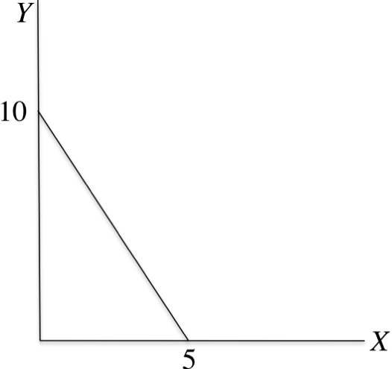 | $8 | $2 | 5 | 0
 | $8 | $12 | 0 | 10
 | $1.20 | $1.20 | 0 | 10
 | $1 | $0.49 | 5 | 0
 | €3 | €9 | 0 | 10

- (17 points) The solid straight lines in the figures below are the production possibility frontiers (PPFs) of the (only) two countries in a Ricardian model. The curves are members of their families of community indifference curves. The dashed straight line is an iso-value line for the prices that clear world markets with free trade. Using the scales on the axes and your knowledge of how the Ricardian model works, identify and record in the table on the next page the quantities and prices requested.

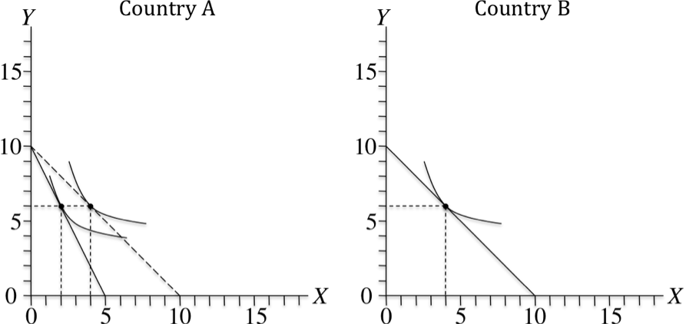

 | In autarky:
 |  | In Country A:
 |  |  | The relative price of X: |  | 2
 |  |  | Production of X |  | 2
 |  |  | Consumption of Y |  | 6
 |  | In Country B:
 |  |  | Production of Y |  | 6
 | In free trade:
 |  | The (world) relative price of X: |  |  | 1
 |  | In Country A:
 |  |  | Production of X |  | 0
 |  |  | Consumption of X |  | 4
 |  |  | Exports (+) or imports (–) of X |  | –4
 |  |  | Production of Y |  | 10
 |  |  | Consumption of Y |  | 6
 |  |  | Exports (+) or imports (–) of Y |  | +4
 |  | In Country B:
 |  |  | Production of X |  | 8
 |  |  | Consumption of X |  | 4
 |  |  | Exports (+) or imports (–) of X |  | +4
 |  |  | Production of Y |  | 2
 |  |  | Consumption of Y |  | 6
 |  |  | Exports (+) or imports (–) of Y |  | –4

- (12 points) In the space below, draw a diagram representing a free-trade equilibrium for a small-open, two-good Ricardian economy that is completely specialized in production of good X.
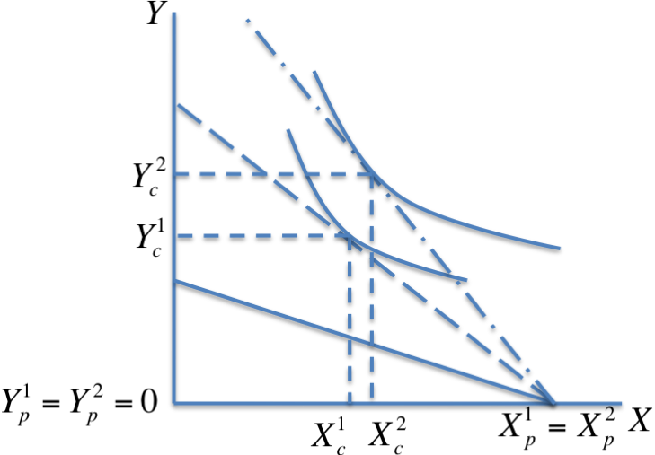
  - (4 points) In your diagram, show the effect on this economy of an increase in the world relative price of good X. Assume that preferences are homothetic.

  - (7 points) Guided by your answer to part (a), but also considering how you might have drawn it differently for valid production possibilities, preferences, and prices, indicate what happens to the variables listed below. That is, for each variable indicate in the blanks provided whether the stated variable necessarily rises (+), necessarily falls (–), necessarily stays the same (0), or could either rise or fall depending on how you draw the curves (?). Thus you will enter one of the four symbols, +, –, 0, or ?, in each blank.

 | i. | Production of X |  | 0
 | ii. | Production of Y |  | 0
 | iii. | Consumption of X |  | ?
 | iv. | Consumption of Y |  | +
 | v. | Quantity of exports |  | ?
 | vi. | Quantity of imports |  | +
 | vii. | Welfare (i.e., utility, as given by indifference curves) |  | +or ?

