Problem Set 7 - Answers
Topics in Trade Policy

- 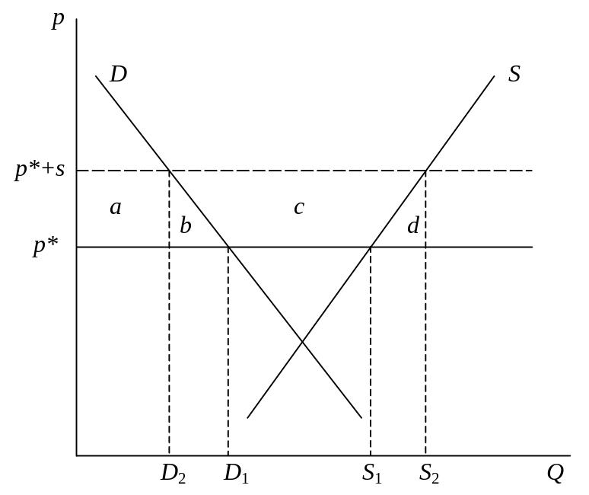Compare, in a small open economy, the effects of an export subsidy with those of a subsidy of the same size to all production. That is, suppose that an amount s per unit of a good were paid as an export subsidy for every unit of the good exported, and contrast this with payment of the same amount s for every unit of the good produced. Which will cost the government more, and which will cause a greater gain or loss of welfare for the country as a whole?
An export subsidy, s, per unit exported raises the price received by exporters in a small open economy to p*+s, causing the price on the domestic market to rise to that level as well (since otherwise producers would only export). The effects, as shown above, are for supply to rise from S₁ to S₂, and demand to fall from D₁ to D₂. Demanders lose “–(a+b)”, suppliers gain “+(a+b+c)”, and government loses (spends on the subsidy) “–(b+c+d)”, for a net loss to the economy of “–(b+d)”.
If instead the government had subsidized all production by this same amount, then producers would have received p*+s for all output and demanders would have been able still to purchase at price p*. Demanders would lose nothing, while suppliers would again gain “+(a+b+c)”, but the government would be paying the subsidy on all output, and thus losing “–(a+b+c+d),” for a net loss to the country of only “–d”.
So the government spends more of its budget on the production subsidy than on the export subsidy, but because the production subsidy does not distort the choice by demanders, it causes a smaller net loss for the country as a whole.

- 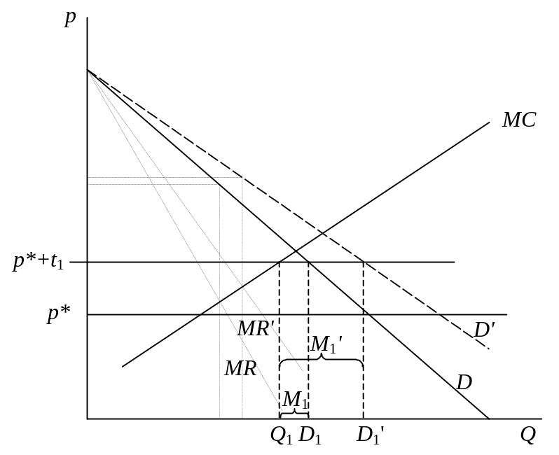The figure below shows domestic demand, D, for a good in a country where there is a single domestic producer with increasing marginal cost shown as MC. Imports of the good are available from abroad at a fixed price p*, subject to a tariff of either t₁ or t₂, which are indicated by the points p*+t₁ and p*+t₂ on the vertical axis. Suppose now that domestic demand for the good expands, for each price, to 25% more than it was before, so that the demand curve shifts out to D' as shown, its vertical intercept remaining the same. Determine how profits of the firm, and tariff revenue of the government, will be affected by this change.
For the case of the lower tariff, t₁, shown above, the firm cannot charge a price higher than p*+t₁, since consumers would otherwise buy from abroad, and it therefore cannot charge the monopoly price that would equate marginal revenue to marginal cost if there were no trade. The marginal revenue curves are drawn in above, but they are irrelevant. On the other hand, the firm can sell all it wants to at price p*+t₁, since its marginal cost rises to equal p*+t₁ at output Q₁, which is less than demand. So it produces Q₁ and sells it domestically, while demanders import the difference, M₁=D₁–Q₁. When the demand curve shifts out to D', this does not change the firm’s marginal cost curve or the highest price that it can charge, p*+t₁, so it also does not change its output. Output remains Q₁, and the firm’s profit is unchanged. Meanwhile, however, imports increase from M₁ to M₁' = D₁'–Q₁, and since the size of the tariff is unchanged, the government collects more tariff revenue.
For the case of the higher tariff, t₂, shown below, the firm still cannot charge more than p*+t₂, but now it cannot sell all it would want to produce at that price. Its only choices are to sell what it can domestically at p*+t₂, or reduce price below that in order to sell more. Since its monopoly price p^{M}, where MR=MC, is above p*+t₂, however, lowering its price would only decrease its profits. Therefore it limits production to Q₂, which is equal to domestic demand at that price, and it serves the entire domestic market. Now, when demand expands to D', it is able to sell more, and it does, producing and selling Q₂'=D₂', therefore making a larger profit. Imports are zero in both cases, so the government earns no tariff revenue in either case.
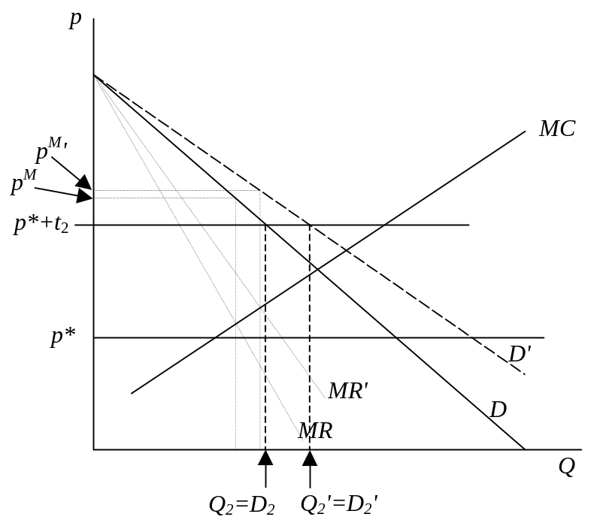
- Consider the Cournot Export Duopoly Model – two identical firms from different countries producing and selling a homogeneous product into (only) a third country and engaged in Cournot competition – and suppose that the governments of both producing countries were to consider providing subsidies for their exports of the good. Using an analysis similar to what we did in class for optimal tariffs and retaliation in competitive markets, determine what you can about the Nash equilibrium export subsidies and the well being of the two exporting countries in that Nash equilibrium compared to free trade. Also, how does welfare in the third (importing) country compare at that equilibrium to what it would have been with free trade?
The reaction curves of the two firms in the Export Duopoly Model, together with their iso-profit curves, show us that for any given level of export subsidy by one firm’s government, and thus a given reaction curve for that firm, the other firm’s profit will rise to a maximum and then fall if it is able to move the equilibrium along the other’s reaction curve in the direction of larger output for itself. For example, in the diagram below, the profit of the home firm starting at the Nash equilibrium E^{N}, rises from π_{x}^{N} to π_{x}^{S} and then falls as we move down and to the right along the foreign firm’s reaction curve, R_{y} from E^{N} to E^{S} and then on to E² . Likewise, from the iso-profit curves for the foreign firm, we can see that this same movement reduces the profit of the foreign firm.
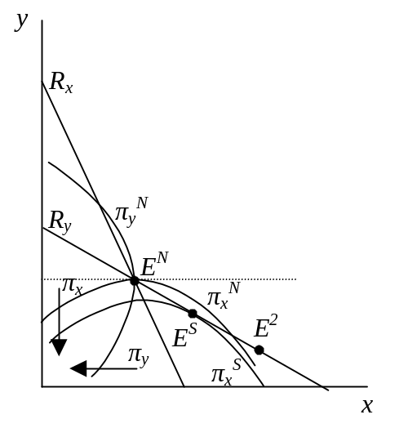Together with the analogous facts for movements along the home firm’s reaction curve from the perspective of the foreign firm, these results tells us what we need to know about how the two governments’ subsidies affect the profits of their national firms, not counting whatever they get in subsidy from their governments. And, since in the export duopoly model the countries do not consume the good, these profits are therefore equal to the benefits to their countries as a whole. We can then infer how national welfare in each country depends on the two levels of subsidy.
That is, in the figure above, if the foreign country’s subsidy s*=0, then the home country would maximize its firm’s profit and therefore its national welfare with a positive subsidy s₀. As the foreign country provides a larger subsidy to its firm, the optimal subsidy for the home firm may rise or fall, as represented by the policy reaction curve R_{s}. At each point along it, by definition, an iso-welfare curve for the home country is horizontal, representing the fact that home-country welfare is maximized there for the given value of the foreign subsidy, and thus for choices along a horizontal line. Similarly, the foreign government’s optimal subsidy if s=0 is s*₀, and its reaction curve R_{s}* shows it too perhaps varying with the level of the home country’s subsidy. Foreign welfare rises with movements to the left in the figure, and the foreign reaction curve is the collection of points where foreign iso-welfare curves are vertical.
Together, the two policy reaction curves tell us that a Nash equilibrium in these export subsidies will have both governments subsidizing their exports. It also tells us, since the iso-welfare curves must cross at that equilibrium (one being vertical and the other horizontal), that it would be possible to increase the welfare of both countries if they could somehow agree to both reduce their subsidies, perhaps to zero.
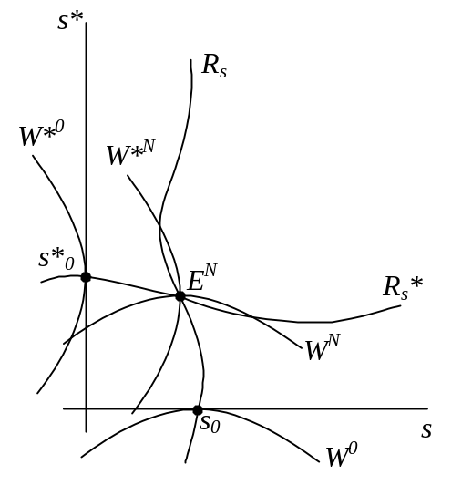Neither of these pictures tells us very much about welfare in the third country, but the effect on it is rather obvious anyway. As both countries subsidize exports to the third country, this will lead to greater sales there at a lower price, and the country’s consumers surely benefit. Since that country, by assumption, has no producers of its own, there is nobody there that is hurt.
- The “tariff equivalent” of an import quota is the tariff that would have led to the same quantity of imports as the quota. Assuming perfect competition, how does the tariff equivalent of a particular quota vary if there is an increase in (rightward shift of) the importing country’s demand for the good? How does it vary if there is an increase in the importing country’s supply of the good? Is it possible for either of these changes to cause the tariff equivalent of the quota to become negative?
A rightward shift of a country’s domestic demand curve shifts its demand for imports curve to the right (by the same amount), while a rightward shift of its domestic supply shifts its demand for imports curve to the left. All this is shown below.
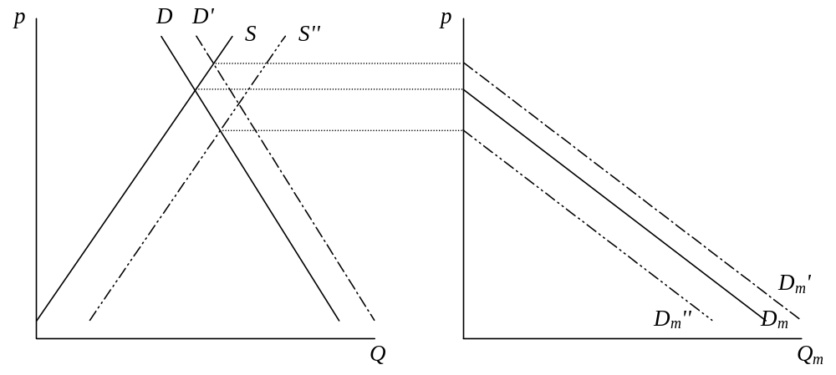
Therefore in the market for imports, the two cases appear respectively as a rightward and a leftward shift of the import demand curve. Only the rightward shift is shown below, since the other case is just the opposite. With the import quota fixed at 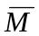, the world price remains in both cases at p_{q}*, the only price at which the world is willing to supply exactly of imports. The effect of a shift in import demand is to change only the domestic price of the imported good, raising it in the case (shown) of a rightward shift in import demand, and lowering it in the case of a leftward shift. Since the tariff equivalent is the difference between this domestic price and the unchanged world price, the tariff equivalent rises in the first case and falls in the second.
No, the tariff equivalent cannot become negative. It will fall if supply expands and import demand therefore shifts to the left, but it cannot fall below zero. When import demand shifts to the point that demand exactly equals at p_{q}*, then further shifts will cause a reduction in the quantity of imports below , and the quota will be redundant. Imports will then be the same as if there were no trade barrier at all, or in other words the same as if the tariff were zero.

- Suppose that the purpose of President Bush, when he levied tariffs on steel last year, was to increase employment in the steel industry to a certain level in order to achieve the benefit of those additional workers voting for Republican candidates in the November election. Based on the small-open economy, partial equilibrium model of a tariff, is this the economically optimal way for him to accomplish this objective? If not, what policy or policies might have achieved it at lower cost to the American economy? Do you think these policies would have been politically acceptable?
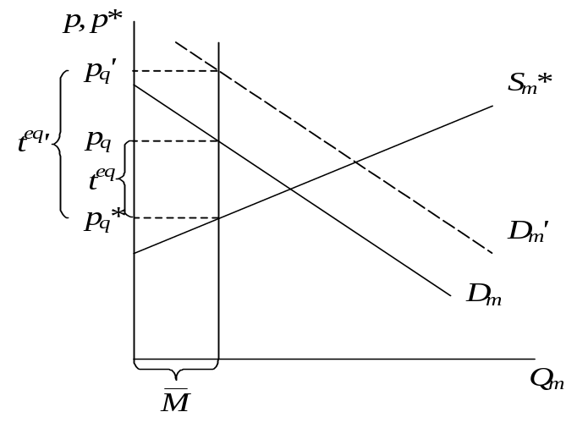Suppose, to keep it simple, that employment in the steel industry is just proportional to output, so that Bush just needed to get steel output up to a certain level in order to create the desired amount of employment. Then the question really is whether a tariff is an effective and/or a good way to increase output. Of course, it may not work, if the desired level of employment and output is greater than you would get with zero imports, since the most that a tariff can do is to reduce imports to zero. But let’s assume also that the desired level of output, call it Q^{T}, is small enough to be achievable with a tariff.
Then, using the small-open-economy, partial equilibrium model, we can illustrate the effect of the tariff on output as shown below. The tariff raises output from Q₁ to Q^{T}, as desired, while at the same time raising the domestic price of steel and reducing demand for steel. Producers gain area “a”, which is presumably what was intended – the producers include the steel workers whose votes are being sought. But demanders of steel lose area “a+b+c+d,” while the government collects tariff revenue of “c”. The net loss to the country is “b+d” as usual.
An alternative policy would have been to pay a direct subsidy to steel producers of the same amount as the tariff per unit of steel, s=t. This too would cause them to expand their output to Q^{T}, since they would now receive p*+s = p*+t for each unit produced. But demanders would now pay the world price p* and would not suffer any loss. On the other hand, the government would be paying s for each unit produced, costing it “a+b.” The net cost to the country would therefore be “b.” Compared to the cost of “b+d” due to the tariff, this would be preferable.
The question then is whether a direct subsidy to steel producers would have been politically acceptable. An economist would argue that, since the tariff was equivalent to the combination of a production subsidy together with a consumption tax, and since the tariff itself was politically acceptable, then logically a production tax should have been just as acceptable. But economists may be naïve. In fact, both the public and the politicians do not see it this way at all, and they would be likely to reject a direct subsidy even while they accept the tariff.
- 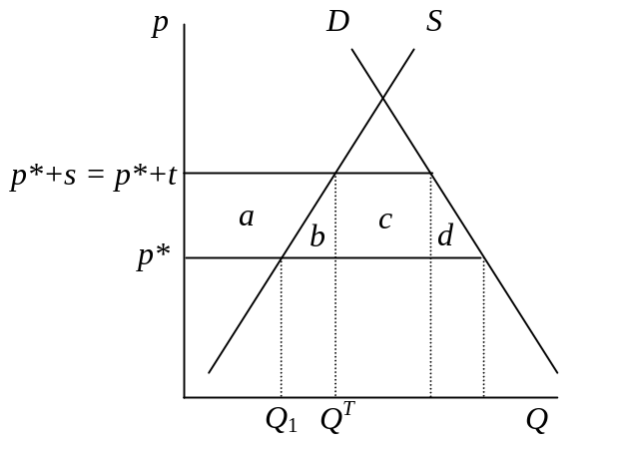Suppose that our country is importing (but also producing) a good whose production causes a negative externality to the world environment. Assuming that the foreign country that is exporting the good to us does not use any policy itself, might an import tariff be beneficial, for us and/or for the world as a whole? Is there any other policy that we could use that would be preferable? What is the optimal solution to the problem of this negative externality from the perspective of the world?
If we are a small country, then a tariff cannot help at all, since our tariff will raise our domestic price by the full amount of the tariff but leave the world price unchanged, and therefore not affect production abroad. Worse still, by raising the domestic price, we stimulate production of the good at home, therefore creating more of the negative externality.
So, for the tariff to make any sense at all, we had better be a big country. If so, then the tariff will raise the domestic price but also lower the world price, as shown in the diagram for the import market below.
This in turn appears as the price changes in the two domestic markets that are shown still further below, in both of which the size of the externality is indicated as E on the vertical axis. Therefore, in addition to the usual gains and losses from the tariff for suppliers and demanders in both countries, and the tariff revenue for the home country government, we also have a gain to the world of area “e*” due to decreased production of the good abroad, as well as a loss to the world of area “e” due to increased production of the good at home.
There is no reason in general why the former should be larger than the latter – that is, why a tariff on a good should reduce world output of it – but I have drawn it that way to give the tariff the benefit of the doubt. If this is the case, then it is possible, in principle, for the benefit from the decreased negative externality to be larger than the dead-weight loss from the tariff, which is the usual triangles “b+d+b*+d*,” although I don’t think that is the case in the figure below. Still, if E were large enough and if world output falls, this could happen.
Is there a better policy? Certainly. Suppose we had taxed consumption instead of imports. Then we would not have stimulated domestic production at all, and that would have to be better. A tax on the home country’s consumption would cause the demand for imports curve to shift to the left and reduce the world price, but now this reduced price would face producers in both countries.
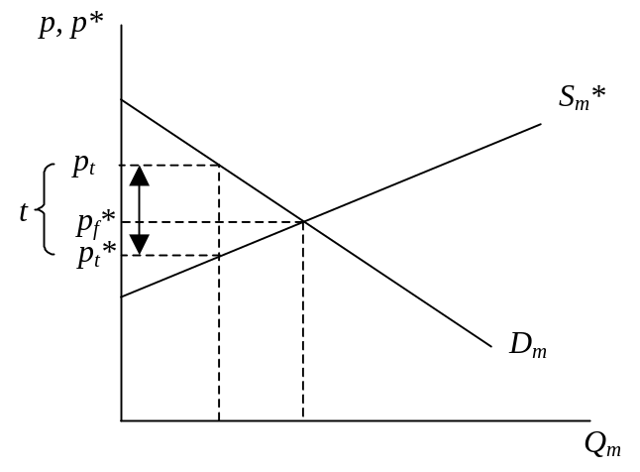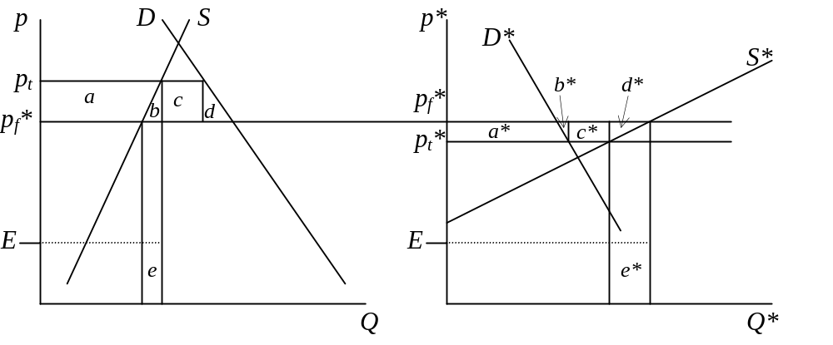This would still not be the first-best policy from a world perspective, since by reducing the price to foreign demanders we are stimulating their demand for a good that causes harm to the world. The optimal policy would be a tax on producers in both countries equal to E, but this is not something that the home country can do alone.

- Suppose that, prior to entering a free trade agreement with the European Union, Macedonia imports 30 tons of steel a year from Russia, subject to a 100% tariff. After entering the free trade agreement, it imports 70 tons of steel from Europe and none from Russia. Based on this information alone, can you tell whether Macedonia has gained or lost by reducing its steel tariff to zero against imports from the EU? If so, show why; if not, show what the answer depends upon.
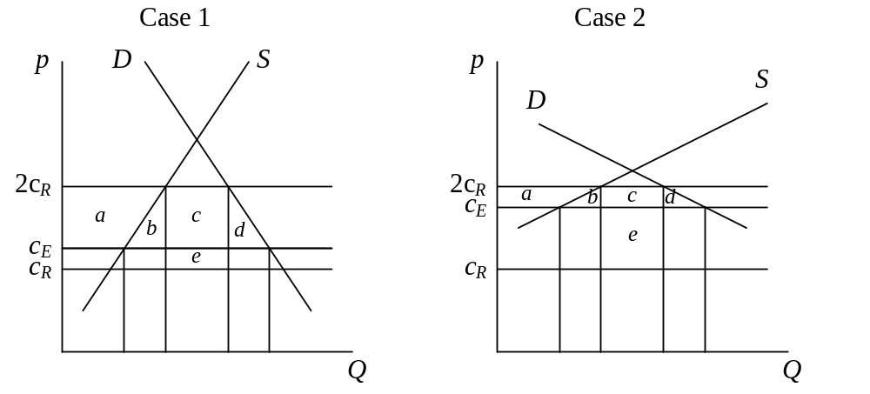No, you can’t tell. There has been both trade creation and trade diversion here, and we know the quantities: 30 tons of imports from Russia have been diverted to the EU, while 40 tons of imports have been created. But the fact that there has been more trade creation than trade diversion is neither necessary nor sufficient for this change to be beneficial. We can see this in the two diagrams below, where S and D are Macedonia’s supply and demand for steel, c_{R} is the cost of steel from Russia and c_{E} is the cost of steel from the EU. We must have c_{R}<c_{E}, since Macedonia was importing from Russia when both Russia and the EU faced the same 100% tariff. And it must also be true that c_{E}<2c_{R}, since otherwise Macedonia would still import from Russia even when the tariff on EU steel is zero. But this leaves room for the Russian cost to be just a bit lower than the EU’s, in which case the trade diversion does not hurt much, and for it to be a lot lower, in which case it hurts a lot.
In both cases, as in the analysis that we did in class (as I write this, we haven’t yet, but I am hopeful), the switch to a zero tariff on imports from the EU causes a net gain of “+(b+d)–e”. (The switch to zero tariff on imports from the EU causes the price of steel in Macedonia to fall from 2c_{R} to c_{E}, causing suppliers to lose “–a,” demanders to gain “+(a+b+c+d),” and government to lose “–(c+e)”.) The quantities supplied, demanded, and imported are the same in both cases, but area “e” is smaller than “b+d” in Case 1, but larger than it in Case 2.

