Problem Set 3 - Answers

Heckscher-Ohlin and Two-Cone Model

- Which of the following characterize the Heckscher-Ohlin Model?
- Perfect mobility of factors across industries Yes
- Perfect mobility of factors across countries No
- Constant returns to scale Yes
- The law of diminishing returns Yes
- Identical technologies across industries No
- Identical technologies across countries Yes
- Monopolistic competition No
- Perfect competition Yes
- Full employment Yes
- Balanced trade Yes
- Factor intensity reversals No (These are assumed not to occur.)
- Identical homothetic preferences Yes (This is not a necessary assumption for all results of the model, but it is an assumption that we will routinely use.)

- Suppose that the price of a good, X, is 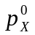 and that potential producers of that good in a country face factor prices w⁰ and r⁰. The three figures below show three ways that these prices might appear in an isoquant-isocost diagram. What can you say, in each case, about what will happen in the X industry in this country? That is, will the good be produced, can these prices constitute an equilibrium, and if so, what technique of production will be used to produce X?

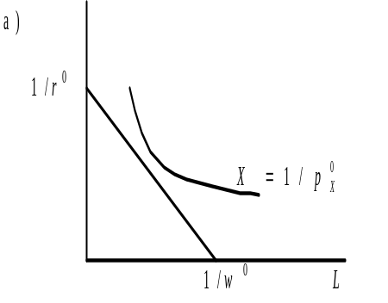This says that a dollar’s worth of X requires more factors than can be bought with one dollar. Therefore good X will not be produced at these prices.
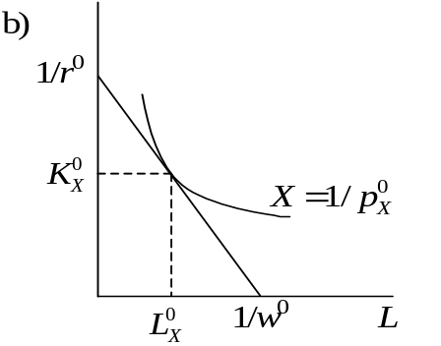Here producers of X exactly break even, spending one dollar on factors that will produce one dollar’s worth of X, if they use the least-cost technique of producing it. That least-cost technique is the tangency between the unit isocost line and the unit-value isoquant, and it therefore uses 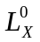 and 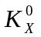 to produce one dollar’s worth of X. (Unless 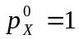, this is not one unit of X itself, so these are not the unit factor requirements a_{LX} and a_{KX}. We cannot determine these from the information given.)

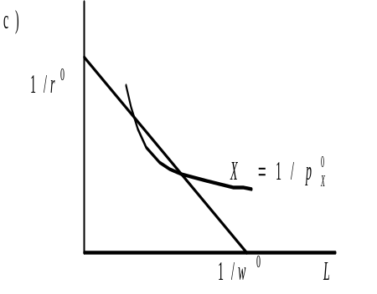Here, all of the points on the isoquant inside the isocost line are ways to produce a dollar’s worth of X at a cost of less than one dollar, thus making a profit. This situation will attract entry into the industry, seeking this profit, and will continue to do so until either the factor prices change (at least one of them rising due to the increased demand for factors) or the price of X falls (due to the increased supply of X). This cannot be an equilibrium situation.

- 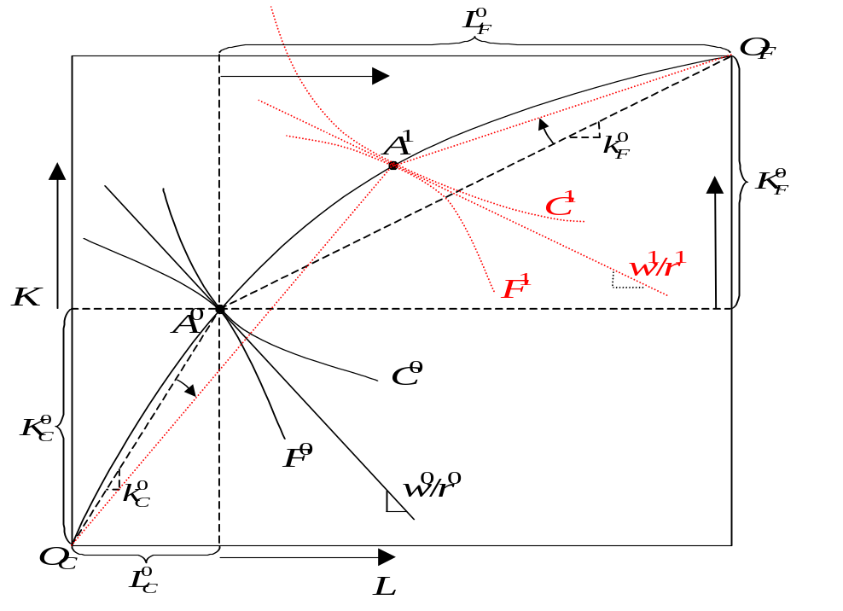The Edgeworth Box below shows the contract curve of a country as well as a particular allocation, A⁰, along that contract curve at which the country would produce, given certain prices, 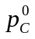 and 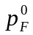. Its outputs at A⁰ are C⁰ and F⁰.

- What is the wage-rental ratio, w⁰/r⁰, in this initial equilibrium? Are you able to determine the factor prices, w⁰ and r⁰, individually? The ratio is shown by the slope of the straight line tangent to both isoquants at A⁰. We cannot determine w⁰ and r⁰, individually.
- Identify in the figure the allocations of labor and capital to each of the industries, 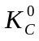, 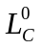 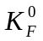, and 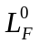, as well as their ratios, 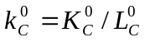 and 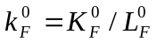. See figure above.
- Now consider the different allocation, also along the contract curve, shown as A¹. In order for the country to produce there, how would prices have to differ from and ? The relative price of cloth must rise in order for the economy to move from A⁰ to A¹. That is, 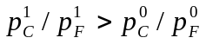.
- How do the factor allocations you looked at in part (b), and their ratios, differ at A¹ from what they were at A⁰? These are shown by the arrows in the figure above, from which we see that 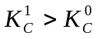, 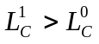, 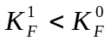, 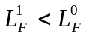, 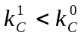, 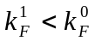.
- Using the full employment conditions for the two factors, show that the capital-labor ratio of the country as a whole, k=K/L, is a weighted average of the ratios in the two sectors, k_{C} and k_{F}.

The full employment conditions are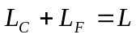, 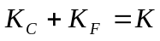.
From the first, 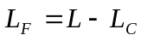. Therefore
which is a weighted average.
- In part (d), you should have found that both ratios, k_{C} and k_{F}, fell in going from A⁰ to A¹. Does this mean, in view of the result in part (e), that k has fallen also? Why or why not? The ratio k has not fallen, since it is just the ratio of the factor endowments, which are given. The reason that k_{C} and k_{F} were both able to fall without lowering k is that the weights, in the weighted average of part (e), have changed. By reallocating resources into the cloth sector, L_{C}/L rises, putting more weight on the larger of the two capital-labor ratios. This makes up for the fall in both of them.
- Draw isoquants for both industries through point A¹. Now identify the wage-rental ratio, w¹/r¹, as you did in part (a). How does it compare to w⁰/r⁰? The wage-rental ratio must be smaller at A¹ than at A⁰: w¹/r¹<w⁰/r⁰. That is, the isoquants are flatter there than at A⁰. The reason is that the capital-labor ratios have both fallen, so that the industries move along their isoquants toward less capital and more labor, and when that happens they get flatter, due to their curvature. I’d be willing to bet that most of you, at least when you first drew the new isoquants, drew them steeper.
- 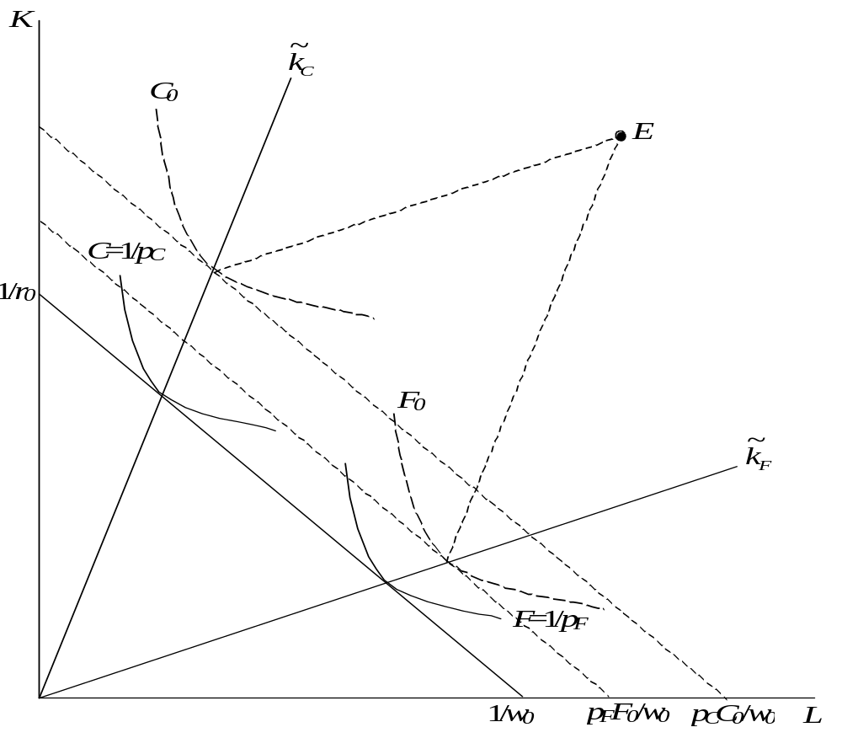Starting from the unit-value isoquants shown below and using the factor endowments at point E, carefully construct the rest of the pieces of the Lerner diagram for this economy. Suppose that this country spends half of its income on Cloth and half on Food. What does it export and what does it import?
The construction of the Lerner Diagram determines the factor prices, w₀ and r₀, that are consistent with producing both goods, and it also determines the ratios of factors employed at those factor prices in both sectors and thus the diversification cone. Since E is in that cone, the country will in fact diversify. The parallelogram construction determines the two factor allocations and thus the isoquants representing the country’s output, C₀ and F₀. The value of these outputs equals the value of their inputs (since profits are zero), and the two additional isocost lines drawn tangent to them therefore shows what they are worth, for example in units of labor by their intercepts with the labor axis. We see that the value of cloth produced is larger than the value of food produced, and thus that the country produces more than half of its income from cloth. Since is spends just half of its income on cloth, it must export cloth and import food.

- Use the HO Model with capital-intensive cloth and labor-intensive food to answer, for a small-open economy that is (and remains) diversified:

- If the labor force increases, what happens to the wage of labor and to labor’s share of national income?

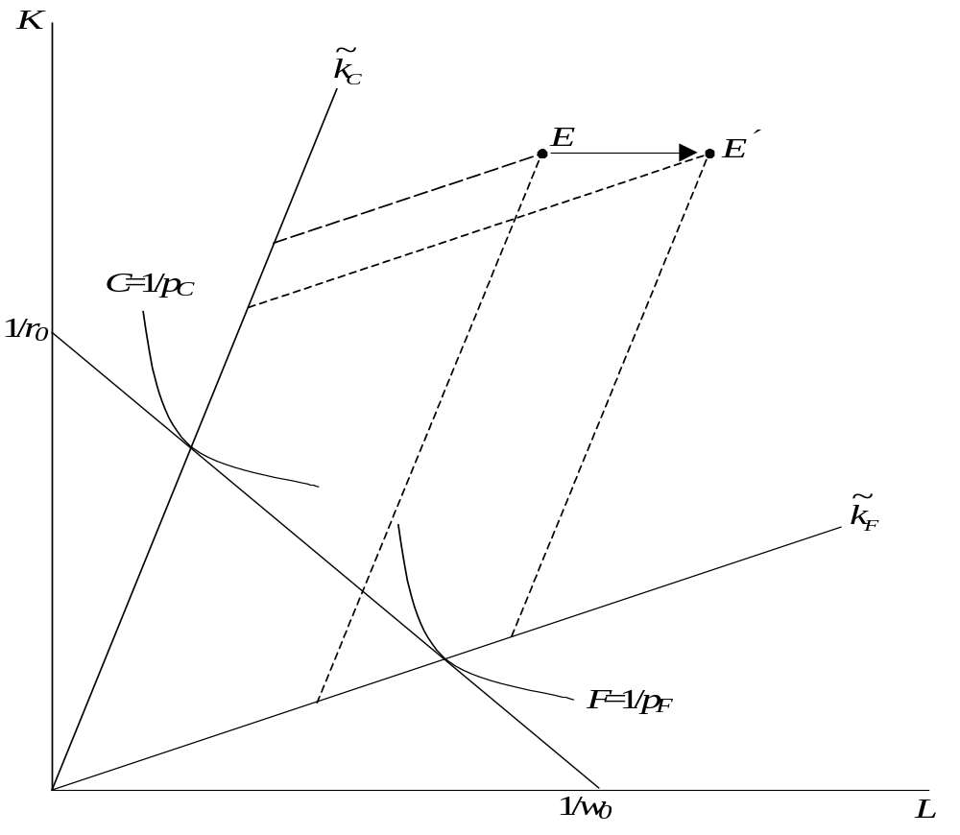
This moves the endowment point straight to the right, from E to E′. Since by assumption we remain inside the diversification cone, this does not change factor prices. The wage remains at w₀. However, since this wage is now paid to more workers, while both the quantity and price of capital have not changed, the share of national income going to labor must have increased.

- If the world price of cloth falls, what happens to the real rental on capital and to the output of food?
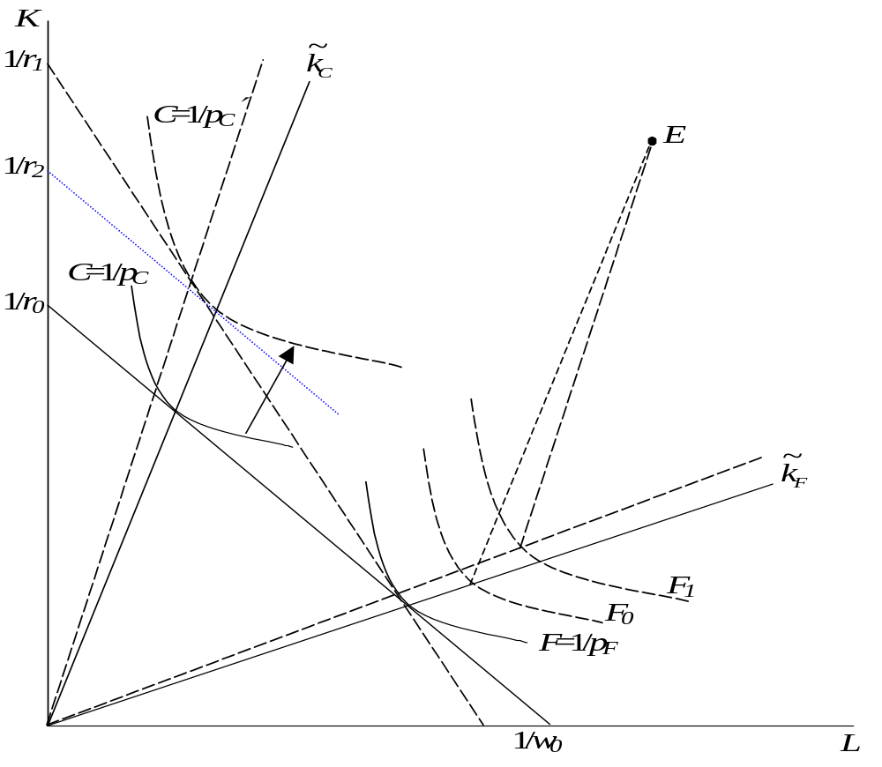The fall in price of cloth shifts the unit-value isoquant for cloth outward from the origin as shown. This causes the common tangent to the two isoquants to become steeper, and also increases the capital-labor ratios employed in both industries. The rental on capital falls to r₁, which is a fall relative to the price of food, which has not changed. To compare it also to the price of cloth, which has fallen, we construct a line parallel to the original isocost line but tangent to the new cloth isoquant. This dotted line intercepts the vertical axis at 1/r₂, and represents a fall in r equal to the fall in p_{C}. Since r₁ has fallen more than this, the rental must have fallen relative to the price of cloth as well, and this is a fall in real terms.

For the output of food, we complete one side of the parallelograms to get the outputs F₀ before the change and F₁ after. Clearly, the output of food has increased.
- Suppose that technology improves in this country only, permitting it to produce more cloth with the same amounts of factors. What happens to its output of cloth and its real wage of labor?

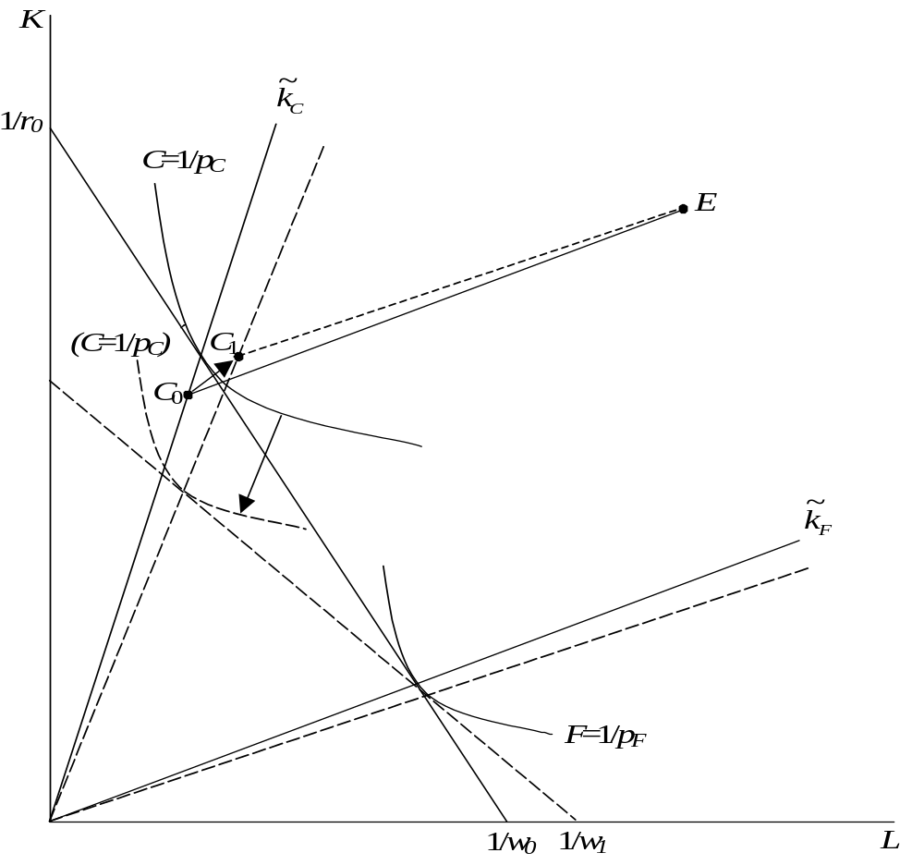This improvement in technology means that producers in the cloth industry can produce a dollar’s worth of cloth using less factors. Thus the unit-value isoquant for cloth shifts inward, as shown. The new common tangent is flatter than the old one, intercepting the wage axis further to the right. This is a fall in the nominal wage, and since both goods prices are unchanged, it is a fall in the real wage too. As for the output of cloth, the parallelogram construction finds the factor allocations to the cloth industry at C₀ before the change and C₁ after, indicating that more of both factors is employed in cloth after the change. Since even the same amount of factors would have produced more cloth with the new technology, the output of cloth must increase.

6. The graph below shows unit value isoquants for three goods, X₁, X₂ , and X₃, based on prices that are assumed to prevail throughout a world of many countries with free trade. Also shown are points representing the factor endowments of several countries, E¹, E², etc. Complete the two-cone Lerner diagram to identify the factor prices, factor ratios, and vectors of factors that will be employed in each sector by each country, and use these to answer the following questions:
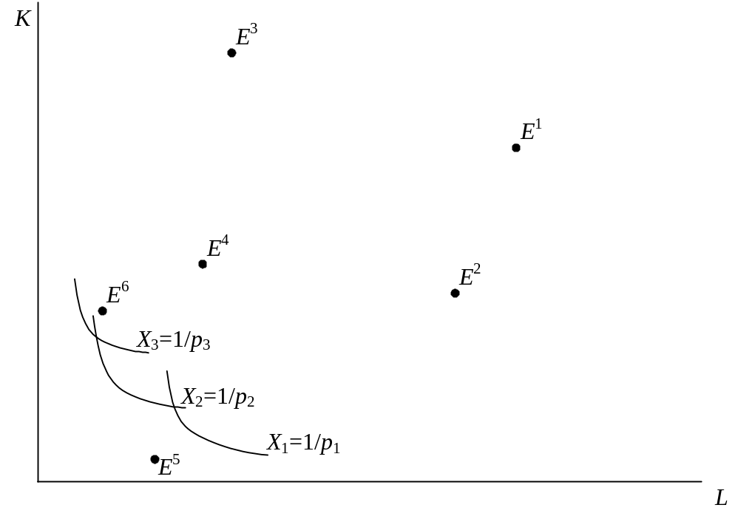

  - In which country or countries will the wage in units of good X₁, be highest, and in which will it be lowest? Would the answer be any different for the wage in units of goods X₂ or X₃?
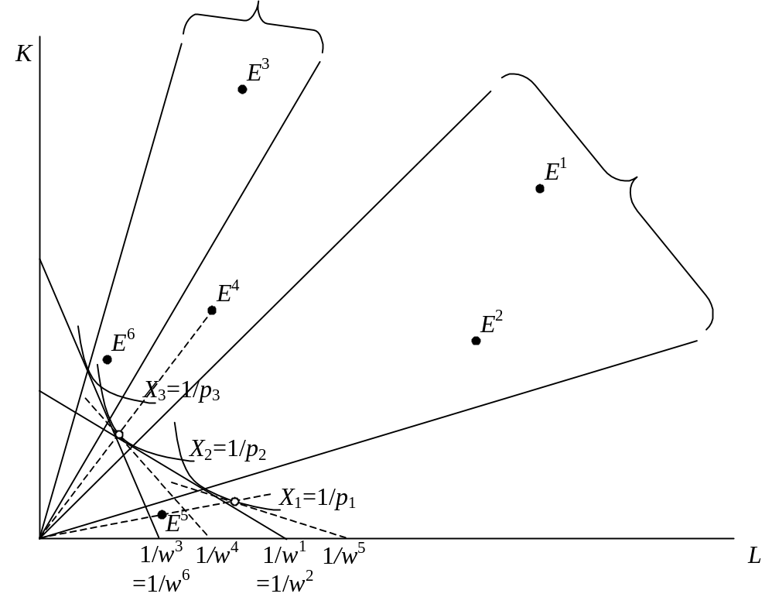Drawing the tangencies to pairs of adjacent isoquants we find the two cones of this equilibrium. Countries 1 and 2 are in the labor-intensive cone with identical nominal wages, and countries 3 and 6 are in the capital-intensive cone also with identical, but higher, wages. Countries 4 and 5 are not in either cone, and they therefore will specialize in goods 1 and 2 respectively. To find their factor prices, we draw rays from the origin through their endowment points and find the isocost lines tangent to their respective isoquants where they cross these rays. This gives us the wages shown as w⁴ and w⁵. Reading from these, we see that the lowest nominal wage is in country 5, while the highest is in both country 3 and country 6. Since prices of goods are the same for all countries, these are the lowest and highest respectively in terms of good 1 or any other good.

  - Which country will produce the largest quantity of each good?
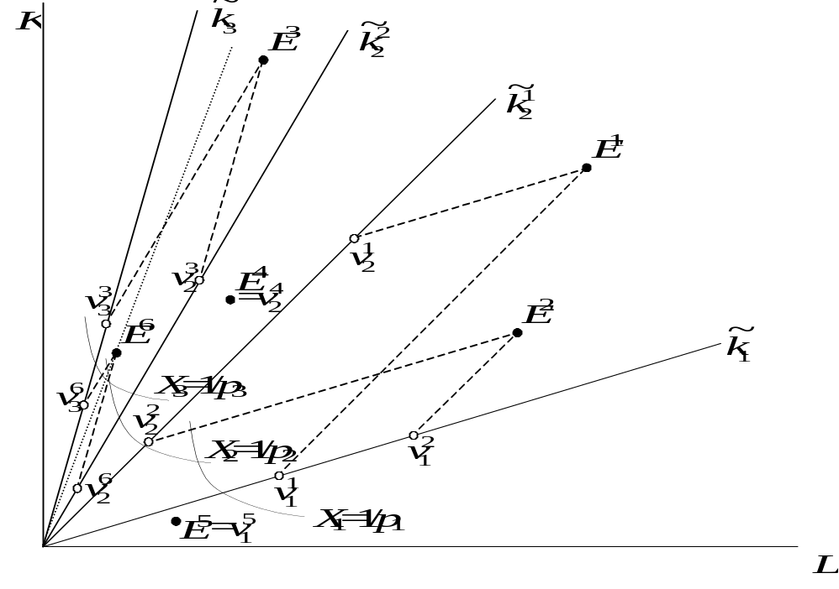For the four countries inside cones, the parallelogram construction identifies the vectors of factors they employ in each of the two goods that they produce, 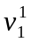 and 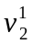 for goods 1 and 2 in country 1, for example. For countries 4 and 5, which completely specialize, their endowment points are themselves the vectors of factors they employ in their only sector. Comparing these vectors, we can observe that country 2 employs more factors in producing good 1 than countries 1 and 5 (the only other countries that produce it), and therefore country 2 has the largest output of good 1. Similarly, country 1 produces the most of good 2 (which is produced by all countries except 5), and country 3 produces the most of good 3.
  - Which country will produce the largest ratio of good X₃ to good X₂?
The dotted line above through E⁶ shows that country 6 has a higher ratio of capital to labor than does country 3 (or any other). Therefore, it produces a higher ratio of the more capital-intensive good 3 to good 2 than does country 3.
  - Suppose that consumer preferences in the world were to shift towards good 2 so as to cause a small increase in the price of good 2, the relative price of goods 1 and 3 remaining constant. Which country or countries would increase their output of good 2?

Holding p₁ and p₃ constant and increasing p₂, the unit value isoquant for X₂ shifts in towards the origin, as shown below. This gives rise to new tangencies with the isoquants. For those countries that were in one of the cones (all but 4 and 5), this causes new capital-labor rays in each sector, and a new parallelogram construction to determine vectors of inputs and thus outputs. The result is that all countries that were previously producing both good 2 and another good now produce more of it, which means that all countries except countries 4 and 5 produce more good 2. (If the price increase were large enough, country 5 would start to produce it too, since the labor-intensive cone would rotate clockwise to encompass its endowment point. However, we are told that the price increase is small.) Rather than show all of this in one diagram, I show this construction below only for countries 1 and 3, and only for good 2.
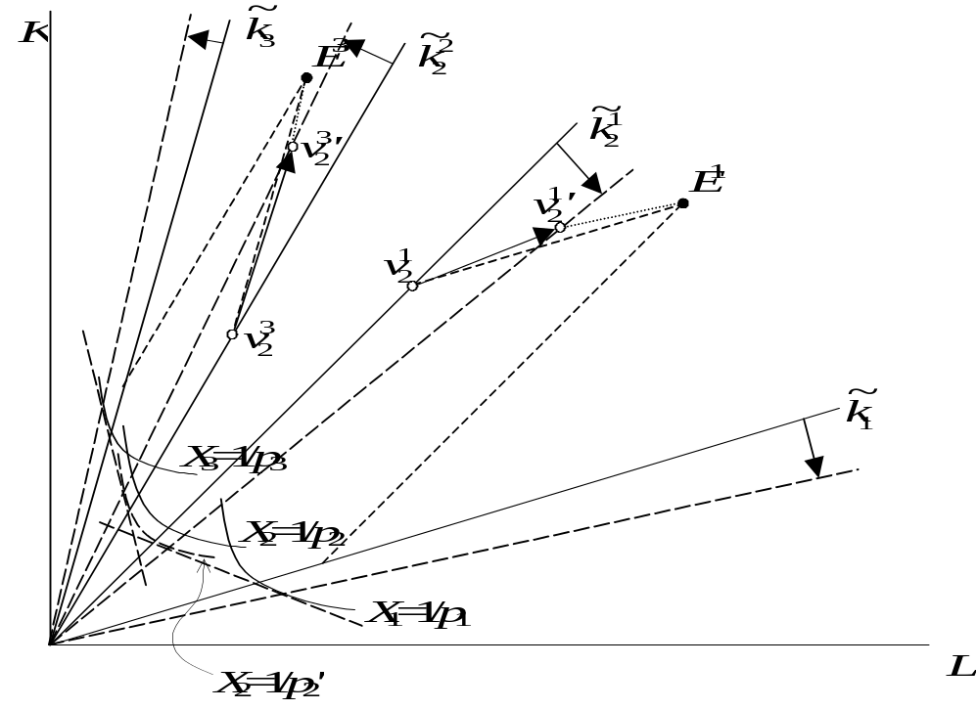

  - Suppose that population grows in an open economy, in a world characterized by a two-cone equilibrium, and that the country is too small to affect world prices, even after this population growth. If the country’s capital stock fails to grow as rapidly as its labor force, what will happen to the real wage of labor, and how will this depend on its pattern of specialization? Would your answer be any different if the country were able, instead, to expand its capital stock in proportion to its population?

Population growth, by itself, will cause the labor endowment to expand while the capital endowment does not, causing the endowment point in a Lerner diagram to move straight to the right as along Path 1 below. As it moves, depending on how far to the left it started (how little labor and how much capital), it will pass into and then out of first cone 2, with a higher wage, and then cone 1. Within each cone the wage will be constant, but outside of them the wage will decrease as L increases. Thus, whenever the country is producing two goods, its wage remains constant in spite of the population growth, but whenever it is producing only one, the wage falls.
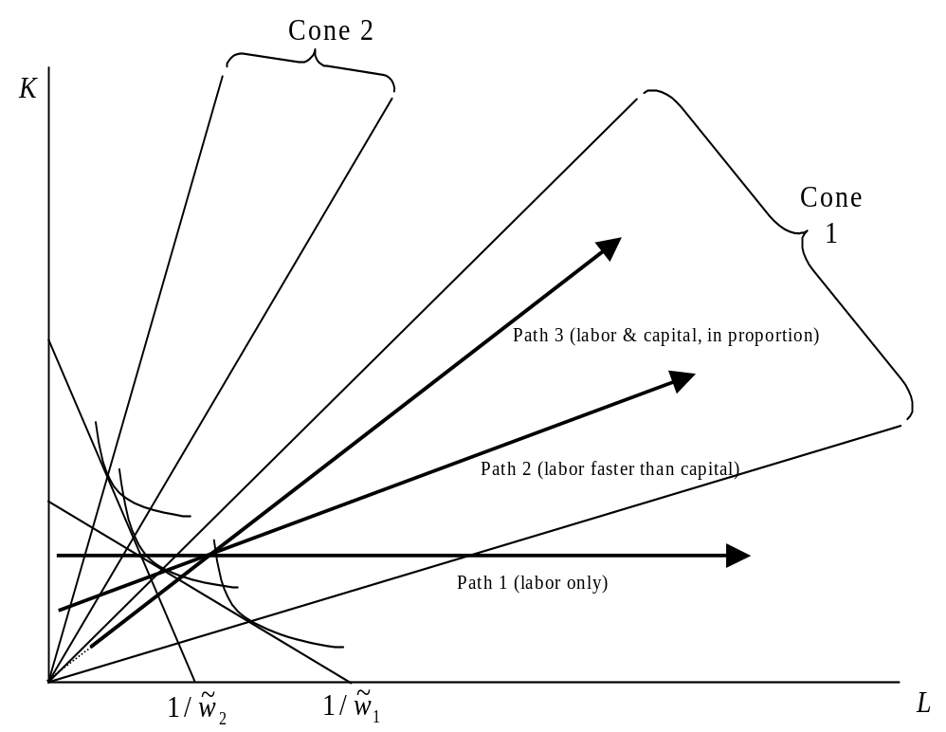
The same story holds if capital is growing along with labor, as long as capital grows more slowly, as along Path 2 above. If capital is growing in proportion to labor, however, as along Path 3, then the capital-labor ratio of the endowment will remain fixed and the economy will stay, either within a cone or outside them, depending on where it started, and its wage will remain fixed.

  - Suppose the world consists of just two countries and three goods, initially in a two-cone equilibrium with country 1 producing the most labor intensive good, X₁, country 2 producing the most capital-intensive good, X₃, and both producing the good of intermediate capital intensity, X₂. Suppose now that a small part of the labor force in country 1 moves to country 2.
  - 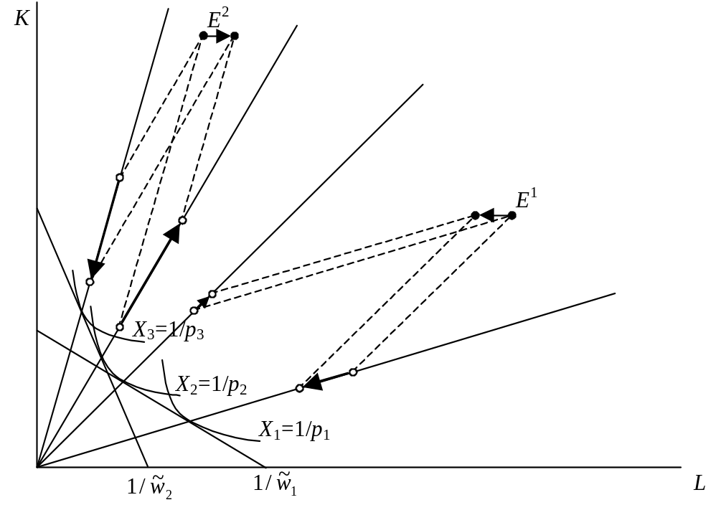At initial prices, what happens to the real wage of the labor that moves? Does it rise, fall, remain unchanged, or is the effect ambiguous?
Prices are fixed here, so a change in the real wage is the same as the change in the nominal wage. The labor moves from a wage of 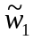 to the higher wage 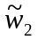, so the migrating labor gets a rise in its real wage.
  - Also at initial prices, how, if at all, will this movement of labor affect the world’s outputs of goods 1, 2, and 3?
From the parallelograms above, we see that both countries produce more of good 2, while the only producers of goods 1 and 3 both reduce their outputs of those goods.
  - Based on your answer to part (b), how would you expect world prices to change as a result, and how would this in turn affect real wages in the two countries? (Without details about preferences, you can’t be sure of the answers to this, but you should be able to give answers that are plausible.)
With more output of good 2 and less of goods 1 and 3, we would expect the price of good 2 to fall, while the prices of 1 and 3 rise. Which of the latter rises by more depends on demand conditions, among other things, but there is no particular reason to expect one or the other, so it may be reasonable to assume, for a start, that p₁/p₃ remains unchanged. If so, then we can examine a fall in p₂ holding p₁ and p₃ constant, as below.

The price change shifts the unit-value isoquant for good 2 outward, causing the common tangent in the labor-intensive cone to rotate clockwise and the common tangent in the capital-intensive cone to rotate counter-clockwise. The result, as shown by the labor intercepts of these tangents, is for the nominal wage to rise in country 1, which lost labor, and to fall in country 2, which gained labor. We know from the Stolper-Samuelson theorem that these changes are also changes in the same 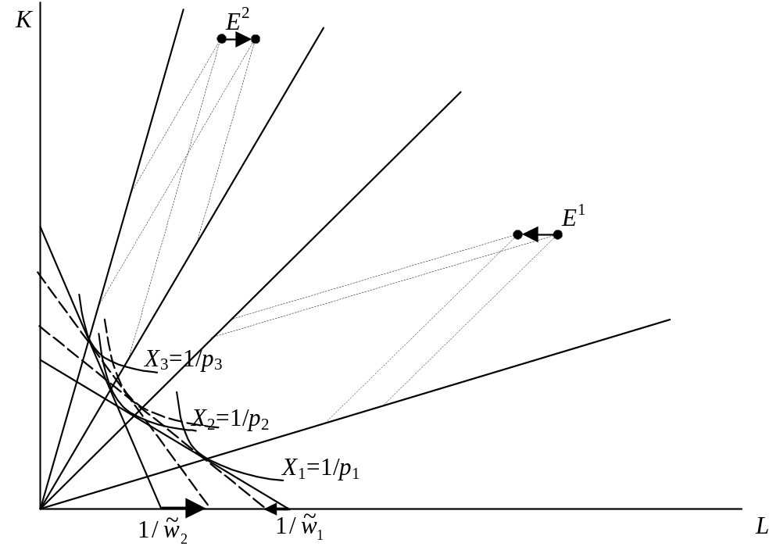direction relative to the changed price of good 2, and therefore, since the other prices have been held constant, they are changes in real wages.

