Using RStudio on Amazon EC2 under the Free Usage Tier
- Go to the homepage for Amazon Web Services, ‘aws.amazon.com’. Sign up by clicking the ‘Sign Up Now’ button on the right. If you already have an AWS account, click “Sign in to the AWS Management Console.”
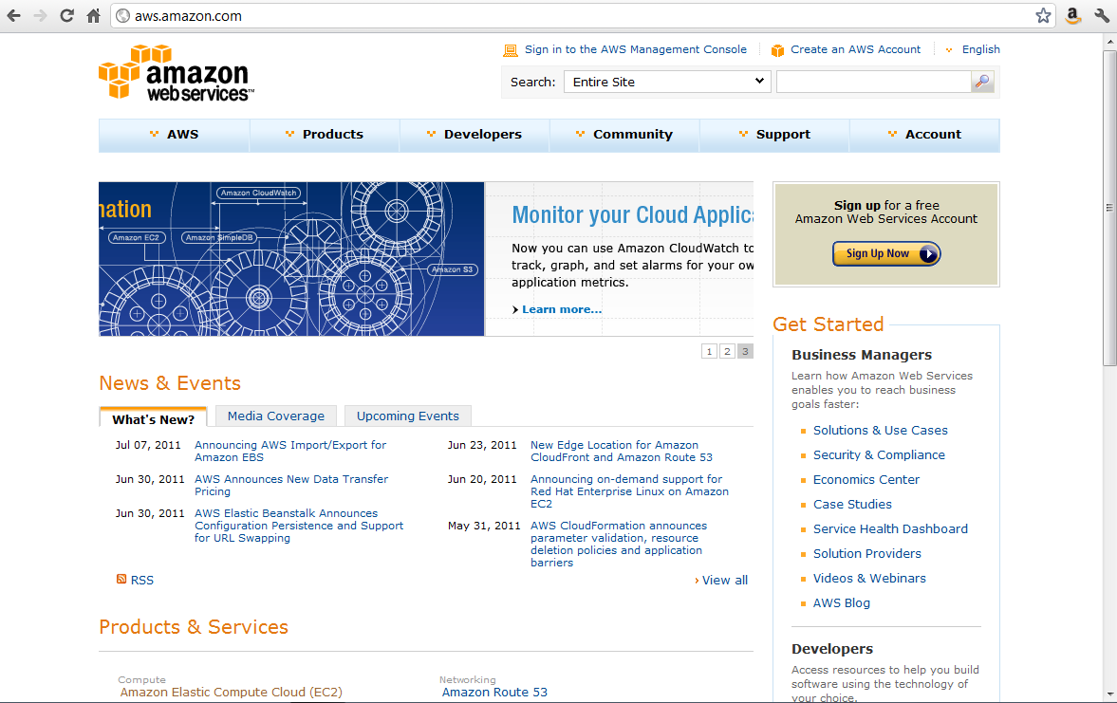
- Create a new Amazon account, or log in to an existing account.
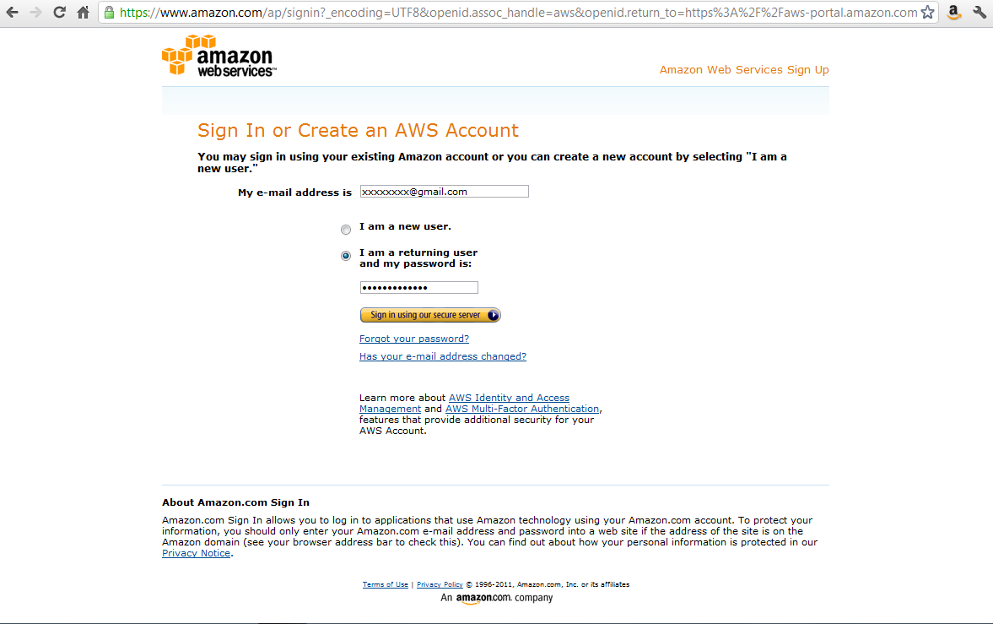
- You will need to provide credit card information, even if you only plan on using the Free Usage Tier.
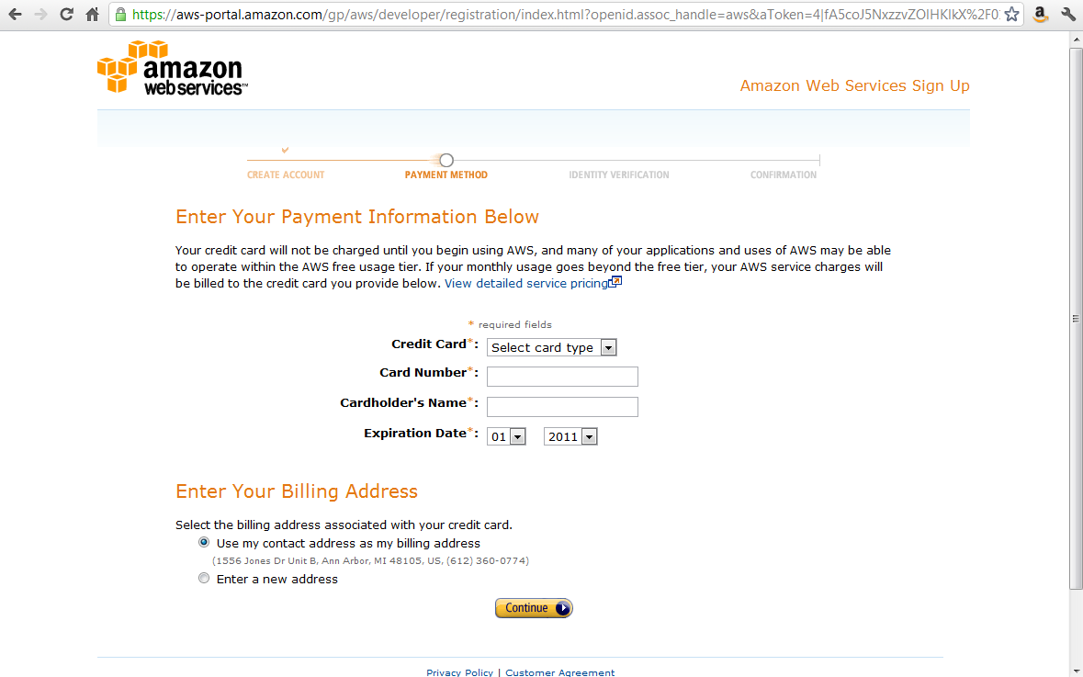

- Provide a telephone number. You will be called and given a PIN number which will be used to verify your identity. When this step is finished, you have an account. Click ‘Continue’ to go back to aws.amazon.com homepage. Log in to AWS by clicking the ‘Sign in to the AWS Management Console’ link on the aws.amazon.com homepage.
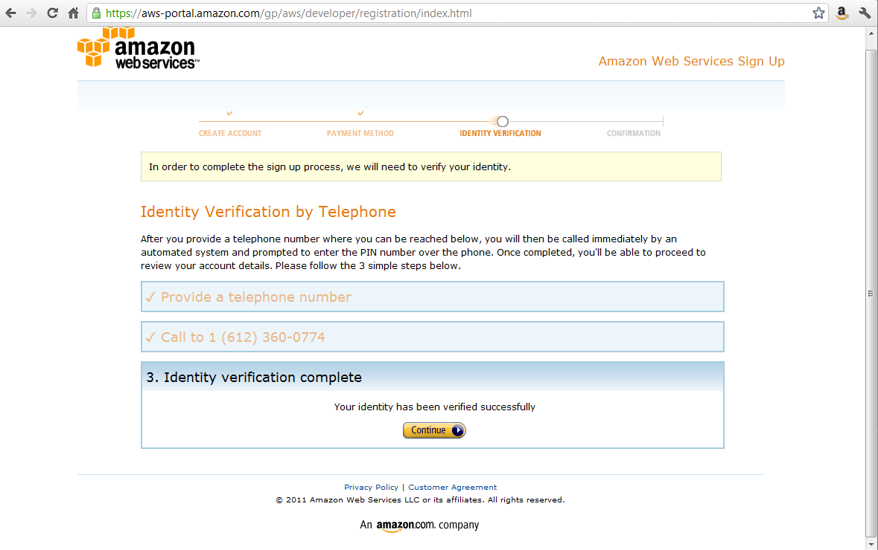
- You are now in the AWS Management Console. Under the ‘EC2’ (Electronic Cloud Computing) tab, click the ‘Launch Instance’ button.
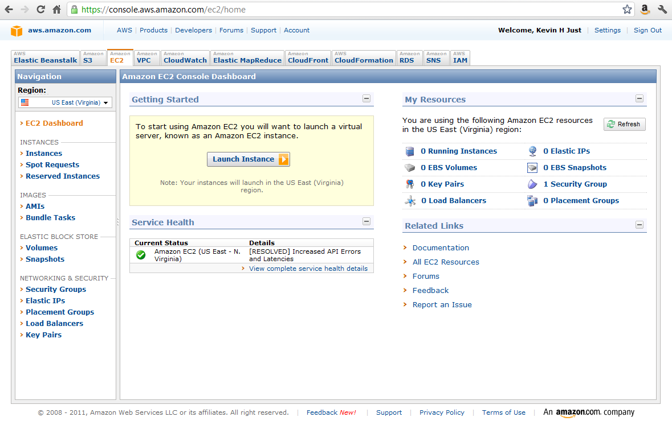
- Choose an instance. Starred instances can be used for free (part of the Free Usage Tier). Select ‘Community AMIs’ and enter ‘agongRStudio2’ into the search box. It will probably take a few seconds for Amazon to search and match the AMI name. Once the name appears, Select it.
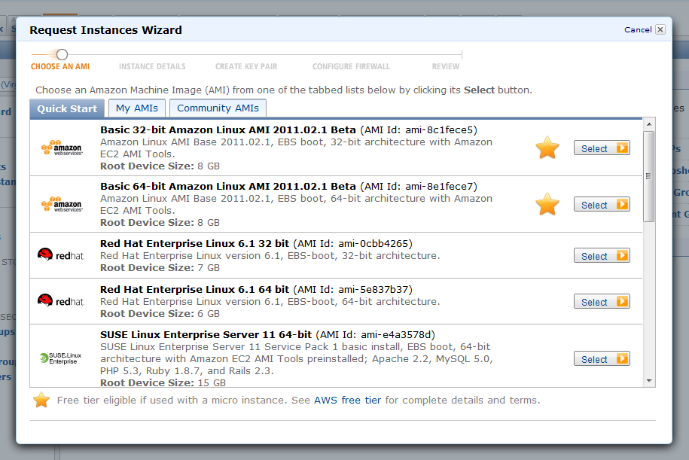
- Next, specify ‘Instance Details’. Keep all defaults. (Note: the Free Usage Tier is for Micro Instances only.) Click ‘Continue’ at successive screens.
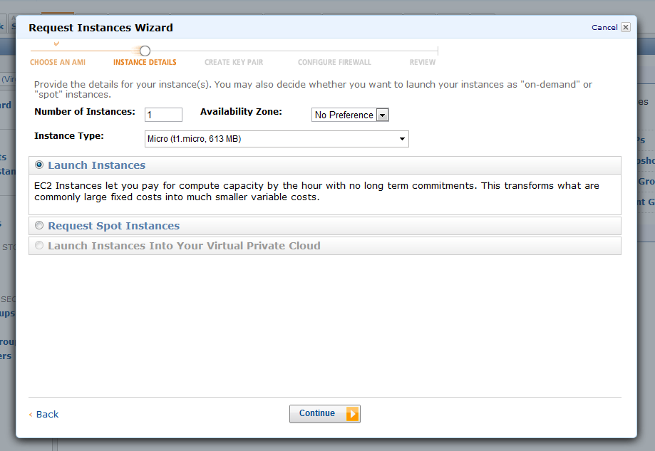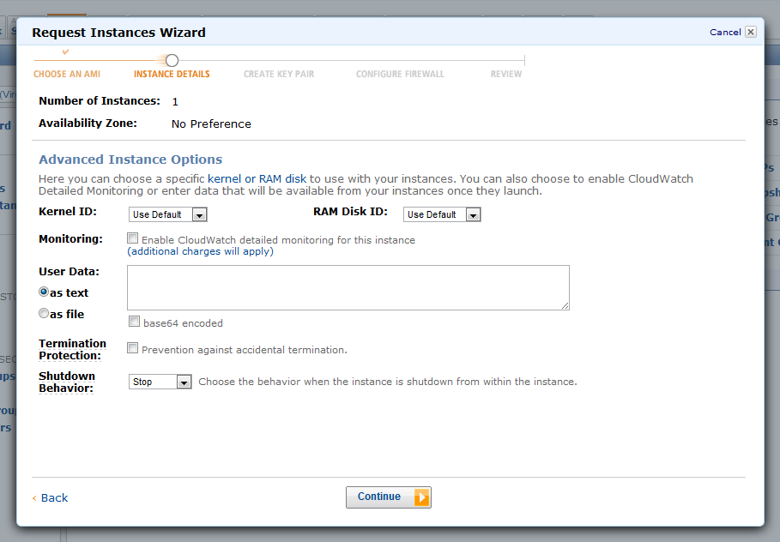
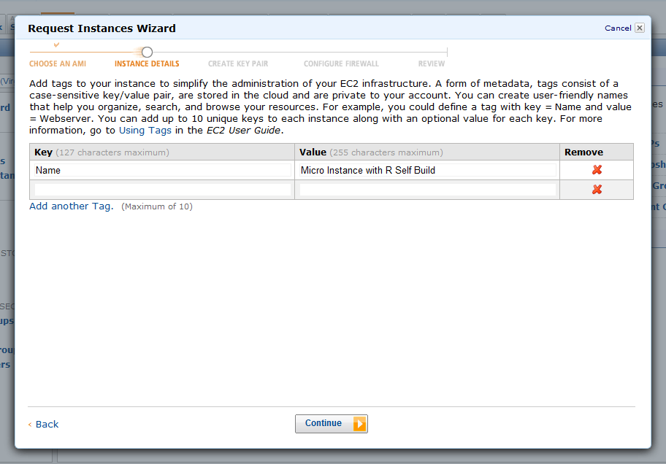

- Choose “Proceed without a keypair.” For more advanced applications, you will need a key pair to authenticate your SSH login. But for this simple demo, you don’t need it.
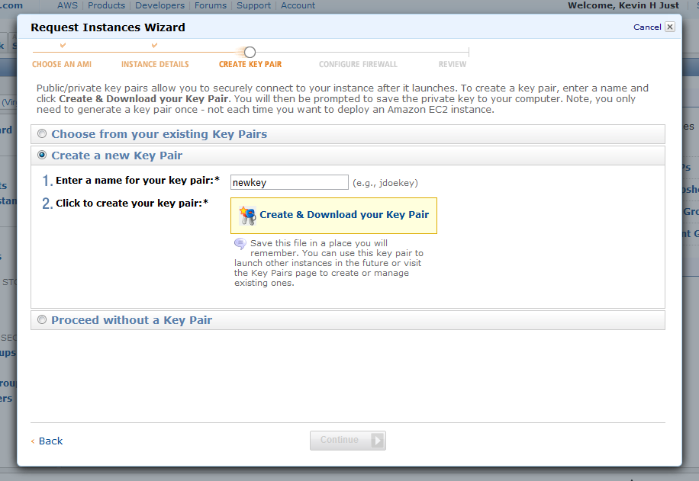
- Create a new Security group. Set the name and description to anything you like. (Here they are set to “basic” and “22 open for SSH.”)
You should add two rules. First, enter 22 into the Port range box, then click “Add Rule.” Then enter 8787 into the Port range box and click “Add Rule again.” Click ‘Continue’.
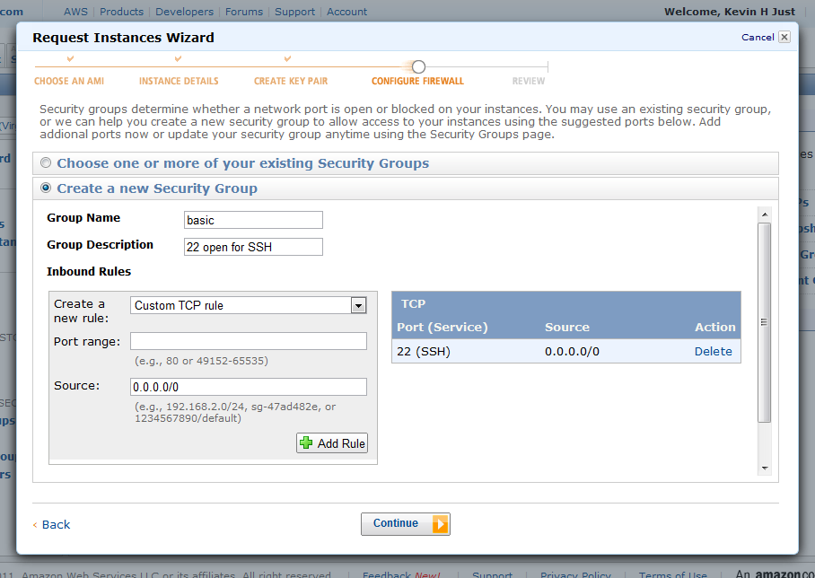
- The Instance is now launching. Click ‘View your instances on the Instances page’.
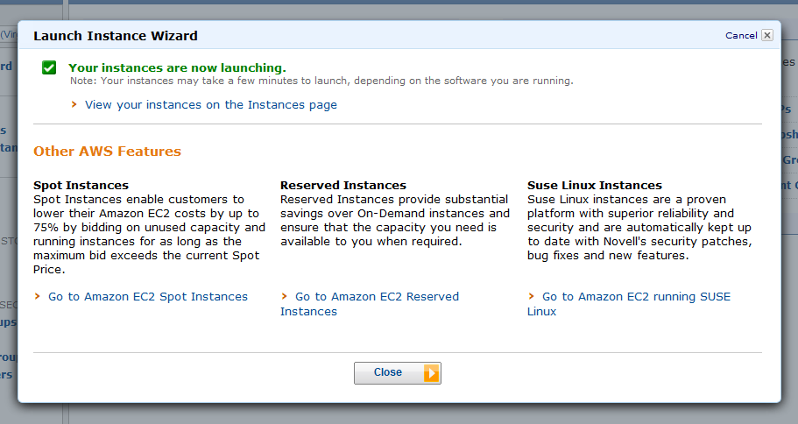

- Next, you need to look up the Public DNS (Domain Name System) from your AWS management console. To find the Public DNS, go to your AWS management console as shown below. Check the box to the left of the newly created instance (here, named ‘Micro Instance with R Self Build’ in Step 7). Details, including the Public DNS, will display. (Note: when you first come to this page, the status of your instance may be “Pending.” You won’t be able to see the DNS until it switches to “Running.” This may take a minute or two. Keep clicking “Refresh” if you get impatient.)
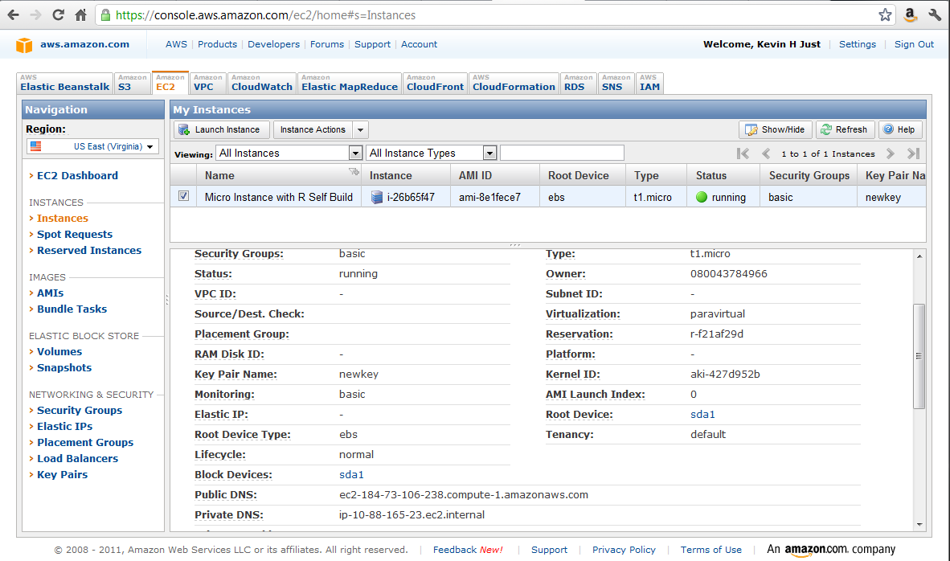
- Last, copy the DNS into the URL bar in your browser. Add “http://” in front, and “:8787” at the end. For example, if my public DNS was “ec2-123-45-678-900.compute-1.amazonaws.com,” I would enter “http://ec2-123-45-678-900.compute-1.amazonaws.com:8787”. Hit enter to go to the web site. If it’s working, you should see a login box for RStudio. Your username is “r-user” and your password is “mypw”. Sign in to get started running R in the cloud!

Sources
http://www.r-bloggers.com/ec2-micro-instance-of-rstudio/
http://www.travisnelson.net/2011/05/04/build-instructions-for-r-on-amazon-ec2/
http://www.travisnelson.net/2011/05/04/accessing-your-ec2-instance-from-windows-using-putty/

